# Serverless Overview

What’s serverless?

* Serverless is a new paradigm in which the developers don’t have to manage servers anymore…
* They just deploy code
* They just deploy… functions !
* Initially... Serverless == FaaS (Function as a Service)
* Serverless was pioneered by AWS Lambda but now also includes anything that’s managed: “databases, messaging, storage, etc.”
* Serverless does not mean there are no servers… it means you just don’t manage / provision / see them

**Serverless in AWS**

|  |  |
| --- | --- |
| * AWS Lambda * DynamoDB * AWS Cognito * AWS API Gateway * Amazon S3 * AWS SNS & SQS * AWS Kinesis Data Firehose Aurora Serverless * Step Functions * Fargate |  |

**Why AWS Lambda**

|  |  |
| --- | --- |
| • Virtual Servers in the Cloud  • Limited by RAM and CPU  • Continuously running  • Scaling means intervention to add / remove servers  • Virtual functions – no servers to manage!  • Limited by time - short executions  • Run on-demand  • Scaling is automated! |  |

**Benefits of AWS Lambda**

* Easy Pricing:
  + Pay per request and compute time
  + Free tier of 1,000,000 AWS Lambda requests and 400,000 GBs of compute time
* Integrated with the whole AWS suite of services
* Integrated with many programming languages
* Easy monitoring through AWS CloudWatch
* Easy to get more resources per functions (up to 10GB of RAM!)
* Increasing RAM will also improve CPU and network!

**AWS Lambda language support**

* Node.js (JavaScript)
* Python
* Java
* C# (.NET Core) / Powershell
* Ruby
* Custom Runtime API (community supported, example Rust or Golang)
* Lambda Container Image
  + The container image must implement the Lambda Runtime API
  + ECS / Fargate is preferred for running arbitrary Docker images

**AWS Lambda Integrations Main ones**

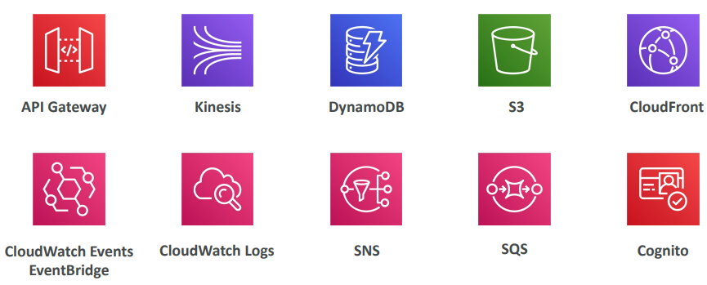

**Example: Serverless Thumbnail creation**

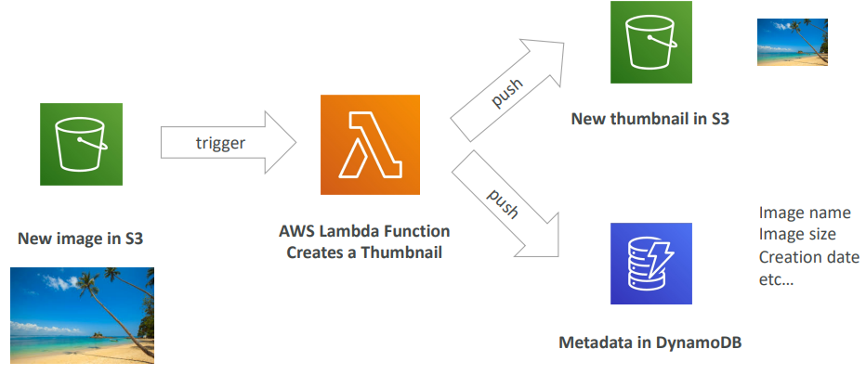

**Example: Serverless CRON Job**

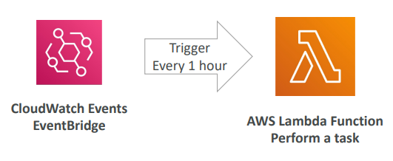

**AWS Lambda Pricing: example**

* You can find overall pricing information here:
* https://aws.amazon.com/lambda/pricing/
* Pay per calls:
* First 1,000,000 requests are free • $0.20 per 1 million requests thereafter ($0.0000002 per request)
* Pay per duration: (in increment of 1 ms)
  + 400,000 GB-seconds of compute time per month for FREE
  + == 400,000 seconds if function is 1GB RAM
  + == 3,200,000 seconds if function is 128 MB RAM
  + After that $1.00 for 600,000 GB-seconds
* It is usually very cheap to run AWS Lambda so it’s very popular

**AWS Lambda Limits to Know - per region**

* Execution:
  + Memory allocation: 128 MB – 10GB (1 MB increments)
  + Maximum execution time: 900 seconds (15 minutes)
  + Environment variables (4 KB)
  + Disk capacity in the “function container” (in /tmp): 512 MB to 10GB
  + Concurrency executions: 1000 (can be increased)
* Deployment:
  + Lambda function deployment size (compressed .zip): 50 MB
  + Size of uncompressed deployment (code + dependencies): 250 MB
  + Can use the /tmp directory to load other files at startup
  + Size of environment variables: 4 KB

**Lambda SnapStart**

|  |  |
| --- | --- |
| * Improves your Lambda functions performance up to 10x at no extra cost for Java 11 and above * When enabled, function is invoked from a preinitialized state (no function initialization from scratch) * When you publish a new version:   + Lambda initializes your function   + Takes a snapshot of memory and disk state of the initialized function   + Snapshot is cached for low-latency access |  |

**Customization At The Edge**

* Many modern applications execute some form of the logic at the edge
* Edge Function:
  + A code that you write and attach to CloudFront distributions
  + Runs close to your users to minimize latency
* CloudFront provides two types: CloudFront Functions & Lambda@Edge
* You don’t have to manage any servers, deployed globally
* Use case: customize the CDN content
* Pay only for what you use
* Fully serverless

**CloudFront Functions & Lambda@Edge Use Cases**

* Website Security and Privacy
* Dynamic Web Application at the Edge
* Search Engine Optimization (SEO)
* Intelligently Route Across Origins and Data Centers
* Bot Mitigation at the Edge
* Real-time Image Transformation
* A/B Testing
* User Authentication and Authorization
* User Prioritization
* User Tracking and Analytics

**CloudFront Functions**

|  |  |
| --- | --- |
| * Lightweight functions written in JavaScript * For high-scale, latency-sensitive CDN customizations * Sub-ms startup times, millions of requests/second * Used to change Viewer requests and responses:   + Viewer Request: after CloudFront receives a request from a viewer   + Viewer Response: before CloudFront forwards the response to the viewer * Native feature of CloudFront (manage code entirely within CloudFront) |  |

**Lambda@Edge**

|  |  |
| --- | --- |
| * Lambda functions written in NodeJS or Python * Scales to 1000s of requests/second * Used to change CloudFront requests and responses:   + Viewer Request – after CloudFront receives a request from a viewer   + Origin Request – before CloudFront forwards the request to the origin   + Origin Response – after CloudFront receives the response from the origin   + Viewer Response – before CloudFront forwards the response to the viewer * Author your functions in one AWS Region (us-east-1), then CloudFront replicates to its location |  |

**CloudFront Functions vs. Lambda@Edge**

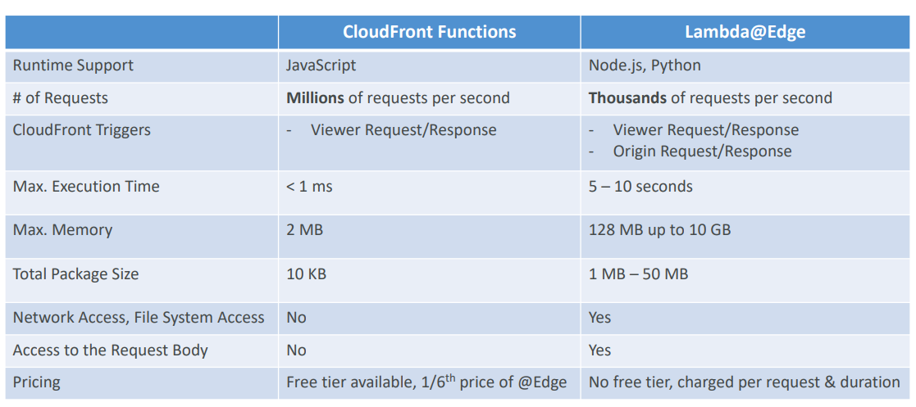

**CoudFront Functions vs. Lambda@Edge - Use Cases**

|  |  |
| --- | --- |
| CloudFront Functions   * Cache key normalization   + Transform request attributes (headers, cookies, query strings, URL) to create an optimal Cache Key * Header manipulation   + Insert/modify/delete HTTP headers in the request or response * URL rewrites or redirects * Request authentication & authorization * Create and validate user-generated tokens (e.g., JWT) to allow/deny requests | Lambda@Edge   * Longer execution time (several ms) * Adjustable CPU or memory * Your code depends on a 3rd libraries (e.g., AWS SDK to access other AWS services) * Network access to use external services for processing * File system access or access to the body of HTTP requests |

**Lambda by default**

|  |  |
| --- | --- |
| * By default, your Lambda function is launched outside your own VPC (in an AWS -owned VPC) * • Therefore, it cannot access resources in your VPC (RDS, ElastiCache, internal ELB…) |  |

**Lambda in VPC**

|  |  |
| --- | --- |
| * You must define the VPC ID, the Subnets and the Security Groups * Lambda will create an ENI (Elastic Network Interface) in your subnets |  |

**Lambda with RDS Proxy**

|  |  |
| --- | --- |
| * If Lambda functions directly access your database, they may open too many connections under high load * RDS Proxy   + Improve scalability by pooling and sharing DB connections   + Improve availability by reducing by 66% the failover time and preserving connections   + Improve security by enforcing IAM authentication and storing credentials in Secrets Manager * The Lambda function must be deployed in your VPC, because RDS Proxy is never publicly accessible |  |

**Invoking Lambda from RDS & Aurora**

|  |  |
| --- | --- |
| * Invoke Lambda functions from within your DB instance * Allows you to process data events from within a database * Supported for RDS for PostgreSQL and Aurora MySQL * Must allow outbound traffic to your Lambda function from within your DB instance (Public, NAT GW, VPC Endpoints) * DB instance must have the required permissions to invoke the Lambda function (Lambda Resource-based Policy & IAM Policy) |  |

**RDS Event Notifications**

|  |  |
| --- | --- |
| * Notifications that tells information about the DB instance itself (created, stopped, start, …) * You don’t have any information about the data itself * Subscribe to the following event categories: DB instance, DB snapshot, DB Parameter Group, DB Security Group, RDS Proxy, Custom Engine Version * Near real-time events (up to 5 minutes) * Send notifications to SNS or subscribe to events using EventBridge |  |

**Amazon DynamoDB**

* Fully managed, highly available with replication across multiple AZs
* NoSQL database - not a relational database - with transaction support
* Scales to massive workloads, distributed database
* Millions of requests per seconds, trillions of row, 100s of TB of storage
* Fast and consistent in performance (single-digit millisecond)
* Integrated with IAM for security, authorization and administration
* Low cost and auto-scaling capabilities
* No maintenance or patching, always available
* Standard & Infrequent Access (IA) Table Class

**DynamoDB - Basics**

* DynamoDB is made of Tables
* Each table has a Primary Key (must be decided at creation time)
* Each table can have an infinite number of items (= rows)
* Each item has attributes (can be added over time – can be null)
* Maximum size of an item is 400KB
* Data types supported are:
* Scalar Types – String, Number, Binary, Boolean, Null
* Document Types – List, Map
* Set Types – String Set, Number Set, Binary Set
* Therefore, in DynamoDB you can rapidly evolve schemas

**DynamoDB –Table example**

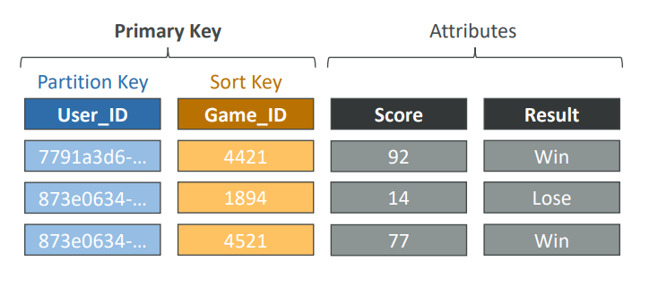

**DynamoDB – Read/Write Capacity Modes**

* Control how you manage your table’s capacity (read/write throughput)
* Provisioned Mode (default)
  + You specify the number of reads/writes per second
  + You need to plan capacity beforehand
  + Pay for provisioned Read Capacity Units (RCU) & Write Capacity Units (WCU)
  + Possibility to add auto-scaling mode for RCU & WCU
* On-Demand Mode
  + Read/writes automatically scale up/down with your workloads
  + No capacity planning needed
  + Pay for what you use, more expensive ($$$)
  + Great for unpredictable workloads, steep sudden spikes

**DynamoDB Accelerator (DAX)**

|  |  |
| --- | --- |
| * Fully managed, highly available, seamless in memory cache for DynamoDB * Help solve read congestion by caching * Microseconds latency for cached data * Doesn’t require application logic modification (compatible with existing DynamoDB APIs) * 5 minutes TTL for cache (default) |  |

**DynamoDB Accelerator (DAX) vs. ElastiCache**

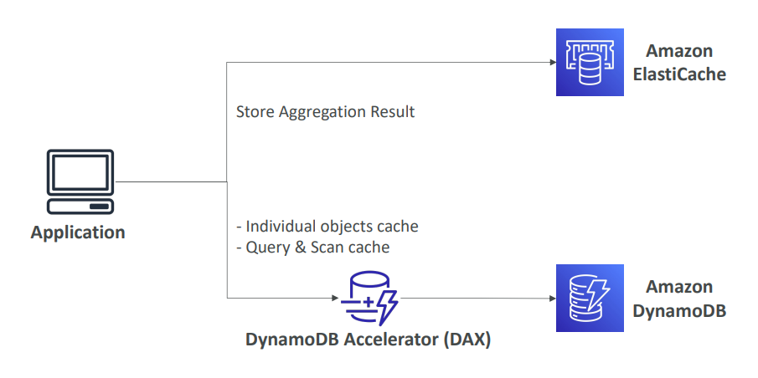

**DynamoDB – Stream Processing**

* Ordered stream of item-level modifications (create/update/delete) in a table
* Use cases:
* React to changes in real-time (welcome email to users)
* Real-time usage analytics
* Insert into derivative tables
* Implement cross-region replication
* Invoke AWS Lambda on changes to your DynamoDB table

|  |  |
| --- | --- |
| DynamoDB Streams   * 24-hour retention * Limited # of consumers * Process using AWS Lambda Triggers, or DynamoDB Stream Kinesis adapter | Kinesis Data Streams (newer)   * 1 year retention * High # of consumers * Process using AWS Lambda, Kinesis Data Analytics, Kineis Data Firehose, AWS Glue Streaming ETL… |

**DynamoDB Streams**

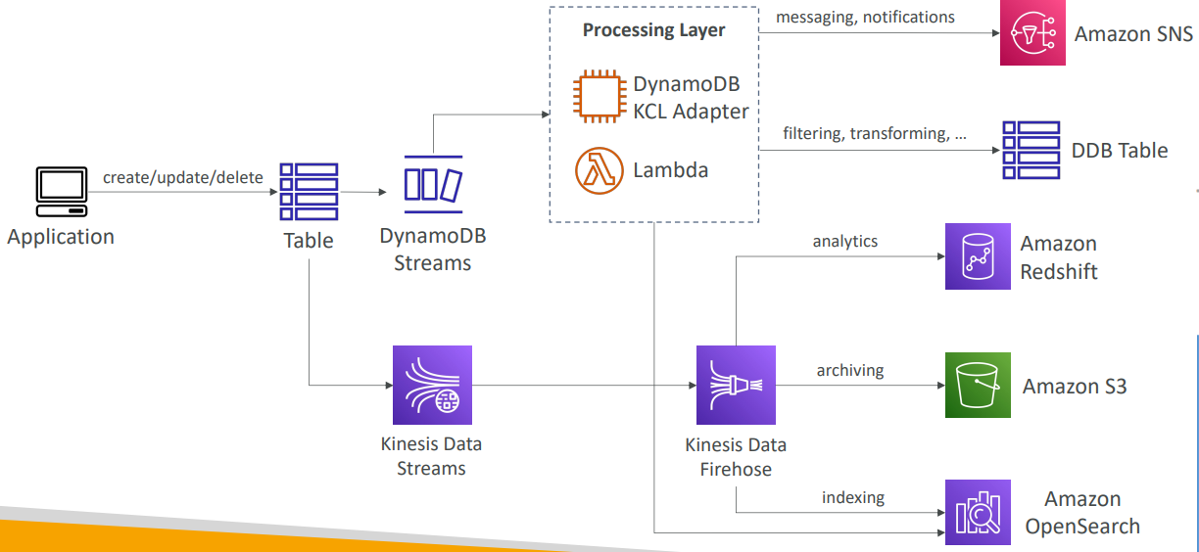

**DynamoDB Global Tables**

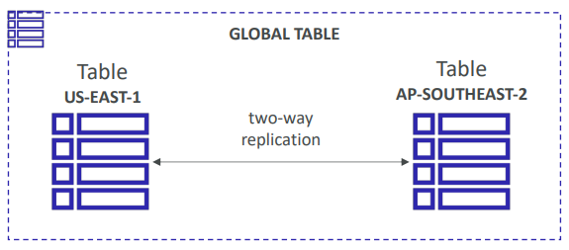

* Make a DynamoDB table accessible with low latency in multiple-regions
* Active-Active replication
* Applications can READ and WRITE to the table in any region
* Must enable DynamoDB Streams as a pre-requisite

**DynamoDB –Time To Live (TTL)**

|  |  |
| --- | --- |
| * Automatically delete items after an expiry timestamp * Use cases: reduce stored data by keeping only current items, adhere to regulatory obligations, web session handling… |  |

**DynamoDB – Backups for disaster recovery**

* Continuous backups using point-in-time recovery (PITR)
  + Optionally enabled for the last 35 days
  + Point-in-time recovery to any time within the backup window
  + The recovery process creates a new table
* On-demand backups
  + Full backups for long-term retention, until explicitly deleted
  + Doesn’t affect performance or latency
  + Can be configured and managed in AWS Backup (enables cross-region copy)
  + The recovery process creates a new table

**DynamoDB – Integration with Amazon S3**

|  |  |
| --- | --- |
| * Export to S3 (must enable PITR) * Works at any point of time in the last 35 days * Doesn’t affect the read capacity of your table * Perform data analysis on top of DynamoDB * Retain snapshots for auditing * ETL on top of S3 data before importing back into * DynamoDB * Export in DynamoDB JSON or ION format * Import from S3 * Import CSV, DynamoDB JSON or ION format * Doesn’t consume any write capacity * Creates a new table * Import errors are logged in CloudWatch Logs |  |

**Example: Building a Serverless API**

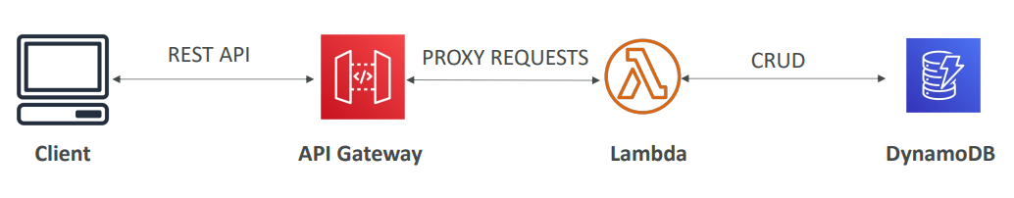

**AWS API Gateway**

* AWS Lambda + API Gateway: No infrastructure to manage
* Support for the WebSocket Protocol • Handle API versioning (v1, v2…)
* Handle different environments (dev, test, prod…)
* Handle security (Authentication and Authorization)
* Create API keys, handle request throttling
* Swagger / Open API import to quickly define APIs
* Transform and validate requests and responses
* Generate SDK and API specifications
* Cache API responses

**API Gateway – Integrations High Level**

* Lambda Function
  + Invoke Lambda function
  + Easy way to expose REST API backed by AWS Lambda
* HTTP
  + Expose HTTP endpoints in the backend
  + Example: internal HTTP API on premise, Application Load Balancer…
  + Why? Add rate limiting, caching, user authentications, API keys, etc…
* AWS Service
  + Expose any AWS API through the API Gateway
  + Example: start an AWS Step Function workflow, post a message to SQS
  + Why? Add authentication, deploy publicly, rate control…

**API Gateway – AWS Service Integration Kinesis Data Streams example**

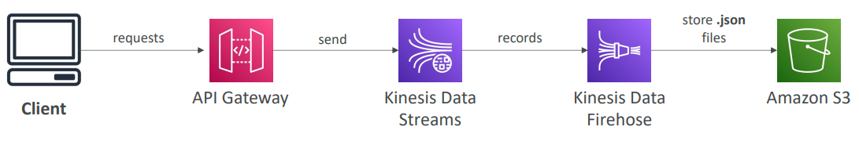

**API Gateway - Endpoint Types**

* Edge-Optimized (default): For global clients
  + Requests are routed through the CloudFront Edge locations (improves latency)
  + The API Gateway still lives in only one region
* Regional:
  + For clients within the same region
  + Could manually combine with CloudFront (more control over the caching strategies and the distribution)
* Private:
  + Can only be accessed from your VPC using an interface VPC endpoint (ENI)
  + Use a resource policy to define access

**API Gateway – Security**

* User Authentication through
  + IAM Roles (useful for internal applications)
  + Cognito (identity for external users – example mobile users)
  + Custom Authorizer (your own logic)
* Custom Domain Name HTTPS security through integration with AWS Certificate Manager (ACM)
  + If using Edge-Optimized endpoint, then the certificate must be in us-east-1
  + If using regional endpoint, the certificate must be in the API Gateway region
  + Must set up CNAME or A-alias record in Route 53

**AWS Step Functions**

|  |  |
| --- | --- |
| * Build serverless visual workflow to orchestrate your Lambda functions * Features: sequence, parallel, conditions, timeouts, error handling, … * Can integrate with EC2, ECS, On -premises servers, API Gateway, SQS queues, etc. … * Possibility of implementing human approval features * Use cases: order fulfillment, data processing, web applications, any workflow |  |

**Amazon Cognito**

* Give users an identity to interact with our web or mobile application
* Cognito User Pools:
  + Sign in functionality for app users
  + Integrate with API Gateway & Application Load Balancer
* Cognito Identity Pools (Federated Identity):
  + Provide AWS credentials to users so they can access AWS resources directly
  + Integrate with Cognito User Pools as an identity provider
* Cognito vs IAM: “hundreds of users”, ”mobile users”, “authenticate with SAML”

**Cognito User Pools (CUP) – User Features**

* Create a serverless database of user for your web & mobile apps
* Simple login: Username (or email) / password combination
* Password reset
* Email & Phone Number Verification
* Multi-factor authentication (MFA)
* Federated Identities: users from Facebook, Google, SAML…

**Cognito User Pools (CUP) - Integrations**

• CUP integrates with API Gateway and Application Load Balancer

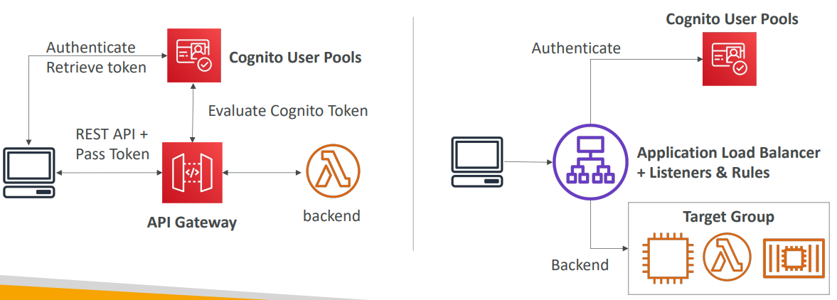

**Cognito Identity Pools (Federated Identities)**

* Get identities for “users” so they obtain temporary AWS credentials
* Users source can be Cognito User Pools, 3rd party logins, etc…
* Users can then access AWS services directly or through API Gateway
* The IAM policies applied to the credentials are defined in Cognito
* They can be customized based on the user_id for fine grained control
* Default IAM roles for authenticated and guest users

**Cognito Identity Pools – Diagram**

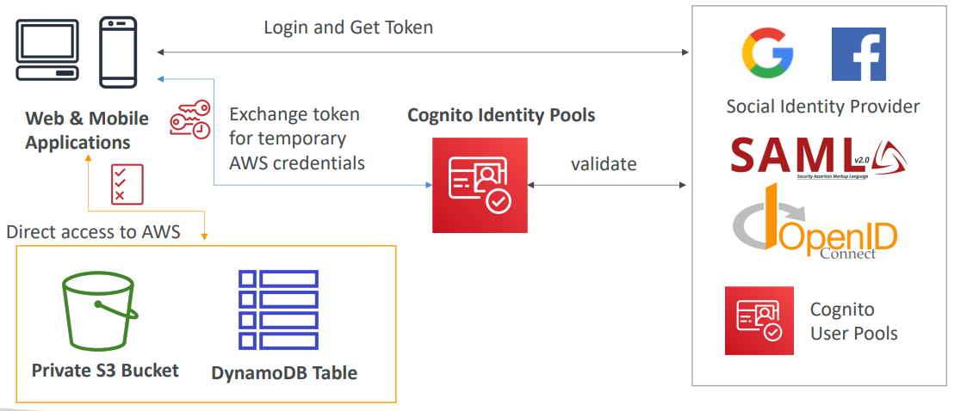

**Cognito Identity Pools Row Level Security in DynamoDB**

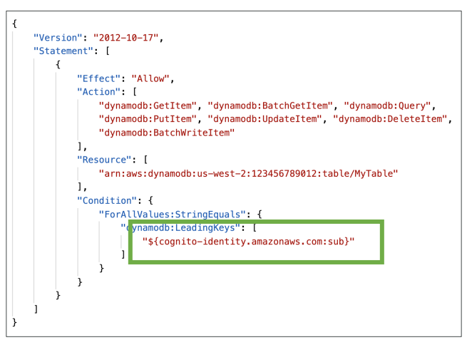

# Serverless Architectures

**Mobile application: MyTodoList**

* We want to create a mobile application with the following requirements
* Expose as REST API with HTTPS
* Serverless architecture
* Users should be able to directly interact with their own folder in S3
* Users should authenticate through a managed serverless service
* The users can write and read to-dos, but they mostly read them
* The database should be scaled, and have some high read throughput

**Mobile app: REST API layer**

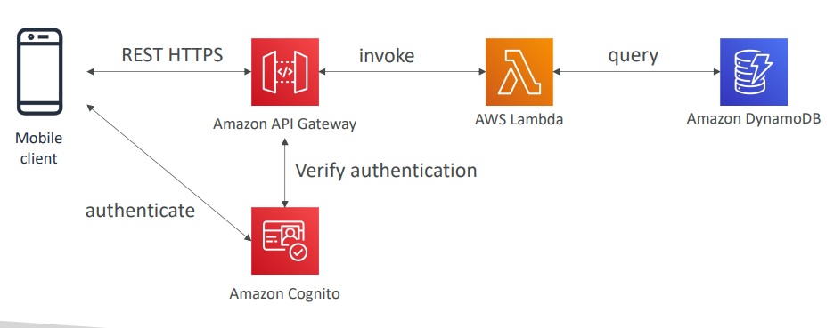

**Mobile app: giving users access to S3**

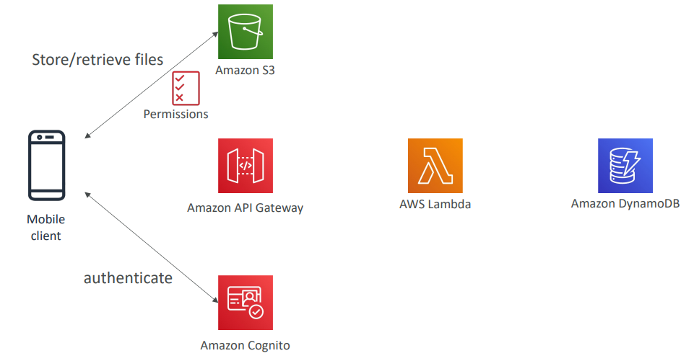

**Mobile app: high read throughput, static data**

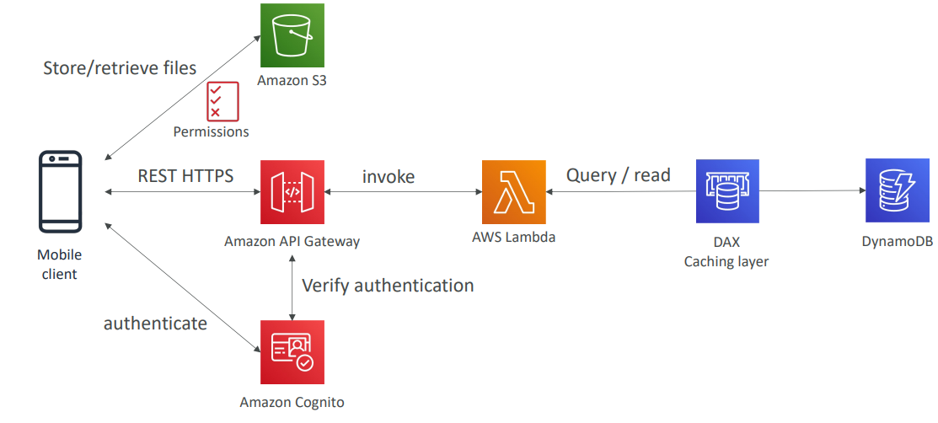

**Mobile app: caching at the API Gateway**

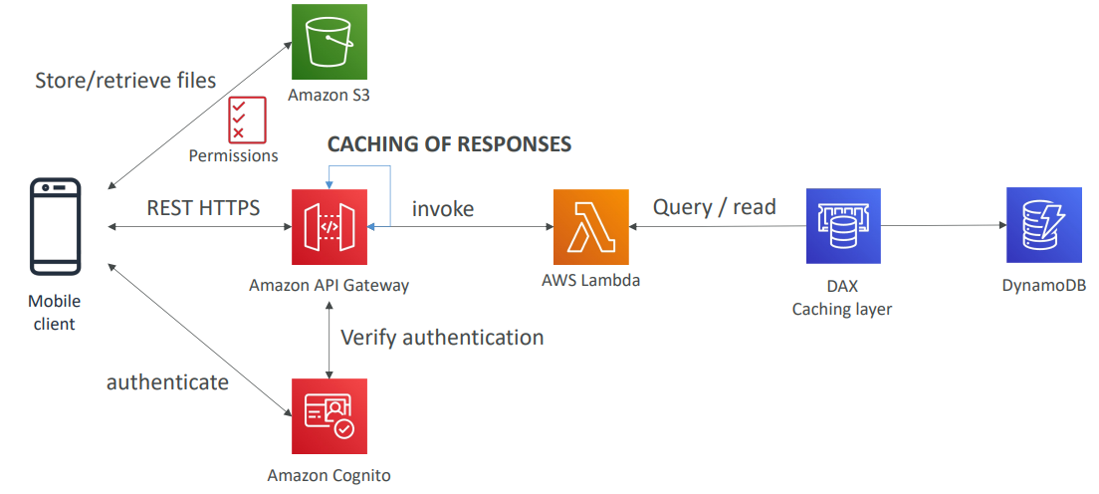

**In this lecture**

* Serverless REST API: HTTPS, API Gateway, Lambda, DynamoDB
* Using Cognito to generate temporary credentials to access S3 bucket with restricted policy. App users can directly access AWS resources this way. Pattern can be applied to DynamoDB, Lambda…
* Caching the reads on DynamoDB using DAX
* Caching the REST requests at the API Gateway level
* Security for authentication and authorization with Cognito

**Serverless hosted website: MyBlog.com**

* This website should scale globally
* Blogs are rarely written, but often read
* Some of the website is purely static files, the rest is a dynamic REST API
* Caching must be implement where possible
* Any new users that subscribes should receive a welcome email
* Any photo uploaded to the blog should have a thumbnail generated

**Serving static content, globally**

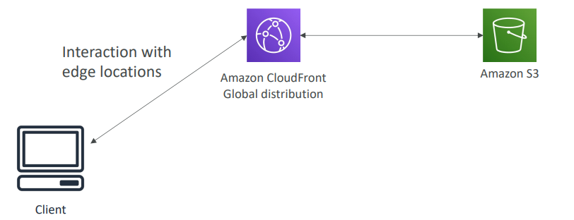

**Serving static content, globally, securely**

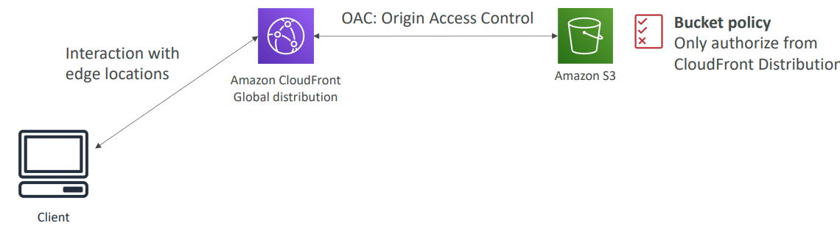

**Adding a public serverless REST API**

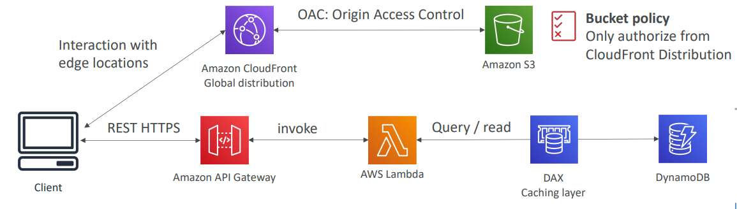

**Leveraging DynamoDB Global Tables**

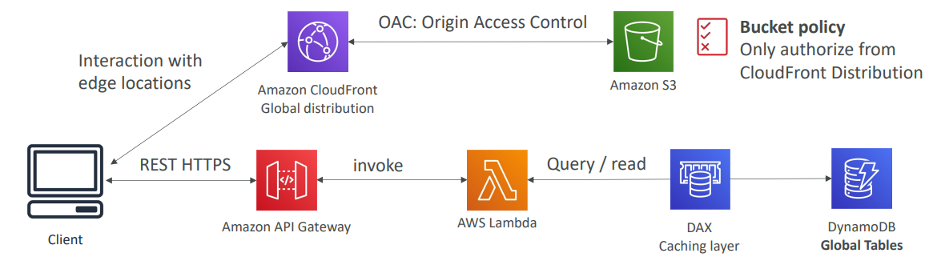

**User Welcome email flow**

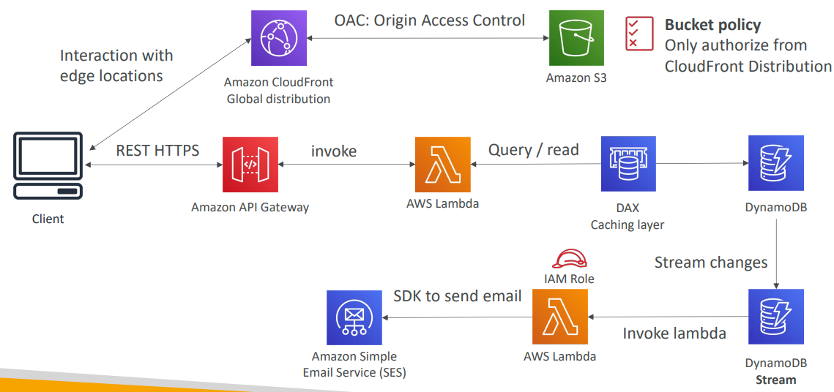

**Thumbnail Generation flow**

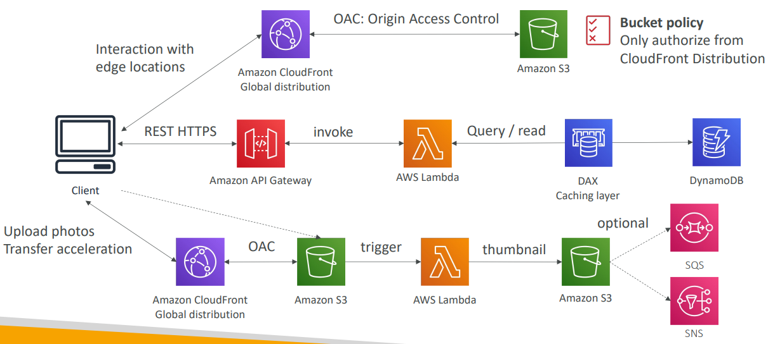

**AWS Hosted Website Summary**

* We’ve seen static content being distributed using CloudFront with S3
* The REST API was serverless, didn’t need Cognito because public
* We leveraged a Global DynamoDB table to serve the data globally
* (we could have used Aurora Global Database)
* We enabled DynamoDB streams to trigger a Lambda function
* The lambda function had an IAM role which could use SES
* SES (Simple Email Service) was used to send emails in a serverless way
* S3 can trigger SQS / SNS / Lambda to notify of events

**Micro Services architecture**

* We want to switch to a micro service architecture
* Many services interact with each other directly using a REST API
* Each architecture for each micro service may vary in form and shape
* We want a micro-service architecture so we can have a leaner development lifecycle for each service

**Micro Services Environment**

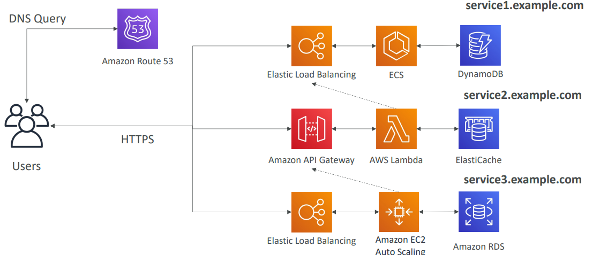

**Discussions on Micro Services**

* You are free to design each micro-service the way you want
* Synchronous patterns: API Gateway, Load Balancers
* Asynchronous patterns: SQS, Kinesis, SNS, Lambda triggers (S3)
* Challenges with micro-services:
  + repeated overhead for creating each new microservice,
  + issues with optimizing server density/utilization
  + complexity of running multiple versions of multiple microservices simultaneously
  + proliferation of client-side code requirements to integrate with many separate services.
* Some of the challenges are solved by Serverless patterns:
  + API Gateway, Lambda scale automatically and you pay per usage
  + You can easily clone API, reproduce environments
  + Generated client SDK through Swagger integration for the API Gateway

**Software updates offloading**

* We have an application running on EC2, that distributes software updates once in a while
* When a new software update is out, we get a lot of request and the content is distributed in mass over the network. It’s very costly
* We don’t want to change our application, but want to optimize our cost and CPU, how can we do it?

**Our application current state**

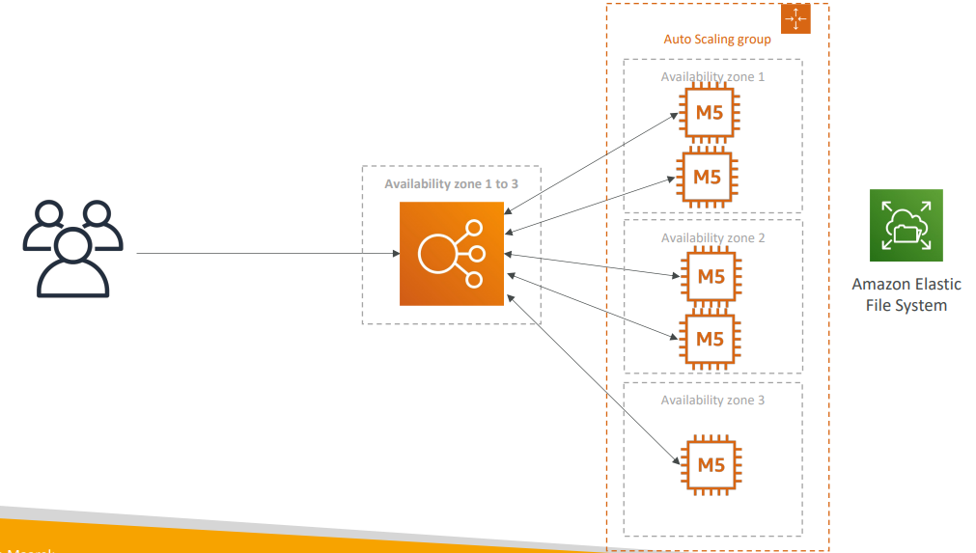

**Easy way to fix things!**

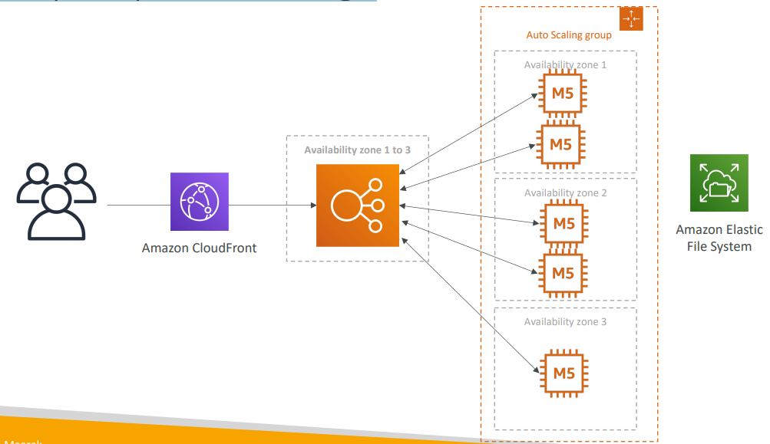

**Why CloudFront?**

* No changes to architecture
* Will cache software update files at the edge
* Software update files are not dynamic, they’re static (never changing)
* Our EC2 instances aren’t serverless
* But CloudFront is, and will scale for us
* Our ASG will not scale as much, and we’ll save tremendously in EC2
* We’ll also save in availability, network bandwidth cost, etc
* Easy way to make an existing application more scalable and cheaper!

# Databases in AWS

* We have a lot of managed databases on AWS to choose from
* Questions to choose the right database based on your architecture:
  + Read-heavy, write-heavy, or balanced workload? Throughput needs? Will it
  + change, does it need to scale or fluctuate during the day?
  + How much data to store and for how long? Will it grow? Average object size? How are they accessed?
  + Data durability? Source of truth for the data ?
  + Latency requirements? Concurrent users?
  + Data model? How will you query the data? Joins? Structured? Semi-Structured?
  + Strong schema? More flexibility? Reporting? Search? RDBMS / NoSQL?
  + License costs? Switch to Cloud Native DB such as Aurora?

**Database Types**

* RDBMS (= SQL / OLTP): RDS, Aurora – great for joins
* NoSQL database – no joins, no SQL : DynamoDB (~JSON), ElastiCache (key / value pairs), Neptune (graphs), DocumentDB (for MongoDB), Keyspaces (for Apache Cassandra)
* Object Store: S3 (for big objects) / Glacier (for backups / archives)
* Data Warehouse (= SQL Analytics / BI): Redshift (OLAP), Athena, EMR
* Search: OpenSearch (JSON) – free text, unstructured searches
* Graphs: Amazon Neptune – displays relationships between data
* Ledger: Amazon Quantum Ledger Database
* Time series: Amazon Timestream
* Note: some databases are being discussed in the Data & Analytics section

**Amazon RDS – Summary**

* Managed PostgreSQL / MySQL / Oracle / SQL Server / DB2 / MariaDB / Custom
* Provisioned RDS Instance Size and EBS Volume Type & Size
* Auto-scaling capability for Storage
* Support for Read Replicas and Multi AZ
* Security through IAM, Security Groups, KMS , SSL in transit
* Automated Backup with Point in time restore feature (up to 35 days)
* Manual DB Snapshot for longer-term recovery
* Managed and Scheduled maintenance (with downtime)
* Support for IAM Authentication, integration with Secrets Manager
* RDS Custom for access to and customize the underlying instance (Oracle & SQL Server)
* Use case: Store relational datasets (RDBMS / OLTP), perform SQL queries, transactions

**Amazon Aurora – Summary**

* Compatible API for PostgreSQL / MySQL, separation of storage and compute
* Storage: data is stored in 6 replicas, across 3 AZ – highly available, self-healing, auto-scaling
* Compute: Cluster of DB Instance across multiple AZ, auto-scaling of Read Replicas
* Cluster: Custom endpoints for writer and reader DB instances
* Same security / monitoring / maintenance features as RDS
* Know the backup & restore options for Aurora
* Aurora Serverless – for unpredictable / intermittent workloads, no capacity planning
* Aurora Global: up to 16 DB Read Instances in each region, < 1 second storage replication
* Aurora Machine Learning: perform ML using SageMaker & Comprehend on Aurora
* Aurora Database Cloning: new cluster from existing one, faster than restoring a snapshot
* Use case: same as RDS, but with less maintenance / more flexibility / more performance / more features

**Amazon ElastiCache – Summary**

* Managed Redis / Memcached (similar offering as RDS, but for caches)
* In-memory data store, sub-millisecond latency
* Select an ElastiCache instance type (e.g., cache.m6g.large)
* Support for Clustering (Redis) and Multi AZ, Read Replicas (sharding)
* Security through IAM, Security Groups, KMS, Redis Auth
* Backup / Snapshot / Point in time restore feature
* Managed and Scheduled maintenance
* Requires some application code changes to be leveraged
* Use Case: Key/Value store, Frequent reads, less writes, cache results for DB queries, store session data for websites, cannot use SQL

**Amazon DynamoDB – Summary**

* AWS proprietary technology, managed serverless NoSQL database, millisecond latency
* Capacity modes: provisioned capacity with optional auto-scaling or on-demand capacity
* Can replace ElastiCache as a key/value store (storing session data for example, using TTL feature)
* Highly Available, Multi AZ by default, Read and Writes are decoupled, transaction capability
* DAX cluster for read cache, microsecond read latency
* Security, authentication and authorization is done through IAM
* Event Processing: DynamoDB Streams to integrate with AWS Lambda, or Kinesis Data Streams
* Global Table feature: active-active setup
* Automated backups up to 35 days with PITR (restore to new table), or on-demand backups
* Export to S3 without using RCU within the PITR window, import from S3 without using WCU
* Great to rapidly evolve schemas
* Use Case: Serverless applications development (small documents 100s KB), distributed serverless cache

**Amazon S3 – Summary**

* S3 is a… key / value store for objects
* Great for bigger objects, not so great for many small objects
* Serverless, scales infinitely, max object size is 5 TB, versioning capability
* Tiers: S3 Standard, S3 Infrequent Access, S3 Intelligent, S3 Glacier + lifecycle policy
* Features: Versioning, Encryption, Replication, MFA-Delete, Access Logs…
* Security: IAM, Bucket Policies, ACL, Access Points, Object Lambda, CORS, Object/Vault Lock
* Encryption: SSE-S3, SSE-KMS, SSE-C, client-side, TLS in transit, default encryption
* Batch operations on objects using S3 Batch, listing files using S3 Inventory
* Performance: Multi-part upload, S3 Transfer Acceleration, S3 Select
* Automation: S3 Event Notifications (SNS, SQS, Lambda, EventBridge)
* Use Cases: static files, key value store for big files, website hosting

**DocumentDB**

* Aurora is an “AWS-implementation” of PostgreSQL / MySQL …
* DocumentDB is the same for MongoDB (which is a NoSQL database)
* MongoDB is used to store, query, and index JSON data
* Similar “deployment concepts” as Aurora
* Fully Managed, highly available with replication across 3 AZ
* DocumentDB storage automatically grows in increments of 10GB
* Automatically scales to workloads with millions of requests per seconds

**Amazon Neptune**

|  |  |
| --- | --- |
| * Fully managed graph database * A popular graph dataset would be a social network   + Users have friends   + Posts have comments   + Comments have likes from users   + Users share and like posts… * Highly available across 3 AZ, with up to 15 read replicas * Build and run applications working with highly connected datasets – optimized for these complex and hard queries * Can store up to billions of relations and query the graph with milliseconds latency * Highly available with replications across multiple AZs * Great for knowledge graphs (Wikipedia), fraud detection, recommendation engines, social networking |  |

**Amazon Neptune – Streams**

|  |  |
| --- | --- |
| * Real-time ordered sequence of every change to your graph data * Changes are available immediately after writing * No duplicates, strict order * Streams data is accessible in an HTTP REST API * Use cases:   + Send notifications when certain changes are made   + Maintain your graph data synchronized in another data store (e.g., S3, OpenSearch, ElastiCache)   + Replicate data across regions in Neptune |  |

**Amazon Keyspaces (for Apache Cassandra)**

* Apache Cassandra is an open-source NoSQL distributed database
* A managed Apache Cassandra-compatible database service
* Serverless, Scalable, highly available, fully managed by AWS
* Automatically scale tables up/down based on the application’s traffic
* Tables are replicated 3 times across multiple AZ
* Using the Cassandra Query Language (CQL)
* Single-digit millisecond latency at any scale, 1000s of requests per second
* Capacity: On-demand mode or provisioned mode with auto-scaling
* Encryption, backup, Point-In-Time Recovery (PITR) up to 35 days
* Use cases: store IoT devices info, time-series data, …

**Amazon QLDB**

* QLDB stands for ”Quantum Ledger Database”
* A ledger is a book recording financial transactions
* Fully Managed, Serverless, High available, Replication across 3 AZ
* Used to review history of all the changes made to your application data over time
* Immutable system: no entry can be removed or modified, cryptographically verifiable

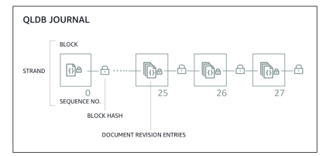

* 2-3x better performance than common ledger blockchain frameworks, manipulate data using SQL
* Difference with Amazon Managed Blockchain: no decentralization component, in accordance with financial regulation rules

**Amazon Timestream**

|  |  |
| --- | --- |
| * Fully managed, fast, scalable, serverless time series database * Automatically scales up/down to adjust capacity * Store and analyze trillions of events per day * 1000s times faster & 1/10th the cost of relational databases * Scheduled queries, multi-measure records, SQL compatibility * Data storage tiering: recent data kept in memory and historical data kept in a cost -optimized storage * Built -in time series analytics functions (helps you identify patterns in your data in near real-time) * Encryption in transit and at rest * Use cases: IoT apps, operational applications, real -time analytics, … |  |

**Amazon Timestream – Architecture**

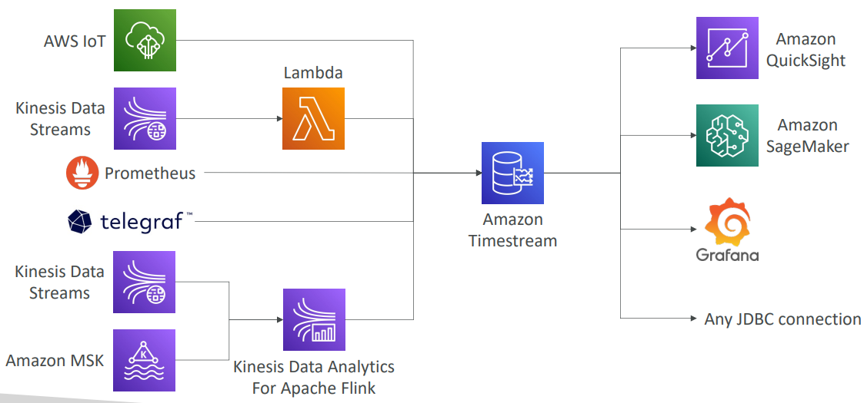

# Data & Analytics

**Amazon Athena**

|  |  |
| --- | --- |
| * Serverless query service to analyze data stored in Amazon S3 * Uses standard SQL language to query the files (built on Presto) * Supports CSV, JSON, ORC, Avro, and Parquet * Pricing: $5.00 per TB of data scanned * Commonly used with Amazon Quicksight for reporting/dashboards * Use cases: Business intelligence / analytics / reporting, analyze & query VPC Flow Logs, ELB Logs, CloudTrail trails, etc... * Exam Tip: analyze data in S3 using serverless SQL, use Athena |  |

**Amazon Athena – Performance Improvement**

* Use columnar data for cost-savings (less scan)
  + Apache Parquet or ORC is recommended
  + Huge performance improvement
  + Use Glue to convert your data to Parquet or ORC
* Compress data for smaller retrievals (bzip2, gzip, lz4, snappy, zlip, zstd…)
* Partition datasets in S3 for easy querying on virtual columns
  + s3://yourBucket/pathToTable

/<PARTITION_COLUMN_NAME>=<VALUE>

/<PARTITION_COLUMN_NAME>=<VALUE>

<PARTITION_COLUMN_NAME>=<VALUE>

/etc…

* + Example: s3://athena-examples/flight/parquet/year=1991/month=1/day=1/
* Use larger files (> 128 MB) to minimize overhead

**Amazon Athena – Federated Query**

|  |  |
| --- | --- |
| * Allows you to run SQL queries across data stored in relational, non-relational, object, and custom data sources (AWS or on-premises) * Uses Data Source Connectors that run on AWS Lambda to run Federated Queries (e.g., CloudWatch Logs, DynamoDB, RDS, …) * Store the results back in Amazon S3 |  |

**Redshift Overview**

* Redshift is based on PostgreSQL, but it’s not used for OLTP
* It’s OLAP – online analytical processing (analytics and data warehousing)
* 10x better performance than other data warehouses, scale to PBs of data
* Columnar storage of data (instead of row based) & parallel query engine
* Two modes: Provisioned cluster or Serverless cluster
* Has a SQL interface for performing the queries
* BI tools such as Amazon Quicksight or Tableau integrate with it
* vs Athena: faster queries / joins / aggregations thanks to indexes

**Redshift Cluster**

|  |  |
| --- | --- |
| * Leader node: for query planning, results aggregation * Compute node: for performing the queries, send results to leader * Provisioned mode: * Choose instance types in advance * Can reserve instances for cost savings |  |

**Redshift – Snapshots & DR**

|  |  |
| --- | --- |
| * Redshift has “Multi-AZ” mode for some clusters * Snapshots are point-in-time backups of a cluster, stored internally in S3 * Snapshots are incremental (only what has changed is saved) * You can restore a snapshot into a new cluster * Automated: every 8 hours, every 5 GB, or on a schedule. Set retention between 1 to 35 days * Manual: snapshot is retained until you delete it * You can configure Amazon Redshift to automatically copy snapshots (automated or manual) of a cluster to another AWS Region |  |

**Loading data into Redshift: Large inserts are MUCH better**

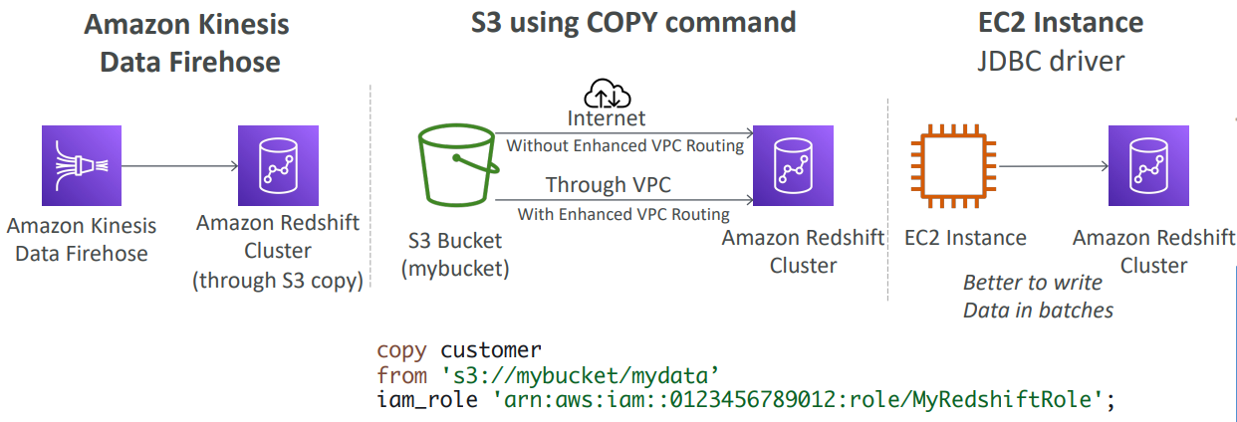

**Redshift Spectrum**

|  |  |
| --- | --- |
| * Query data that is already in S3 without loading it * Must have a Redshift cluster available to start the query * The query is then submitted to thousands of Redshift Spectrum nodes |  |

**Amazon OpenSearch Service**

* Amazon OpenSearch is successor to Amazon ElasticSearch
* In DynamoDB, queries only exist by primary key or indexes…
* With OpenSearch, you can search any field, even partially matches
* It’s common to use OpenSearch as a complement to another database
* Two modes: managed cluster or serverless cluster
* Does not natively support SQL (can be enabled via a plugin)
* Ingestion from Kinesis Data Firehose, AWS IoT, and CloudWatch Logs
* Security through Cognito & IAM, KMS encryption, TLS
* Comes with OpenSearch Dashboards (visualization)

**OpenSearch patterns DynamoDB**

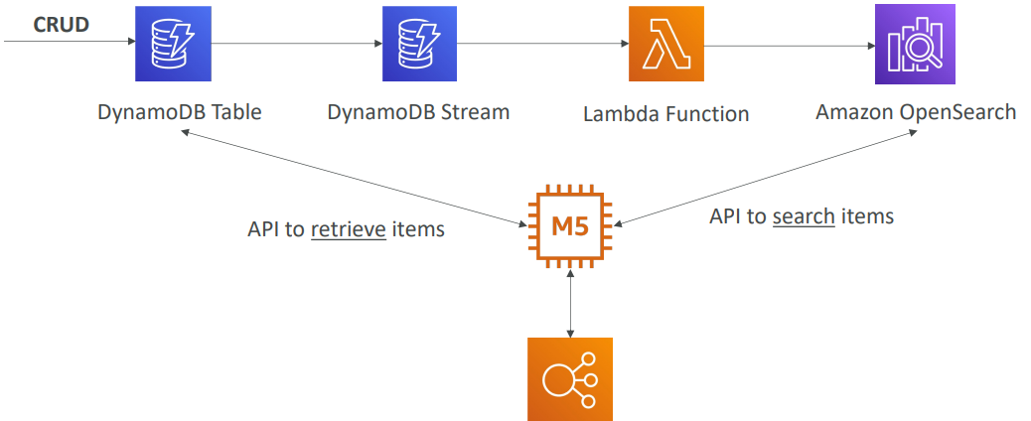

**OpenSearch patterns CloudWatch Logs**

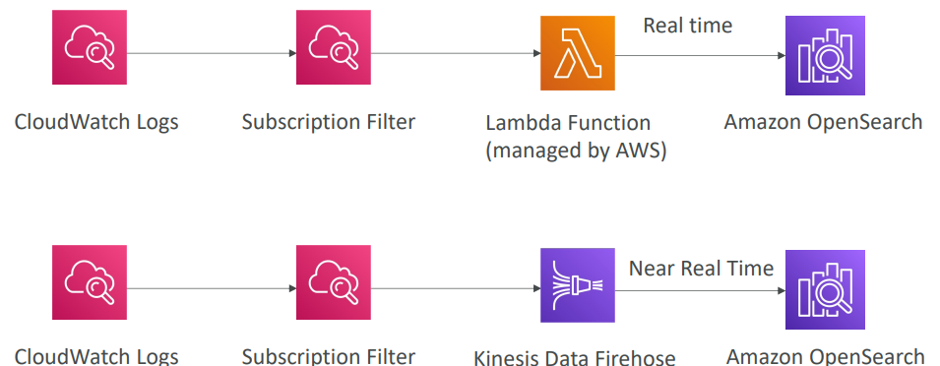

**OpenSearch patterns Kinesis Data Streams & Kinesis Data Firehose**

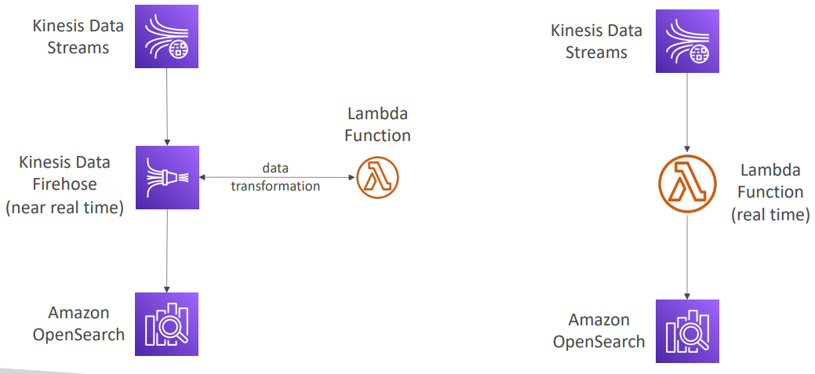

**Amazon EMR**

* EMR stands for “Elastic MapReduce”
* EMR helps creating Hadoop clusters (Big Data) to analyze and process vast amount of data
* The clusters can be made of hundreds of EC2 instances
* EMR comes bundled with Apache Spark, HBase, Presto, Flink…
* EMR takes care of all the provisioning and configuration
* Auto-scaling and integrated with Spot instances
* Use cases: data processing, machine learning, web indexing, big data…

**Amazon EMR – Node types & purchasing**

* Master Node: Manage the cluster, coordinate, manage health – long running
* Core Node: Run tasks and store data – long running
* Task Node (optional): Just to run tasks – usually Spot
* Purchasing options:
  + On-demand: reliable, predictable, won’t be terminated
  + Reserved (min 1 year): cost savings (EMR will automatically use if available)
  + Spot Instances: cheaper, can be terminated, less reliable
* Can have long-running cluster, or transient (temporary) cluster

**Amazon QuickSight**

**https://aws.amazon.com/quicksight/**

|  |  |
| --- | --- |
| * Serverless machine learning-powered business intelligence service to create interactive dashboards * Fast, automatically scalable, embeddable, with per-session pricing * Use cases:   + Business analytics   + Building visualizations   + Perform ad-hoc analysis   + Get business insights using data * Integrated with RDS, Aurora, Athena, Redshift, S3… * In-memory computation using SPICE engine if data is imported into QuickSight * Enterprise edition: Possibility to setup Column-Level security (CLS) |  |
|  |  |

**QuickSight Integrations**

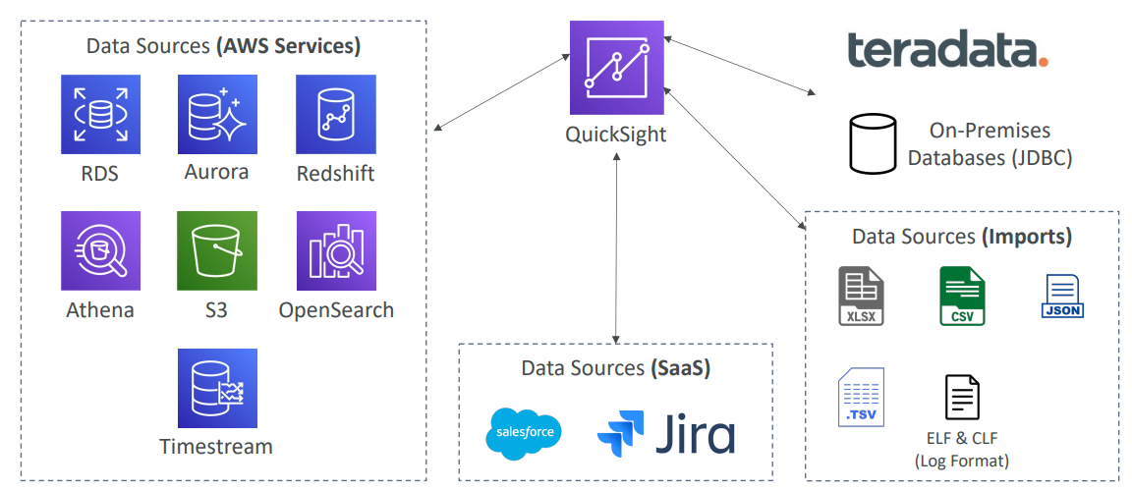

**QuickSight – Dashboard & Analysis**

* Define Users (standard versions) and Groups (enterprise version)
* These users & groups only exist within QuickSight, not IAM !!
* A dashboard…
  + is a read-only snapshot of an analysis that you can share
  + preserves the configuration of the analysis (filtering, parameters, controls, sort)
* You can share the analysis or the dashboard with Users or Groups
* To share a dashboard, you must first publish it
* Users who see the dashboard can also see the underlying data

**AWS Glue**

• Managed extract, transform, and load (ETL) service

• Useful to prepare and transform data for analytics

• Fully serverless service

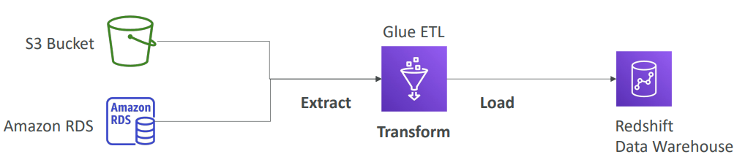

**AWS Glue – Convert data into Parquet format**

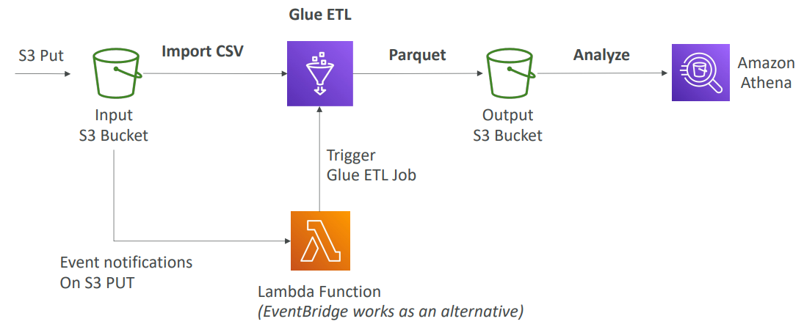

**Glue Data Catalog: catalog of datasets**

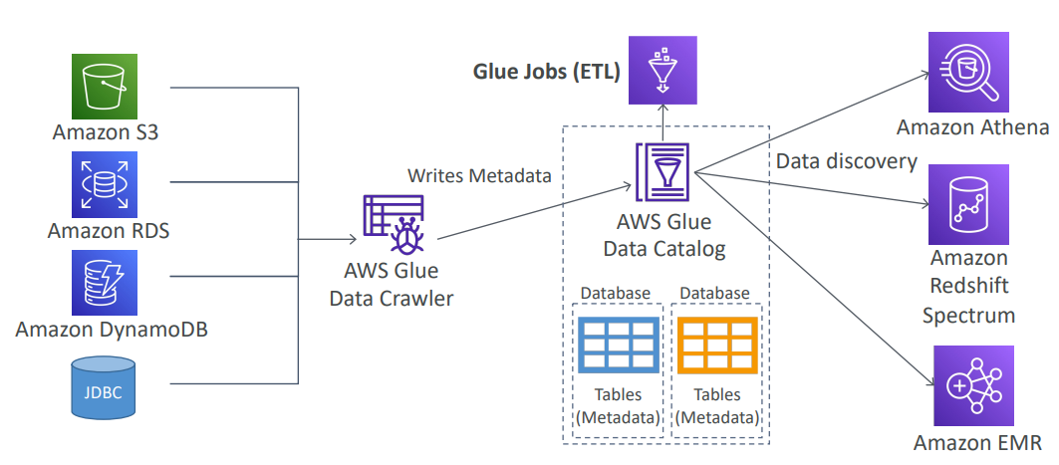

**Glue – things to know at a high-level**

* Glue Job Bookmarks: prevent re-processing old data
* Glue Elastic Views:
  + Combine and replicate data across multiple data stores using SQL
  + No custom code, Glue monitors for changes in the source data, serverless
  + Leverages a “virtual table” (materialized view)
* Glue DataBrew: clean and normalize data using pre-built transformation
* Glue Studio: new GUI to create, run and monitor ETL jobs in Glue
* Glue Streaming ETL (built on Apache Spark Structured Streaming): compatible with Kinesis Data Streaming, Kafka, MSK (managed Kafka)

**AWS Lake Formation**

* Data lake = central place to have all your data for analytics purposes
* Fully managed service that makes it easy to setup a data lake in days
* Discover, cleanse, transform, and ingest data into your Data Lake
* It automates many complex manual steps (collecting, cleansing, moving,cataloging data, …) and de-duplicate (using ML Transforms)
* Combine structured and unstructured data in the data lake
* Out-of-the-box source blueprints: S3, RDS, Relational & NoSQL DB…
* Fine-grained Access Control for your applications (row and column-level)
* Built on top of AWS Glue

**AWS Lake Formation**

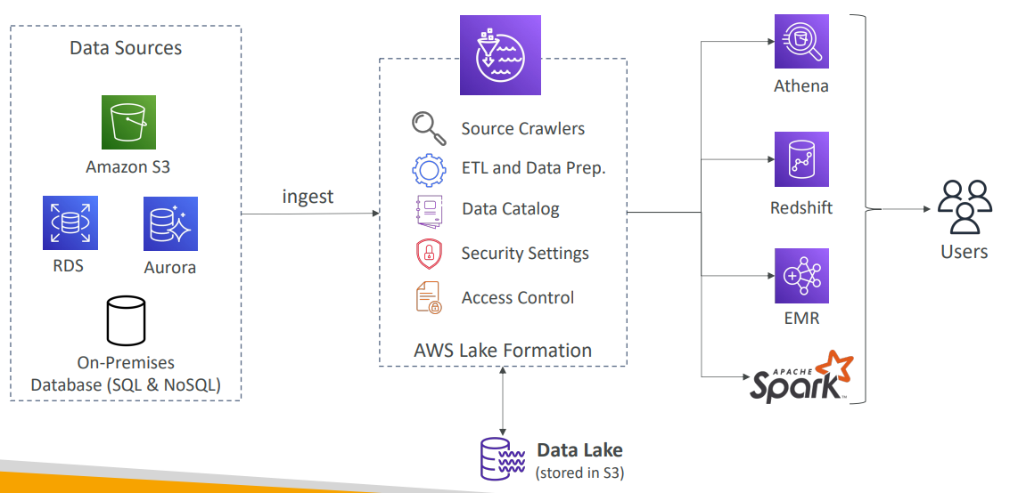

**AWS Lake Formation Centralized Permissions Example**

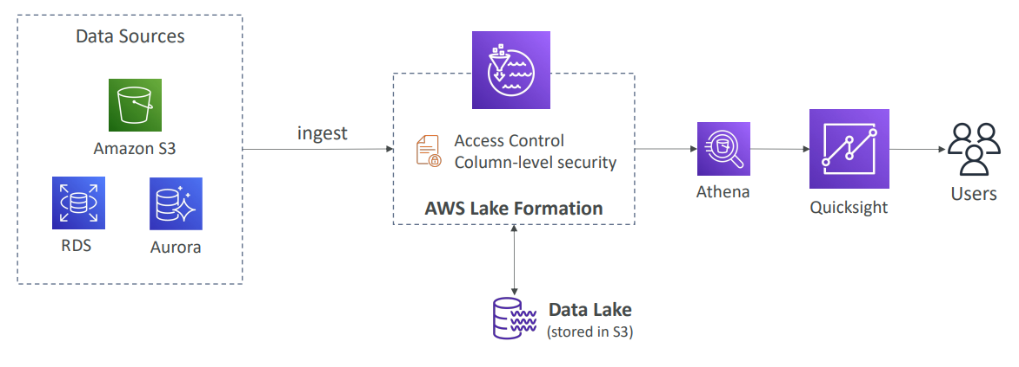

**Kinesis Data Analytics for SQL applications**

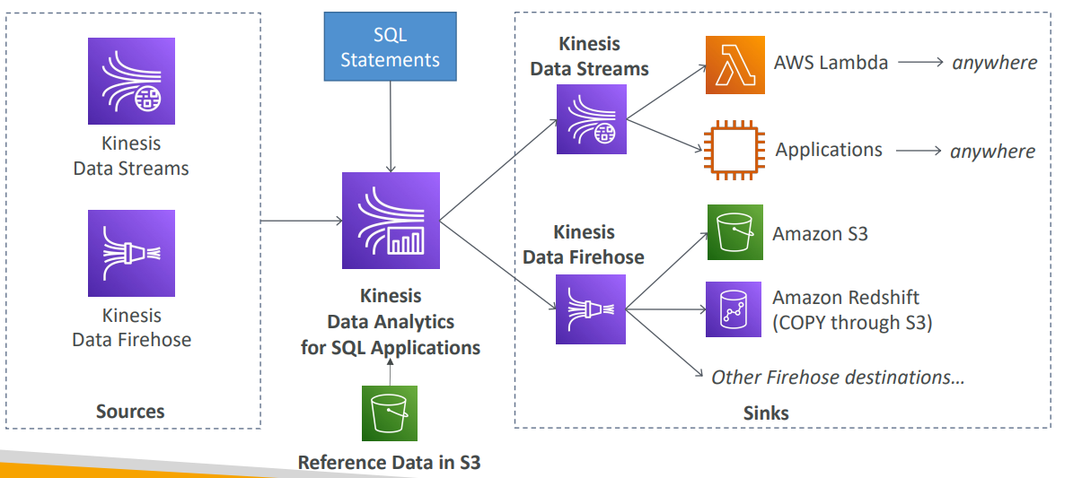

**Kinesis Data Analytics (SQL application)**

* Real-time analytics on Kinesis Data Streams & Firehose using SQL
* Add reference data from Amazon S3 to enrich streaming data
* Fully managed, no servers to provision
* Automatic scaling
* Pay for actual consumption rate
* Output:
  + Kinesis Data Streams: create streams out of the real-time analytics queries
  + Kinesis Data Firehose: send analytics query results to destinations
* Use cases:
  + Time-series analytics
  + Real-time dashboards
  + Real-time metrics

Kinesis Data Analytics for Apache Flink

* Use Flink (Java, Scala or SQL) to process and analyze streaming data

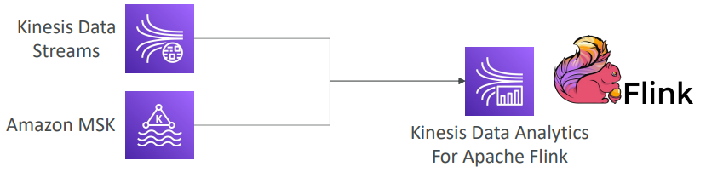

* Run any Apache Flink application on a managed cluster on AWS
  + provisioning compute resources, parallel computation, automatic scaling
  + application backups (implemented as checkpoints and snapshots)
  + Use any Apache Flink programming features
  + Flink does not read from Firehose (use Kinesis Analytics for SQL instead)

**Amazon Managed Streaming for Apache Kafka (Amazon MSK)**

* Alternative to Amazon Kinesis
* Fully managed Apache Kafka on AWS
  + Allow you to create, update, delete clusters
  + MSK creates & manages Kafka brokers nodes & Zookeeper nodes for you
  + Deploy the MSK cluster in your VPC, multi-AZ (up to 3 for HA)
  + Automatic recovery from common Apache Kafka failures
  + Data is stored on EBS volumes for as long as you want
* MSK Serverless
  + Run Apache Kafka on MSK without managing the capacity
  + MSK automatically provisions resources and scales compute & storage

**Apache Kafka at a high level**

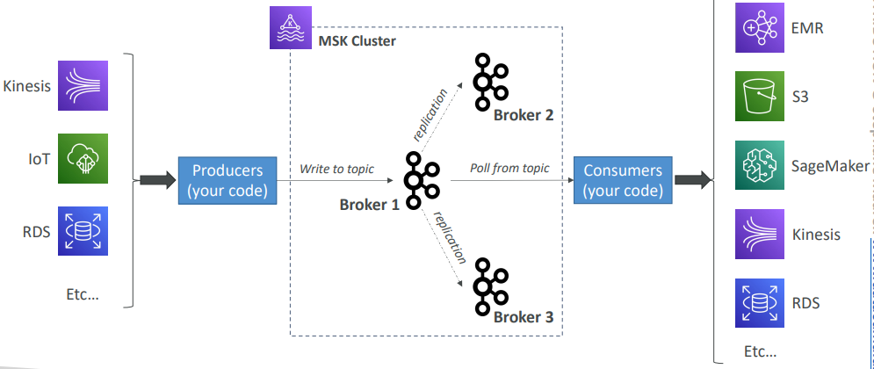

**Kinesis Data Streams vs. Amazon MSK**

|  |  |
| --- | --- |
| * 1 MB message size limit * Data Streams with Shards * Shard Splitting & Merging * TLS In-flight encryption * • KMS at-rest encryption | * 1MB default, configure for higher (ex: 10MB) * Kafka Topics with Partitions * Can only add partitions to a topic * PLAINTEXT or TLS In-flight Encryption * KMS at-rest encryption |

**Amazon MSK Consumers**

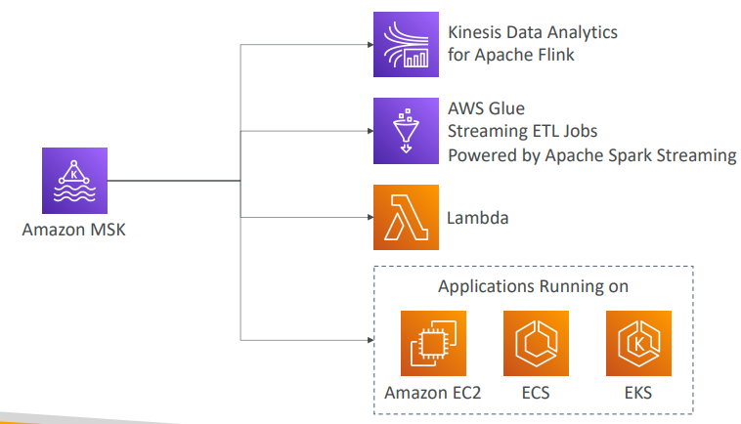

**Big Data Ingestion Pipeline**

* We want the ingestion pipeline to be fully serverless
* We want to collect data in real time
* We want to transform the data
* We want to query the transformed data using SQL
* The reports created using the queries should be in S3
* We want to load that data into a warehouse and create dashboards

**Big Data Ingestion Pipeline**

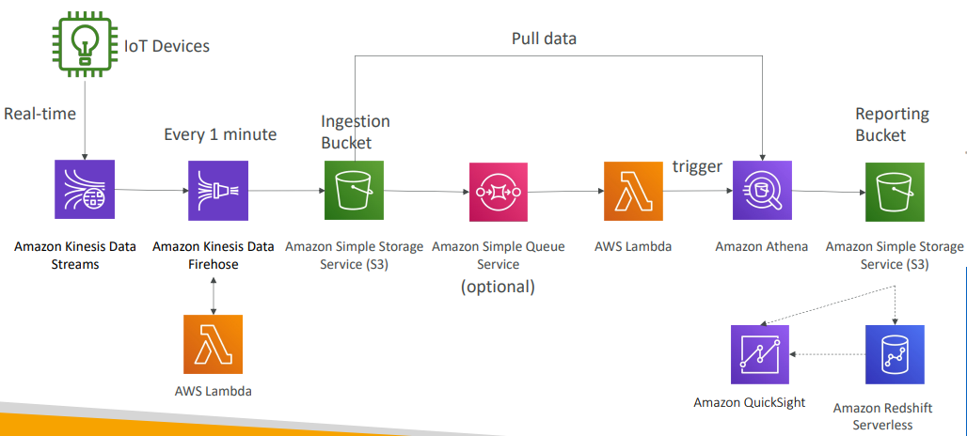

**Big Data Ingestion Pipeline discussion**

* IoT Core allows you to harvest data from IoT devices
* Kinesis is great for real-time data collection
* Firehose helps with data delivery to S3 in near real-time (1 minute)
* Lambda can help Firehose with data transformations
* Amazon S3 can trigger notifications to SQS
* Lambda can subscribe to SQS (we could have connecter S3 to Lambda)
* Athena is a serverless SQL service and results are stored in S3
* The reporting bucket contains analyzed data and can be used by reporting tool such as AWS QuickSight, Redshift, etc…

# Machine Learning

Amazon Rekognition

* Find objects, people, text, scenes in images and videos using ML
* Facial analysis and facial search to do user verification, people counting
* Create a database of “familiar faces” or compare against celebrities
* Use cases:
  + Labeling
  + Content Moderation
  + Text Detection
  + Face Detection and Analysis (gender, age range, emotions…)
  + Face Search and Verification
  + Celebrity Recognition
  + Pathing (ex: for sports game analysis)

**Amazon Rekognition – Content Moderation**

|  |  |
| --- | --- |
| * Detect content that is inappropriate, unwanted, or offensive (image and videos) * Used in social media, broadcast media, advertising, and e-commerce situations to create a safer user experience * Set a Minimum Confidence Threshold for items that will be flagged * Flag sensitive content for manual review in Amazon Augmented AI (A2I) * Help comply with regulations |  |

**Amazon Transcribe**

* Automatically convert speech to text
* Uses a deep learning process called automatic speech recognition (ASR) to convert speech to text quickly and accurately
* Automatically remove Personally Identifiable Information (PII) using Redaction
* Supports Automatic Language Identification for multi-lingual audio
* Use cases:
  + transcribe customer service calls
  + automate closed captioning and subtitling
  + generate metadata for media assets to create a fully searchable archive



**Amazon Polly**

* Turn text into lifelike speech using deep learning
* Allowing you to create applications that talk



**Amazon Polly – Lexicon & SSML**

* Customize the pronunciation of words with Pronunciation lexicons
  + Stylized words: St3ph4ne => “Stephane”
  + Acronyms: AWS => “Amazon Web Services”
* Upload the lexicons and use them in the SynthesizeSpeech operation
* Generate speech from plain text or from documents marked up with Speech Synthesis Markup Language (SSML) – enables more customization
  + emphasizing specific words or phrases
  + using phonetic pronunciation
  + including breathing sounds, whispering
  + using the Newscaster speaking style

**Amazon Translate**

* Natural and accurate language translation
* Amazon Translate allows you to localize content - such as websites and applications - for international users, and to easily translate large volumes of text efficiently

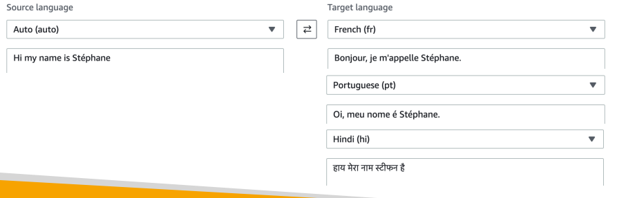

**Amazon Lex & Connect**

* Amazon Lex: (same technology that powers Alexa)
  + Automatic Speech Recognition (ASR) to convert speech to text
  + Natural Language Understanding to recognize the intent of text, callers
  + Helps build chatbots, call center bots
* Amazon Connect:
  + Receive calls, create contact flows, cloud-based virtual contact center
  + Can integrate with other CRM systems or AWS
  + No upfront payments, 80% cheaper than traditional contact center solutions

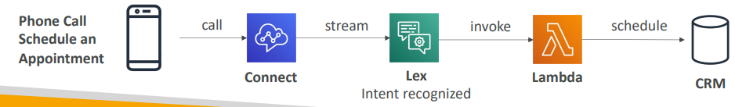

Amazon Comprehend

* For Natural Language Processing – NLP
* Fully managed and serverless service
* Uses machine learning to find insights and relationships in text
  + Language of the text
  + Extracts key phrases, places, people, brands, or events
  + Understands how positive or negative the text is
  + Analyzes text using tokenization and parts of speech
  + Automatically organizes a collection of text files by topic
* Sample use cases:
  + analyze customer interactions (emails) to find what leads to a positive or negative experience
  + Create and groups articles by topics that Comprehend will uncover

**Amazon Comprehend Medical**

* Amazon Comprehend Medical detects and returns useful information in unstructured clinical text:
  + Physician’s notes
  + Discharge summaries
  + Test results
  + Case notes
* Uses NLP to detect Protected Health Information (PHI) – DetectPHI API
* Store your documents in Amazon S3, analyze real-time data with Kinesis Data Firehose, or use Amazon Transcribe to transcribe patient narratives into text that can be analyzed by Amazon Comprehend Medical.

**Amazon SageMaker**

* Fully managed service for developers / data scientists to build ML models
* Typically, difficult to do all the processes in one place + provision servers
* Machine learning process (simplified): predicting your exam score

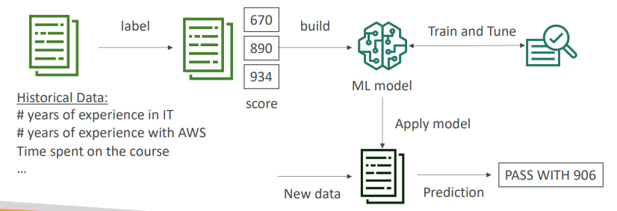

**Amazon Forecast**

* Fully managed service that uses ML to deliver highly accurate forecasts
* Example: predict the future sales of a raincoat
* 50% more accurate than looking at the data itself
* Reduce forecasting time from months to hours
* Use cases: Product Demand Planning, Financial Planning, Resource Planning, …

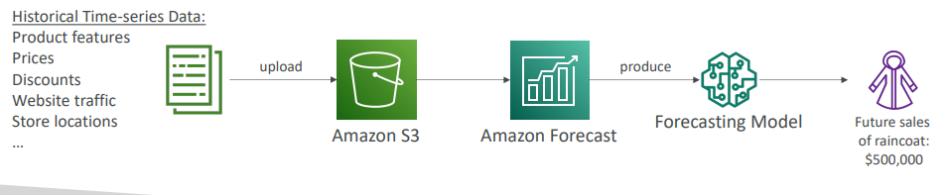

**Amazon Kendra**

* Fully managed document search service powered by Machine Learning
* Extract answers from within a document (text, pdf, HTML, PowerPoint, MS Word, FAQs…)
* Natural language search capabilities
* Learn from user interactions/feedback to promote preferred results (Incremental Learning)
* Ability to manually fine-tune search results (importance of data, freshness, custom, …)

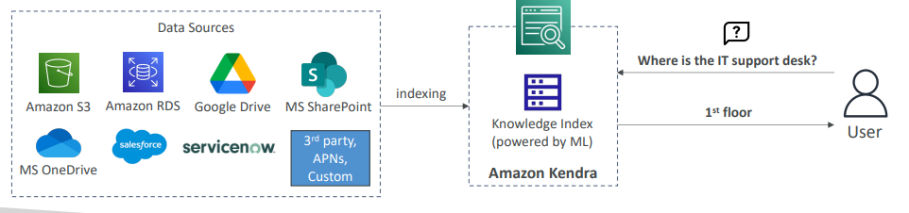

**Amazon Personalize**

* Fully managed ML-service to build apps with real-time personalized recommendations
* Example: personalized product recommendations/re-ranking, customized direct marketing
* Example: User bought gardening tools, provide recommendations on the next one to buy
* Same technology used by Amazon.com
* Integrates into existing websites, applications, SMS, email marketing systems, …
* Implement in days, not months (you don’t need to build, train, and deploy ML solutions)
* Use cases: retail stores, media and entertainment…

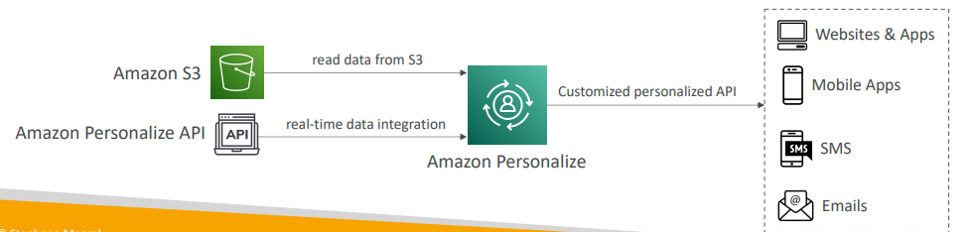

**Amazon Textract**

• Automatically extracts text, handwriting, and data from any scanned documents using AI and ML

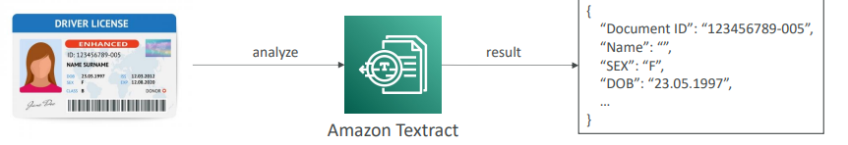

• Extract data from forms and tables

• Read and process any type of document (PDFs, images, …)

• Use cases:

• Financial Services (e.g., invoices, financial reports)

• Healthcare (e.g., medical records, insurance claims)

• Public Sector (e.g., tax forms, ID documents, passports)

AWS Machine Learning- Summary

* Rekognition : face detection, labeling, celebrity recognition
* Transcribe: audio to text (ex: subtitles) • Polly: text to audio
* Polly: text to audio
* Translate: translations
* Lex: build conversational bots – chatbots
* Connect: cloud contact center
* Comprehend: natural language processing
* SageMaker: machine learning for every developer and data scientist
* Forecast: build highly accurate forecasts
* Kendra: ML-powered search engine
* Personalize: real-time personalized recommendations
* Textract: detect text and data in documents

# AWS Monitoring, Audit and Performance

* Amazon CloudWatch Metrics
* CloudWatch provides metrics for every services in AWS
* Metric is a variable to monitor (CPUUtilization, NetworkIn…)
* Metrics belong to namespaces
* Dimension is an attribute of a metric (instance id, environment, etc…).
* Up to 30 dimensions per metric
* Metrics have timestamps
* Can create CloudWatch dashboards of metrics
* Can create CloudWatch Custom Metrics (for the RAM for example)

**CloudWatch Metric Streams**

|  |  |
| --- | --- |
| * Continually stream CloudWatch metrics to a destination of your choice, with near-real-time delivery and low latency. * Amazon Kinesis Data Firehose (and then its destinations) * 3rd party service provider: Datadog, Dynatrace, New Relic, Splunk, Sumo Logic… * Option to filter metrics to only stream a subset of them |  |

**CloudWatch Logs**

* Log groups: arbitrary name, usually representing an application
* Log stream: instances within application / log files / containers
* Can define log expiration policies (never expire, 1 day to 10 years…)
* CloudWatch Logs can send logs to:
  + Amazon S3 (exports)
  + Kinesis Data Streams
  + Kinesis Data Firehose
  + AWS Lambda
  + OpenSearch
* Logs are encrypted by default
* Can setup KMS-based encryption with your own keys

**CloudWatch Logs – Sources**

* SDK, CloudWatch Logs Agent, CloudWatch Unified Agent
* Elastic Beanstalk: collection of logs from application
* ECS: collection from containers
* AWS Lambda: collection from function logs
* VPC Flow Logs: VPC specific logs
* API Gateway
* CloudTrail based on filter
* Route53: Log DNS queries

**CloudWatch Logs Insights**

<https://mng.workshop.aws/operations-2022/detect/cwlogs.html>

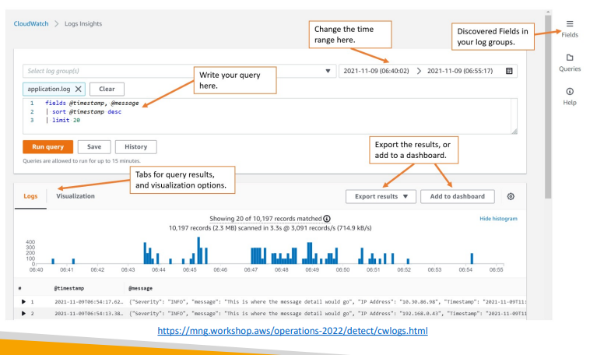

**CloudWatch Logs Insights**

|  |  |
| --- | --- |
| * Search and analyze log data stored in CloudWatch Logs • Example: find a specific IP inside a log, count occurrences of “ERROR” in your logs… * Provides a purpose -built query language * Automatically discovers fields from AWS services and JSON log events * Fetch desired event fields, filter based on conditions, calculate aggregate statistics, sort events, limit number of events… * Can save queries and add them to CloudWatch Dashboards * Can query multiple Log Groups in different AWS accounts • It’s a query engine, not a real-time engine |  |

**CloudWatch Logs – S3 Export**

|  |  |
| --- | --- |
| • Log data can take up to 12 hours to become available for export  • The API call is CreateExportTask  • Not near-real time or real-time… use Logs Subscriptions instead |  |

**CloudWatch Logs Subscriptions**

* Get a real-time log events from CloudWatch Logs for processing and analysis
* Send to Kinesis Data Streams, Kinesis Data Firehose, or Lambda
* Subscription Filter – filter which logs are events delivered to your destination

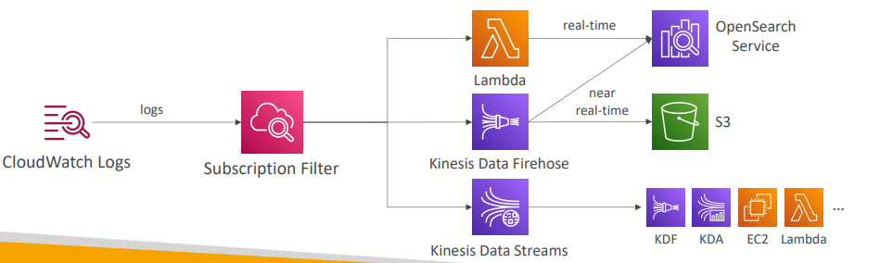

**CloudWatch Logs Aggregation Multi-Account & Multi Region**

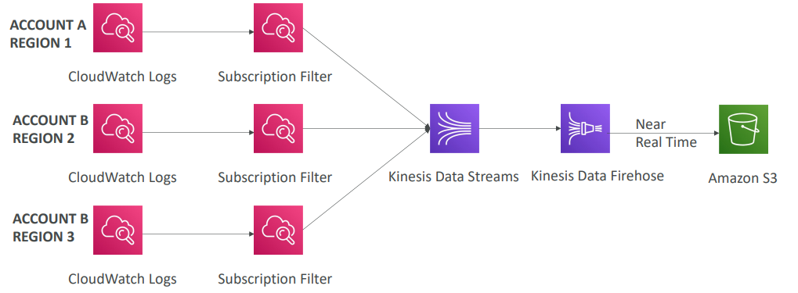

**CloudWatch Logs Subscriptions**

**•** Cross-Account Subscription – send log events to resources in a different AWS account (KDS, KDF)

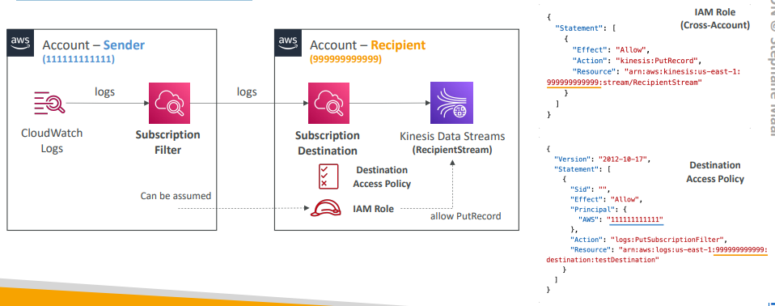

**CloudWatch Logs for EC2**

|  |  |
| --- | --- |
| * By default, no logs from your EC2 machine will go to CloudWatch * You need to run a CloudWatch agent on EC2 to push the log files you want * Make sure IAM permissions are correct * The CloudWatch log agent can be setup on-premises too |  |

**CloudWatch Logs Agent & Unified Agent**

* For virtual servers (EC2 instances, on-premises servers…)
* CloudWatch Logs Agent
  + Old version of the agent
  + Can only send to CloudWatch Logs
* CloudWatch Unified Agent
  + Collect additional system-level metrics such as RAM, processes, etc…
  + Collect logs to send to CloudWatch Logs
  + Centralized configuration using SSM Parameter Store

**CloudWatch Unified Agent – Metrics**

* Collected directly on your Linux server / EC2 instance
* CPU (active, guest, idle, system, user, steal)
* Disk metrics (free, used, total), Disk IO (writes, reads, bytes, iops)
* RAM (free, inactive, used, total, cached)
* Netstat (number of TCP and UDP connections, net packets, bytes)
* Processes (total, dead, bloqued, idle, running, sleep)
* Swap Space (free, used, used %)
* Reminder: out-of-the box metrics for EC2 – disk, CPU, network (high level)

CloudWatch Alarms

* Alarms are used to trigger notifications for any metric
* Various options (sampling, %, max, min, etc…)
* Alarm States:
  + OK
  + INSUFFICIENT_DATA
  + ALARM
* Period:
  + Length of time in seconds to evaluate the metric
  + High resolution custom metrics: 10 sec, 30 sec or multiples of 60 sec

**CloudWatch Alarm Targets**

* Stop, Terminate, Reboot, or Recover an EC2 Instance
* Trigger Auto Scaling Action
* Send notification to SNS (from which you can do pretty much anything)

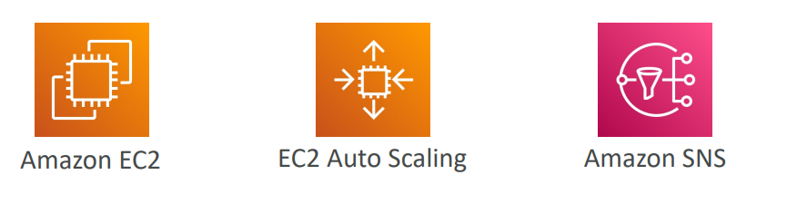

**CloudWatch Alarms – Composite Alarms**

* CloudWatch Alarms are on a single metric
* Composite Alarms are monitoring the states of multiple other alarms
* AND and OR conditions
* Helpful to reduce “alarm noise” by creating complex composite alarms

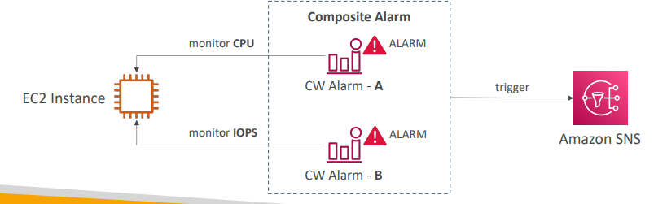

**EC2 Instance Recovery**

* Status Check:
  + Instance status = check the EC2 VM
  + System status = check the underlying hardware
  + Attached EBS status = check attached EBS volumes

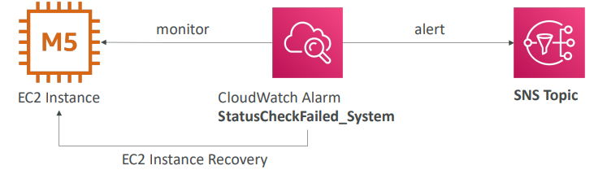

* Recovery: Same Private, Public, Elastic IP, metadata, placement group

**CloudWatch Alarm: good to know**

* Alarms can be created based on CloudWatch Logs Metrics Filters

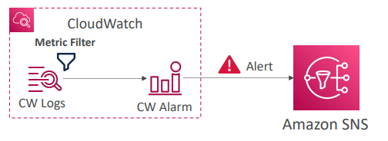

* To test alarms and notifications, set the alarm state to Alarm using CLI aws cloudwatch set-alarm-state --alarm-name "myalarm" --state-value
* ALARM --state-reason "testing purposes"

**Amazon EventBridge (formerly CloudWatch Events)**

* Schedule: Cron jobs (scheduled scripts)

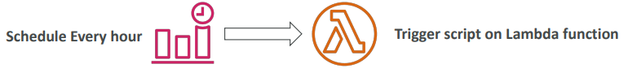

* Event Pattern: Event rules to react to a service doing something

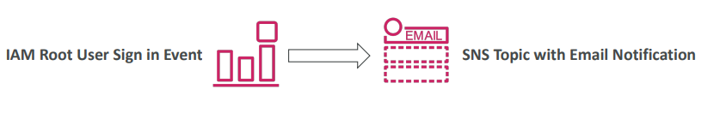

* Trigger Lambda functions, send SQS/SNS messages…

**Amazon EventBridge Rules**

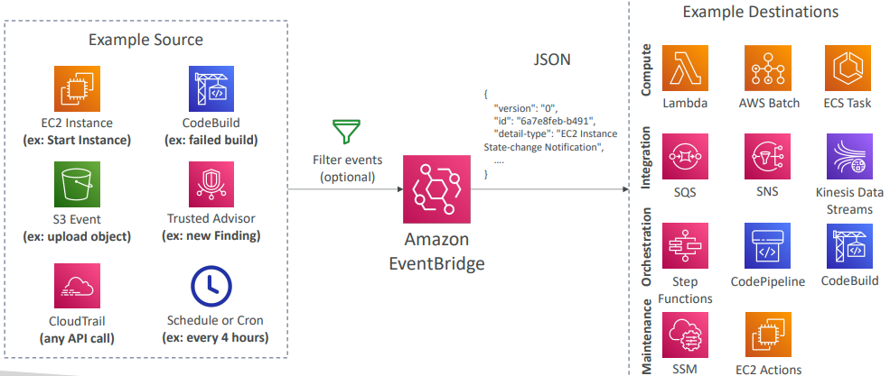

**Amazon EventBridge**

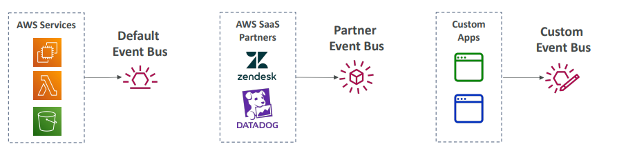

* Event buses can be accessed by other AWS accounts using Resource-based Policies
* You can archive events (all/filter) sent to an event bus (indefinitely or set period)
* Ability to replay archived events

**Amazon EventBridge – Schema Registry**

|  |  |
| --- | --- |
| * EventBridge can analyze the events in your bus and infer the schema * The Schema Registry allows you to generate code for your application, that will know in advance how data is structured in the event bus * Schema can be versioned |  |

**Amazon EventBridge – Resource-based Policy**

* Manage permissions for a specific Event Bus
* Example: allow/deny events from another AWS account or AWS region
* Use case: aggregate all events from your AWS Organization in a single AWS account or AWS region

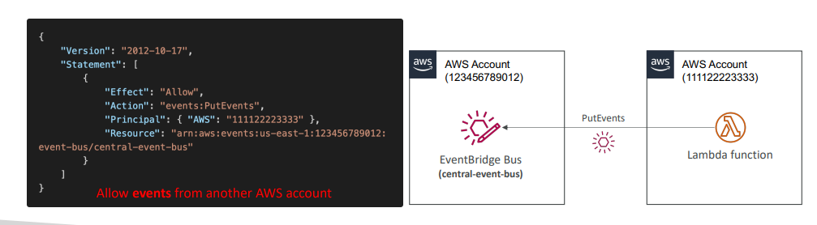

**CloudWatch Container Insights**

|  |  |
| --- | --- |
| • Collect, aggregate, summarize metrics and logs from containers  • Available for containers on…  • Amazon Elastic Container Service (Amazon ECS)  • Amazon Elastic Kubernetes Services (Amazon EKS)  • Kubernetes platforms on EC2  • Fargate (both for ECS and EKS)  • In Amazon EKS and Kubernetes, CloudWatch Insights is using a containerized version of the CloudWatch Agent to discover containers |  |

**CloudWatch Lambda Insights**

|  |  |
| --- | --- |
| * Monitoring and troubleshooting solution for serverless applications running on AWS Lambda * Collects, aggregates, and summarizes system -level metrics including CPU time, memory, disk, and network * Collects, aggregates, and summarizes diagnostic information such as cold starts and Lambda worker shutdowns * Lambda Insights is provided as a Lambda Layer |  |

**CloudWatch Contributor Insights**

|  |  |
| --- | --- |
| * Analyze log data and create time series that display contributor data.   + See metrics about the top-N contributors   + The total number of unique contributors, and their usage. * This helps you find top talkers and understand who or what is impacting system performance. * Works for any AWS-generated logs (VPC, DNS, etc..) * For example, you can find bad hosts, identify the heaviest network users, or find the URLs that generate the most errors. * You can build your rules from scratch, or you can also use sample rules that AWS has created – leverages your CloudWatch Logs * CloudWatch also provides built-in rules that you can use to analyze metrics from other AWS services. |  |

**CloudWatch Application Insights**

* Provides automated dashboards that show potential problems with monitored applications, to help isolate ongoing issues
* Your applications run on Amazon EC2 Instances with select technologies only (Java, .NET, Microsoft IIS Web Server, databases…)
* And you can use other AWS resources such as Amazon EBS, RDS, ELB, ASG, Lambda, SQS, DynamoDB, S3 bucket, ECS, EKS, SNS, API Gateway…
* Powered by SageMaker
* Enhanced visibility into your application health to reduce the time it will take you to troubleshoot and repair your applications
* Findings and alerts are sent to Amazon EventBridge and SSM OpsCenter

**CloudWatch Insights and Operational Visibility**

* CloudWatch Container Insights
  + ECS, EKS, Kubernetes on EC2, Fargate, needs agent for Kubernetes
  + Metrics and logs
* CloudWatch Lambda Insights
  + Detailed metrics to troubleshoot serverless applications
* CloudWatch Contributors Insights
  + Find “Top-N” Contributors through CloudWatch Logs
* CloudWatch Application Insights
  + Automatic dashboard to troubleshoot your application and related AWS services

**AWS CloudTrail**

* Provides governance, compliance and audit for your AWS Account
* CloudTrail is enabled by default!
* Get an history of events / API calls made within your AWS Account by:
  + Console
  + SDK
  + CLI
  + AWS Services
* Can put logs from CloudTrail into CloudWatch Logs or S3
* A trail can be applied to All Regions (default) or a single Region.
* If a resource is deleted in AWS, investigate CloudTrail first!

**CloudTrail Diagram**

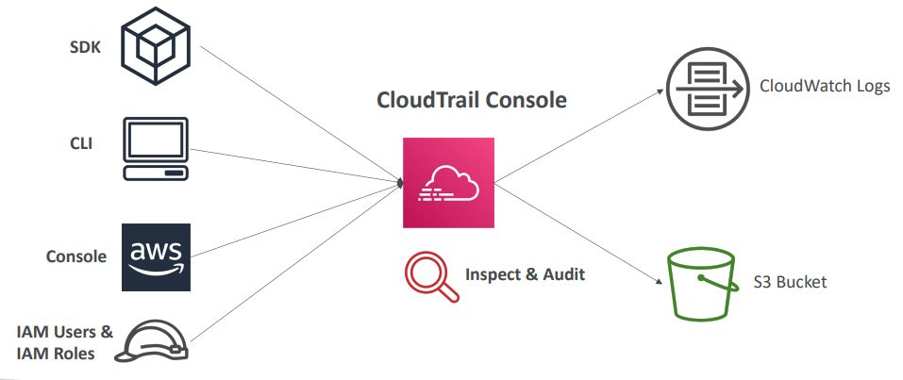

**CloudTrail Events**

* Management Events:
  + Operations that are performed on resources in your AWS account
  + Examples:
    - Configuring security (IAM AttachRolePolicy)
    - Configuring rules for routing data (Amazon EC2 CreateSubnet)
    - Setting up logging (AWS CloudTrail CreateTrail)
  + By default, trails are configured to log management events.
  + Can separate Read Events (that don’t modify resources) from Write Events (that may modify resources)
* Data Events:
  + By default, data events are not logged (because high volume operations)
  + Amazon S3 object-level activity (ex: GetObject, DeleteObject, PutObject): can separate Read and Write Events
  + AWS Lambda function execution activity (the Invoke API)

**CloudTrail Insights**

* Enable CloudTrail Insights to detect unusual activity in your account:
  + inaccurate resource provisioning
  + hitting service limits
  + Bursts of AWS IAM actions
  + Gaps in periodic maintenance activity
* CloudTrail Insights analyzes normal management events to create a baseline
* And then continuously analyzes write events to detect unusual patterns
  + Anomalies appear in the CloudTrail console
  + Event is sent to Amazon S3
  + An EventBridge event is generated (for automation needs)

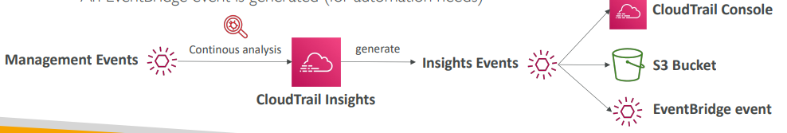

**CloudTrail Events Retention**

* Events are stored for 90 days in CloudTrail
* To keep events beyond this period, log them to S3 and use Athena

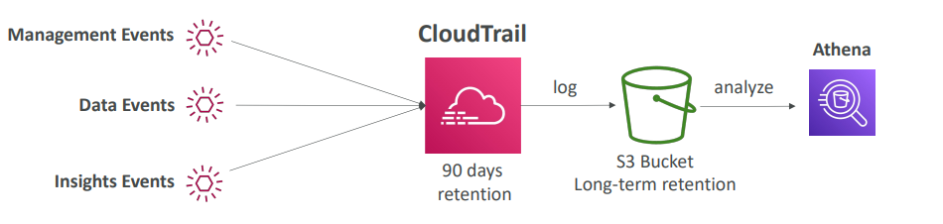

**Amazon EventBridge – Intercept API Calls**

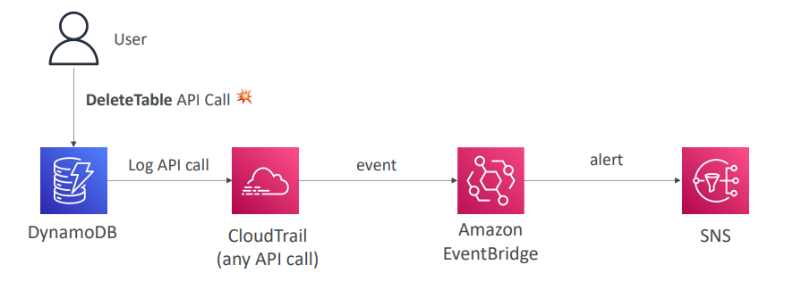

**Amazon EventBridge + CloudTrail**

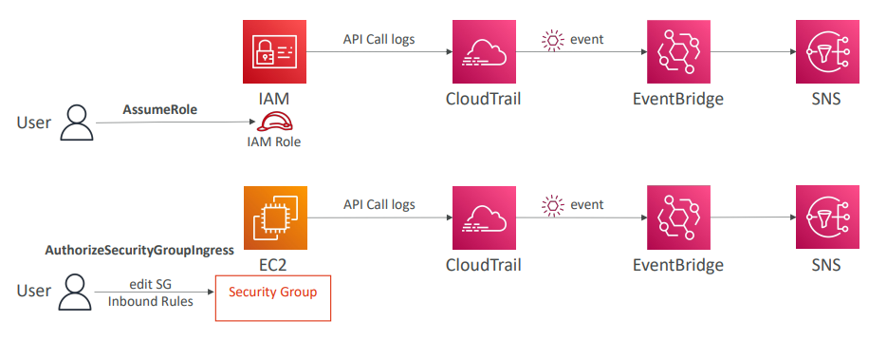

**AWS Config**

* Helps with auditing and recording compliance of your AWS resources
* Helps record configurations and changes over time
* Questions that can be solved by AWS Config:
  + Is there unrestricted SSH access to my security groups?
  + Do my buckets have any public access?
  + How has my ALB configuration changed over time?
* You can receive alerts (SNS notifications) for any changes
* AWS Config is a per-region service
* Can be aggregated across regions and accounts
* Possibility of storing the configuration data into S3 (analyzed by Athena)

**Config Rules**

* Can use AWS managed config rules (over 75)
* Can make custom config rules (must be defined in AWS Lambda)
  + Ex: evaluate if each EBS disk is of type gp2
  + Ex: evaluate if each EC2 instance is t2.micro
* Rules can be evaluated / triggered:
  + For each config change
  + And / or: at regular time intervals
* AWS Config Rules does not prevent actions from happening (no deny)
* Pricing: no free tier, $0.003 per configuration item recorded per region, $0.001 per config rule evaluation per region

**AWS Config Resource**

* View compliance of a resource over time

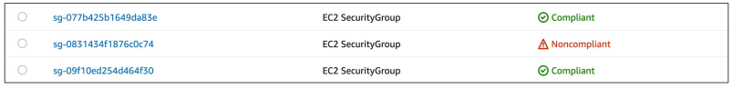

* View configuration of a resource over time

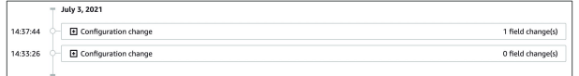

* View CloudTrail API calls of a resource over time

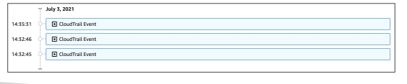

**Config Rules – Remediations**

* Automate remediation of non-compliant resources using SSM Automation Documents
* Use AWS-Managed Automation Documents or create custom Automation Documents
  + Tip: you can create custom Automation Documents that invokes Lambda function
* You can set Remediation Retries if the resource is still non-compliant after auto- remediation

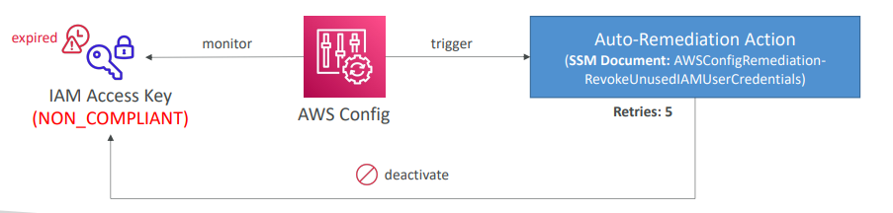

**Config Rules – Notifications**

* Use EventBridge to trigger notifications when AWS resources are noncompliant

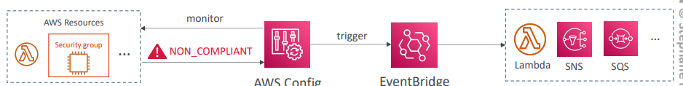

* Ability to send configuration changes and compliance state notifications to SNS (all events – use SNS Filtering or filter at client-side)

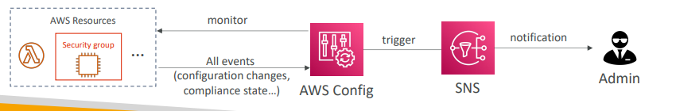

**CloudWatch vs CloudTrail vs Config**

* CloudWatch
  + Performance monitoring (metrics, CPU, network, etc…) & dashboards
  + Events & Alerting
  + Log Aggregation & Analysis
* CloudTrail
  + Record API calls made within your Account by everyone
  + Can define trails for specific resources
  + Global Service
* Config
  + Record configuration changes
  + Evaluate resources against compliance rules
  + Get timeline of changes and compliance

**For an Elastic Load Balancer**

* CloudWatch:
  + Monitoring Incoming connections metric
  + Visualize error codes as % over time
  + Make a dashboard to get an idea of your load balancer performance
* Config:
  + Track security group rules for the Load Balancer
  + Track configuration changes for the Load Balancer
  + Ensure an SSL certificate is always assigned to the Load Balancer (compliance)
* CloudTrail:
  + Track who made any changes to the Load Balancer with API calls

# Advanced Identity in AWS

AWS Organizations

* Global service
* Allows to manage multiple AWS accounts
* The main account is the management account
* Other accounts are member accounts
* Member accounts can only be part of one organization
* Consolidated Billing across all accounts - single payment method
* Pricing benefits from aggregated usage (volume discount for EC2, S3…)
* Shared reserved instances and Savings Plans discounts across accounts
* API is available to automate AWS account creation

**AWS Organizations**

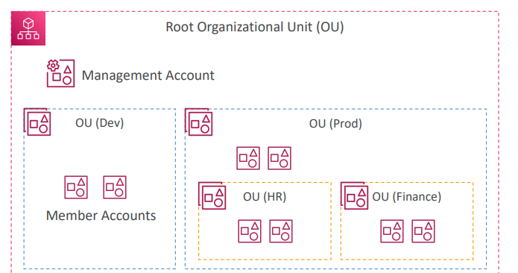

**Organizational Units (OU) – Examples**

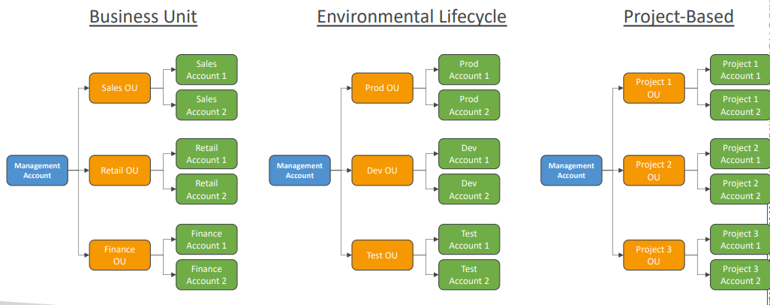

**AWS Organizations**

* Advantages
  + Multi Account vs One Account Multi VPC
  + Use tagging standards for billing purposes
  + Enable CloudTrail on all accounts, send logs to central S3 account
  + Send CloudWatch Logs to central logging account
  + Establish Cross Account Roles for Admin purposes
* Security: Service Control Policies (SCP)
* IAM policies applied to OU or Accounts to restrict Users and Roles
* They do not apply to the management account (full admin power)
* Must have an explicit allow from the root through each OU in the direct path
* to the target account (does not allow anything by default – like IAM)

**SCP Hierarchy**

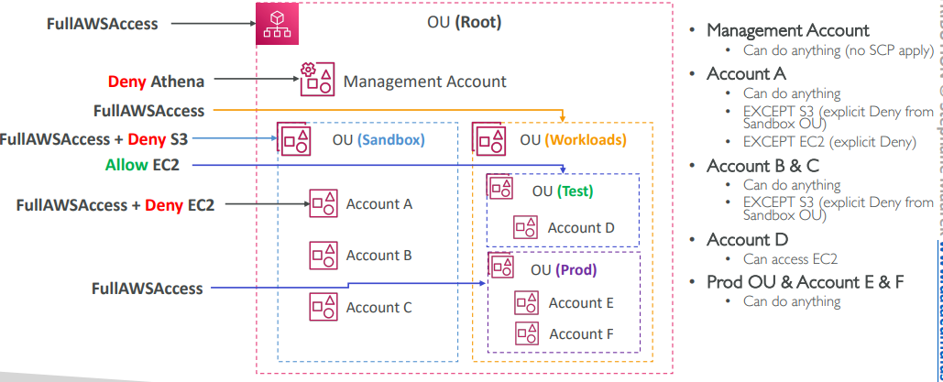

**SCP Examples Blocklist and Allowlist strategies**

<https://docs.aws.amazon.com/organizations/latest/userguide/orgs_manage_policies_example-scps.html>

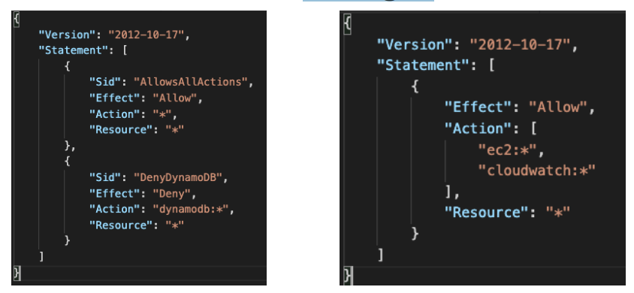

**IAM Conditions**

|  |  |
| --- | --- |
| aws:SourceIp  restrict the client IP from  which the API calls are being made | aws:RequestedRegion  restrict the region the  API calls are made to |

**IAM Conditions**

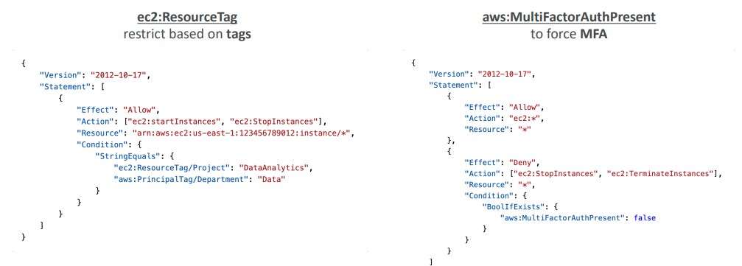

**IAM for S3**

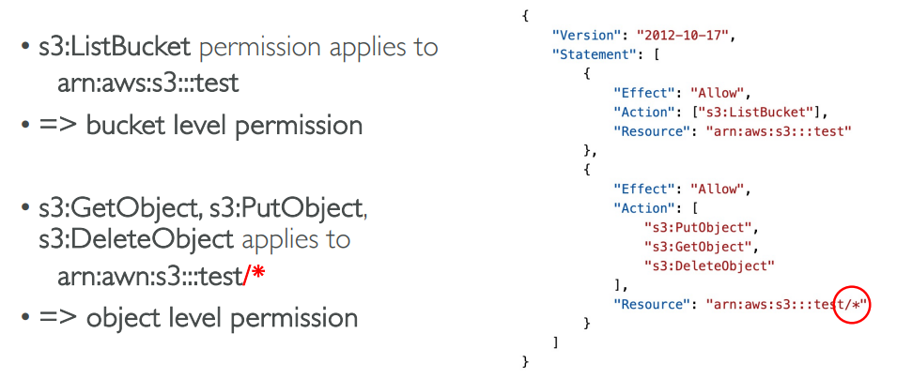

**Resource Policies & aws:PrincipalOrgID**

• aws:PrincipalOrgID can be used in any resource policies to restrict access to accounts that are member of an AWS Organization

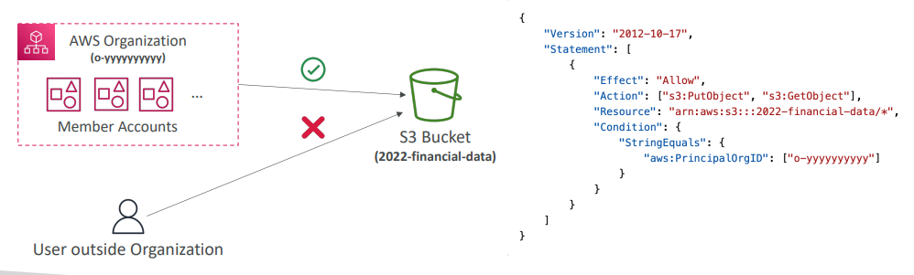

**IAM Roles vs Resource Based Policies**

* Cross account:
* attaching a resource-based policy to a resource (example: S3 bucket policy)
* OR using a role as a proxy

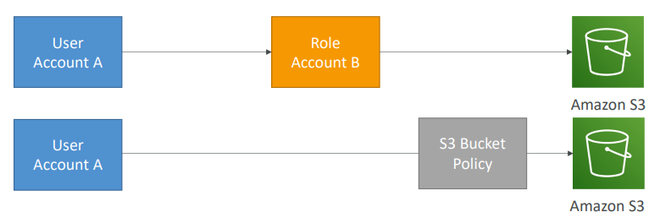

**IAM Roles vs Resource-Based Policies**

* When you assume a role (user, application or service), you give up your original permissions and take the permissions assigned to the role
* When using a resource-based policy, the principal doesn’t have to give up his permissions
* Example: User in account A needs to scan a DynamoDB table in Account A and dump it in an S3 bucket in Account B.
* Supported by: Amazon S3 buckets, SNS topics, SQS queues, etc…

**Amazon EventBridge – Security**

|  |  |
| --- | --- |
| * When a rule runs, it needs permissions on the target * Resource-based policy: Lambda, SNS, SQS, S3 buckets, API Gateway… * IAM role: EC2 Auto Scaling, Systems Manager Run Command, ECS task… |  |

**IAM Permission Boundaries**

* IAM Permission Boundaries are supported for users and roles (not groups)
* Advanced feature to use a managed policy to set the maximum permissions an IAM entity can get.

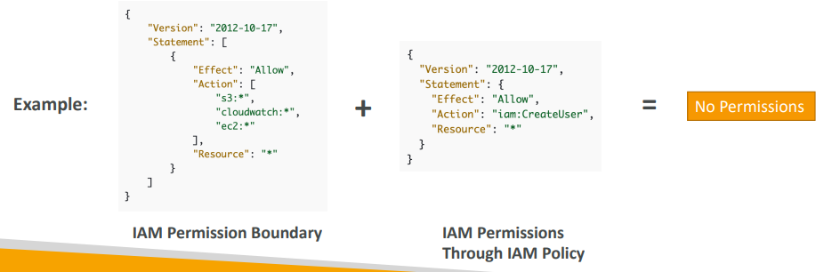

**IAM Permission Boundaries**

|  |  |
| --- | --- |
| Can be used in combinations of AWS Organizations SCP  <https://docs.aws.amazon.com/IAM/latest/UserGuide/access_policies_boundaries.html> | Use cases   * Delegate responsibilities to non administrators within their permission boundaries, for example create new IAM users * Allow developers to self-assign policies and manage their own permissions, while making sure they can’t “escalate” their privileges (= make themselves admin) * Useful to restrict one specific user (instead of a whole account using Organizations & SCP) |

**IAM Policy Evaluation Logic**

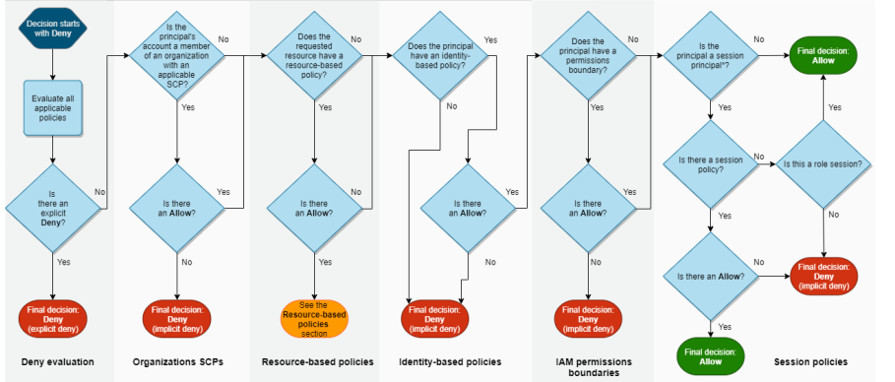

<https://docs.aws.amazon.com/IAM/latest/UserGuide/reference_policies_evaluation-logic.html>

**Example IAM Policy**

|  |  |
| --- | --- |
| * Can you perform sqs:CreateQueue? * Can you perform sqs:DeleteQueue? * Can you perform ec2:DescribeInstances? |  |

**AWS IAM Identity Center (successor to AWS Single Sign-On)**

* One login (single sign-on) for all your
  + AWS accounts in AWS Organizations
  + Business cloud applications (e.g., Salesforce, Box, Microsoft 365, …)
  + SAML2.0-enabled applications
  + EC2 Windows Instances
* Identity providers
  + Built-in identity store in IAM Identity Center
  + 3rd party: Active Directory (AD), OneLogin, Okta…

**AWS IAM Identity Center – Login Flow**

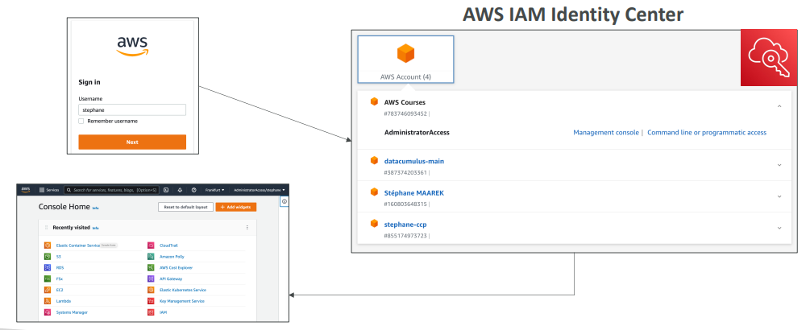

**AWS IAM Identity Center**

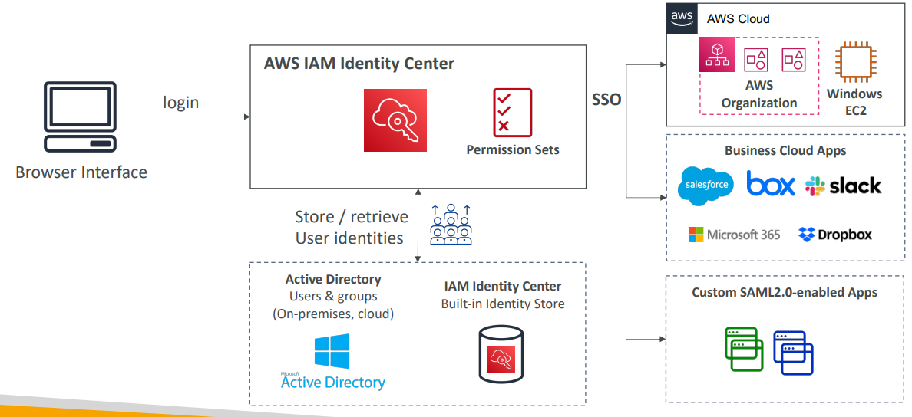

**IAM Identity Center**

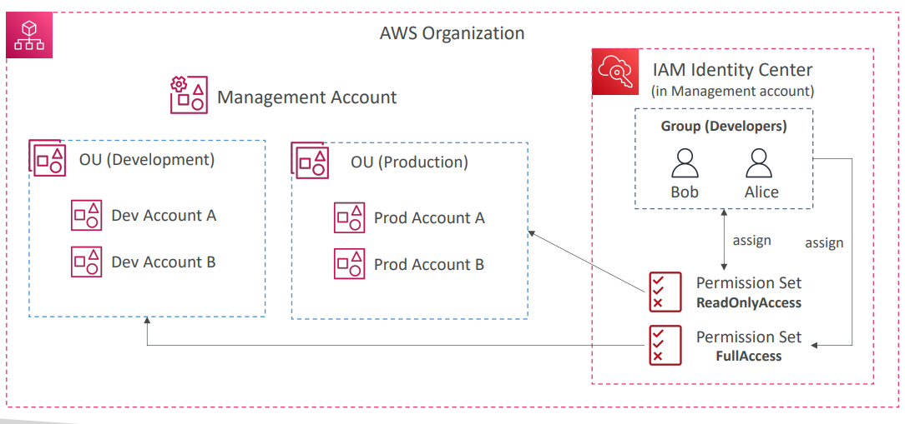

**AWS IAM Identity Center**

|  |  |
| --- | --- |
| * Fine-grained Permissions and Assignments * Multi-Account Permissions   + Manage access across AWS accounts in your AWS Organization   + Permission Sets – a collection of one or more IAM Policies assigned to users and groups to define AWS access * Application Assignments   + SSO access to many SAML 2.0 business applications (Salesforce,Box, Microsoft 365, …)   + Provide required URLs, certificates, and metadata * Attribute-Based Access Control (ABAC)   + Fine-grained permissions based on users’ attributes stored in IAM Identity Center Identity Store   + Example: cost center, title, locale, …   + Use case: Define permissions once, then modify AWS access by changing the attributes |  |

**What is Microsoft Active Directory (AD)?**

|  |  |
| --- | --- |
| * Found on any Windows Server with AD Domain Services * Database of objects: User Accounts, Computers, Printers, File Shares, Security Groups * Centralized security management, create account, assign permissions * Objects are organized in trees * A group of trees is a forest |  |

**AWS Directory Services**

|  |  |
| --- | --- |
| * AWS Managed Microsoft AD * Create your own AD in AWS, manage users locally, supports MFA * Establish “trust” connections with your on- premises AD * AD Connector * Directory Gateway (proxy) to redirect to on- premises AD, supports MFA * Users are managed on the on-premises AD * Simple AD * AD-compatible managed directory on AWS * Cannot be joined with on-premises AD |  |

**IAM Identity Center – Active Directory Setup**

* Connect to an AWS Managed Microsoft AD (Directory Service)
  + Integration is out of the box

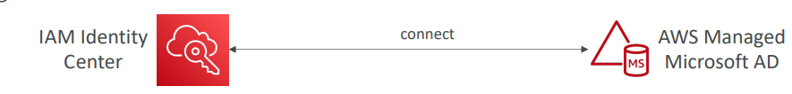

* Connect to a Self-Managed Directory
  + Create Two-way Trust Relationship using AWS Managed Microsoft AD
  + Create an AD Connector

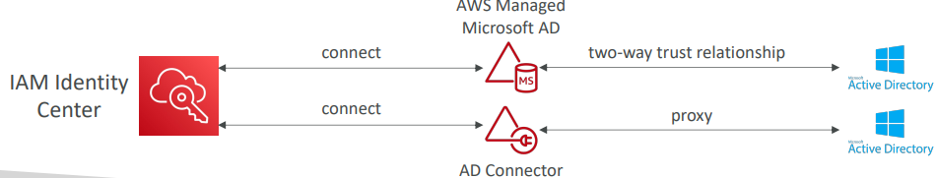

**AWS Control Tower**

* Easy way to set up and govern a secure and compliant multi-account AWS environment based on best practices
* AWS Control Tower uses AWS Organizations to create accounts
* Benefits:
  + Automate the set up of your environment in a few clicks
  + Automate ongoing policy management using guardrails
  + Detect policy violations and remediate them
  + Monitor compliance through an interactive dashboard

**AWS Control Tower – Guardrails**

* Provides ongoing governance for your Control Tower environment (AWS Accounts)
* Preventive Guardrail – using SCPs (e.g., Restrict Regions across all your accounts)
* Detective Guardrail – using AWS Config (e.g., identify untagged resources)

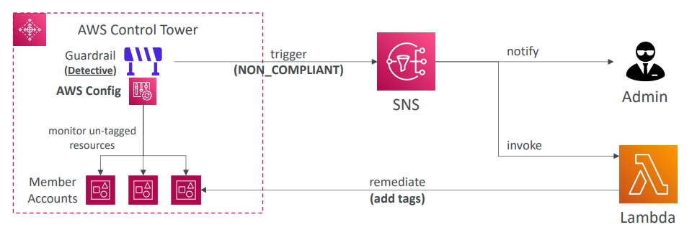

# AWS Security & Encryption

**Why encryption?**

Encryption in flight (TLS / SSL)

* Data is encrypted before sending and decrypted after receiving
* TLS certificates help with encryption (HTTPS)
* Encryption in flight ensures no MITM (man in the middle attack) can happen

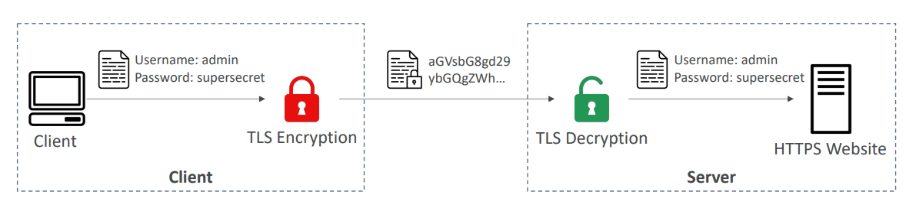

**Why encryption?**

Server-side encryption at rest

* Data is encrypted after being received by the server
* Data is decrypted before being sent
* It is stored in an encrypted form thanks to a key (usually a data key)
* The encryption / decryption keys must be managed somewhere, and the server must have access to it

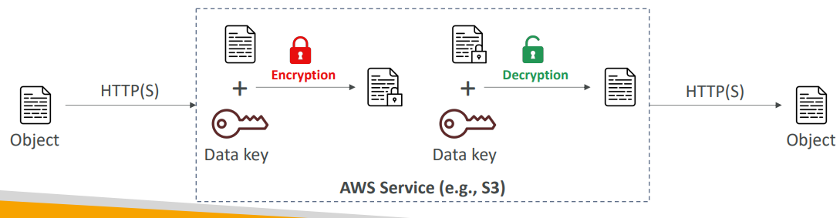

**Why encryption? Client-side encryption**

* Data is encrypted by the client and never decrypted by the server
* Data will be decrypted by a receiving client
* The server should not be able to decrypt the data
* Could leverage Envelope Encryption

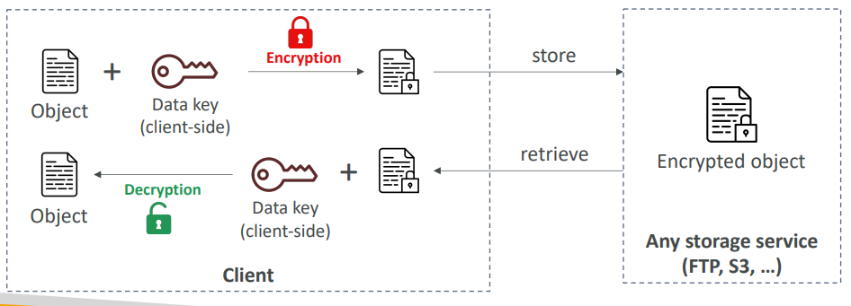

**AWS KMS (Key Management Service)**

* Anytime you hear “encryption” for an AWS service, it’s most likely KMS
* AWS manages encryption keys for us
* Fully integrated with IAM for authorization
* Easy way to control access to your data
* Able to audit KMS Key usage using CloudTrail
* Seamlessly integrated into most AWS services (EBS, S3, RDS, SSM…)
* Never ever store your secrets in plaintext, especially in your code!
  + KMS Key Encryption also available through API calls (SDK, CLI)
  + Encrypted secrets can be stored in the code / environment variables

**KMS Keys Types**

* KMS Keys is the new name of KMS Customer Master Key
* Symmetric (AES-256 keys)
  + Single encryption key that is used to Encrypt and Decrypt
  + AWS services that are integrated with KMS use Symmetric CMKs
  + You never get access to the KMS Key unencrypted (must call KMS API to use)
* Asymmetric (RSA & ECC key pairs)
  + Public (Encrypt) and Private Key (Decrypt) pair
  + Used for Encrypt/Decrypt, or Sign/Verify operations
  + The public key is downloadable, but you can’t access the Private Key unencrypted
  + Use case: encryption outside of AWS by users who can’t call the KMS API

**AWS KMS (Key Management Service)**

|  |  |
| --- | --- |
| * Types of KMS Keys:   + AWS Owned Keys (free): SSE-S3, SSE-SQS, SSE-DDB (default key)   + AWS Managed Key: free (aws/service-name, example: aws/rds or aws/ebs)   + Customer managed keys created in KMS: $1 / month   + Customer managed keys imported: $1 / month   + + pay for API call to KMS ($0.03 / 10000 calls) * Automatic Key rotation:   + AWS-managed KMS Key: automatic every 1 year   + Customer-managed KMS Key: (must be enabled) automatic & on-demand   + Imported KMS Key: only manual rotation possible using alias |  |

**Copying Snapshots across regions**

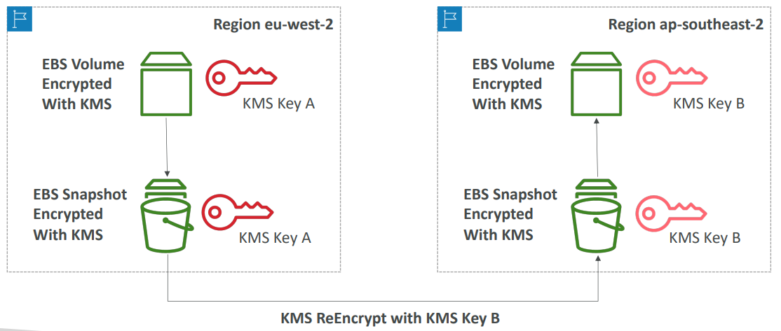

**KMS Key Policies**

* Control access to KMS keys, “similar” to S3 bucket policies
* Difference: you cannot control access without them
* Default KMS Key Policy:
  + Created if you don’t provide a specific KMS Key Policy
  + Complete access to the key to the root user = entire AWS account
* Custom KMS Key Policy:
  + Define users, roles that can access the KMS key
  + Define who can administer the key
  + Useful for cross-account access of your KMS key

**Copying Snapshots across accounts**

|  |  |
| --- | --- |
| * Create a Snapshot, encrypted with your own KMS Key (Customer Managed Key) * Attach a KMS Key Policy to authorize cross-account access * Share the encrypted snapshot * (in target) Create a copy of the Snapshot, encrypt it with a CMK in your account * Create a volume from the snapshot |  |

**KMS Multi -Region Keys**

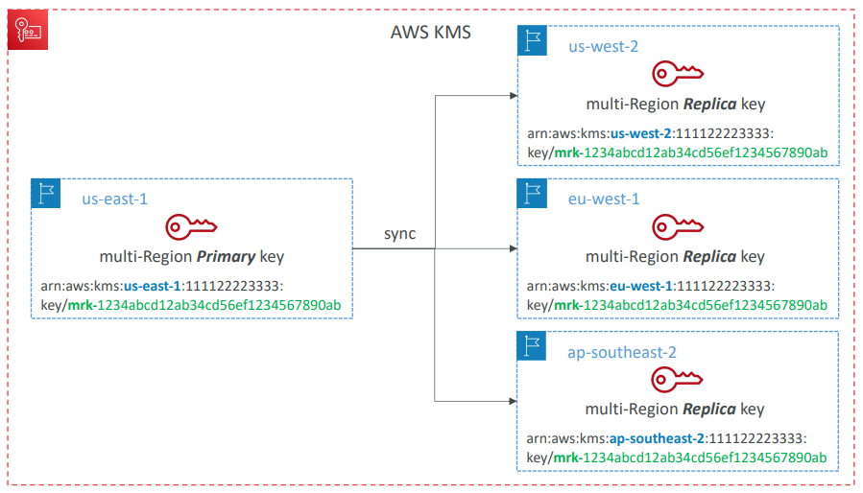

**KMS Multi-Region Keys**

* Identical KMS keys in different AWS Regions that can be used interchangeably
* Multi-Region keys have the same key ID, key material, automatic rotation…
* Encrypt in one Region and decrypt in other Regions
* No need to re-encrypt or making cross-Region API calls
* KMS Multi-Region are NOT global (Primary + Replicas)
* Each Multi-Region key is managed independently
* Use cases: global client-side encryption, encryption on Global DynamoDB, Global Aurora

**DynamoDB Global Tables and KMS MultiRegion Keys Client-Side encryption**

|  |  |
| --- | --- |
| * We can encrypt specific attributes client-side in our DynamoDB table using the Amazon DynamoDB Encryption Client * Combined with Global Tables, the client-side encrypted data is replicated to other regions * If we use a multi-region key, replicated in the same region as the DynamoDB Global table, then clients in these regions can use lowlatency API calls to KMS in their region to decrypt the data client-side * Using client-side encryption we can protect specific fields and guarantee only decryption if the client has access to an API key |  |

**Global Aurora and KMS Multi-Region Keys Client-Side encryption**

|  |  |
| --- | --- |
| * We can encrypt specific attributes client-side in our Aurora table using the AWS Encryption SDK * Combined with Aurora Global Tables, the client-side encrypted data is replicated to other regions * If we use a multi-region key, replicated in the same region as the Global Aurora DB, then clients in these regions can use low-latency API calls to KMS in their region to decrypt the data client-side * Using client-side encryption we can protect specific fields and guarantee only decryption if the client has access to an API key, we can protect specific fields even from database admins |  |

**S3 Replication Encryption Considerations**

* Unencrypted objects and objects encrypted with SSE-S3 are replicated by default
* Objects encrypted with SSE-C (customer provided key) can be replicated
* For objects encrypted with SSE-KMS, you need to enable the option
* Specify which KMS Key to encrypt the objects within the target bucket
* Adapt the KMS Key Policy for the target key
* An IAM Role with kms:Decrypt for the source KMS Key and kms:Encrypt for the target KMS Key
* You might get KMS throttling errors, in which case you can ask for a Service Quotas increase
* You can use multi-region AWS KMS Keys, but they are currently treated as independent keys by Amazon S3 (the object will still be decrypted and then encrypted)

**AMI Sharing Process Encrypted via KMS**

|  |  |
| --- | --- |
| * AMI in Source Account is encrypted with KMS Key from Source Account * Must modify the image attribute to add a Launch Permission which corresponds to the specified target AWS account * Must share the KMS Keys used to encrypted the snapshot the AMI references with the target account / IAM Role * The IAM Role/User in the target account must have the permissions to DescribeKey, ReEncrypted, CreateGrant, Decrypt * When launching an EC2 instance from the AMI, optionally the target account can specify a new KMS key in its own account to re-encrypt the volumes |  |

**SSM Parameter Store**

|  |  |
| --- | --- |
| * Secure storage for configuration and secrets * Optional Seamless Encryption using KMS * Serverless, scalable, durable, easy SDK * Version tracking of configurations / secrets * Security through IAM * Notifications with Amazon EventBridge * Integration with CloudFormation |  |

**SSM Parameter Store Hierarchy**

|  |  |
| --- | --- |
| * /my-department/ * my-app/ * dev/ * db-url * db-password * prod/ * db-url * db-password * other-app/ * /other-department/ * /aws/reference/secretsmanager/secret_ID_in_Secrets_Manager * /aws/service/ami-amazon-linux-latest/amzn2-ami-hvm-x86_64-gp2 (public) |  |

**Standard and advanced parameter tiers**

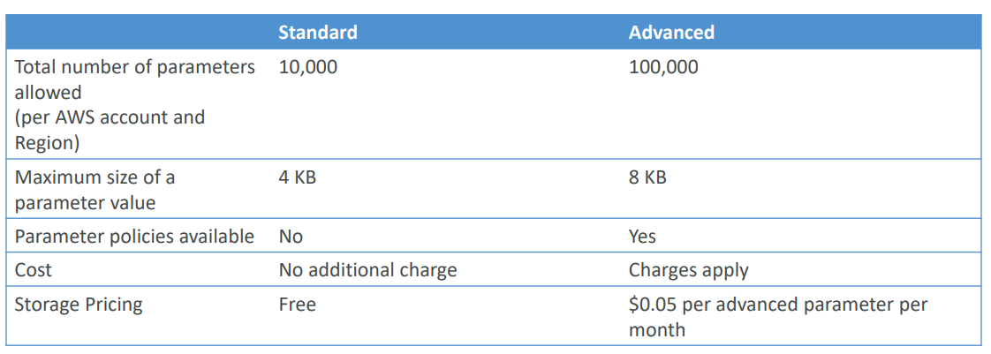

**Parameters Policies (for advanced parameters)**

* Allow to assign a TTL to a parameter (expiration date) to force updating or deleting sensitive data such as passwords
* Can assign multiple policies at a time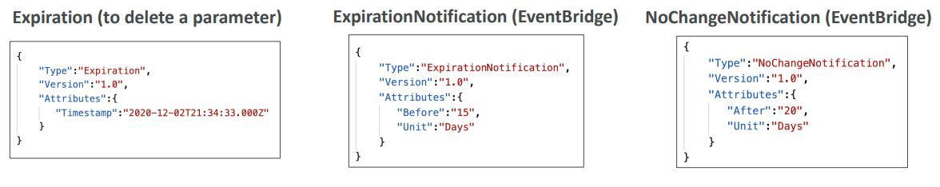

**AWS Secrets Manager**

* Newer service, meant for storing secrets
* Capability to force rotation of secrets every X days
* Automate generation of secrets on rotation (uses Lambda)
* Integration with Amazon RDS (MySQL, PostgreSQL, Aurora)
* Secrets are encrypted using KMS
* Mostly meant for RDS integration

**AWS Secrets Manager – Multi-Region Secrets**

* Replicate Secrets across multiple AWS Regions
* Secrets Manager keeps read replicas in sync with the primary Secret
* Ability to promote a read replica Secret to a standalone Secret
* Use cases: multi-region apps, disaster recovery strategies, multi-region DB…

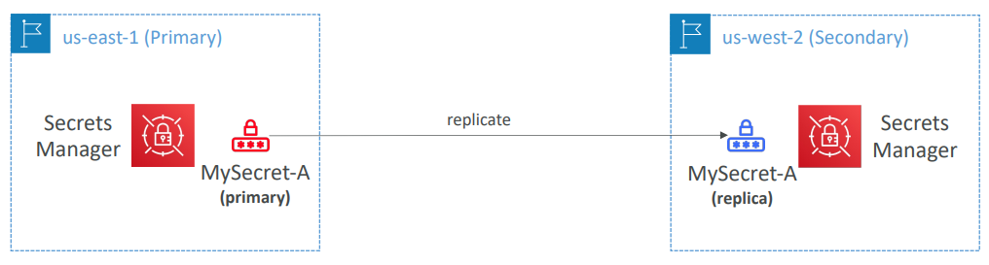

**AWS Certificate Manager (ACM)**

|  |  |
| --- | --- |
| * Easily provision, manage, and deploy TLS Certificates * Provide in-flight encryption for websites (HTTPS) * Supports both public and private TLS certificates * Free of charge for public TLS certificates * Automatic TLS certificate renewal * Integrations with (load TLS certificates on)   + Elastic Load Balancers (CLB, ALB, NLB)   + CloudFront Distributions   + APIs on API Gateway * Cannot use ACM with EC2 (can’t be extracted) |  |

**ACM – Requesting Public Certificates**

* List domain names to be included in the certificate
  + Fully Qualified Domain Name (FQDN): corp.example.com
  + Wildcard Domain: *.example.com
* Select Validation Method: DNS Validation or Email validation
  + DNS Validation is preferred for automation purposes
  + Email validation will send emails to contact addresses in the WHOIS database
  + DNS Validation will leverage a CNAME record to DNS config (ex: Route 53)
* It will take a few hours to get verified
* The Public Certificate will be enrolled for automatic renewal • ACM automatically renews ACM-generated certificates 60 days before expiry

**ACM – Importing Public Certificates**

|  |  |
| --- | --- |
| • Option to generate the certificate outside of ACM and then import it  • No automatic renewal, must import a new certificate before expiry  • ACM sends daily expiration events starting 45 days prior to expiration  • The # of days can be configured  • Events are appearing in EventBridge  • AWS Config has a managed rule named acm-certificate-expiration-check to check for expiring certificates (configurable number of days) |  |

**ACM – Integration with ALB**

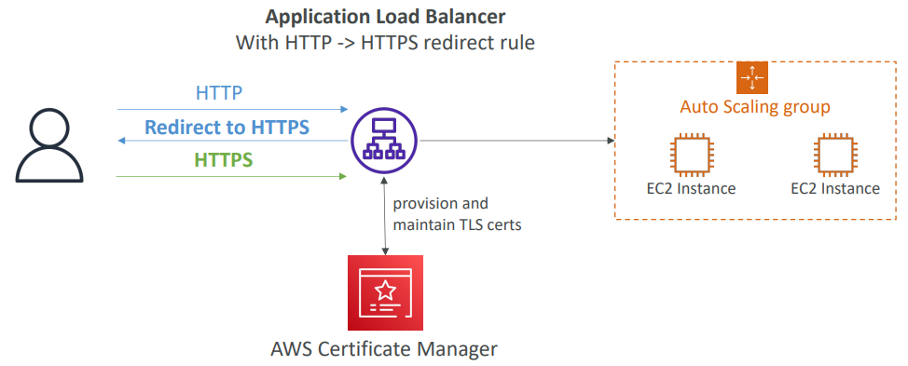

**API Gateway - Endpoint Types**

* Edge-Optimized (default): For global clients
  + Requests are routed through the CloudFront Edge locations (improves latency)
  + The API Gateway still lives in only one region
* Regional:
  + For clients within the same region
  + Could manually combine with CloudFront (more control over the caching strategies and the distribution)
* Private:
  + Can only be accessed from your VPC using an interface VPC endpoint (ENI)
  + Use a resource policy to define access

**ACM – Integration with API Gateway**

|  |  |
| --- | --- |
| * Create a Custom Domain Name in API Gateway * Edge-Optimized (default): For global clients   + Requests are routed through the CloudFront Edge locations (improves latency)   + The API Gateway still lives in only one region   + The TLS Certificate must be in the same region as CloudFront, in us-east-1   + Then setup CNAME or (better) A-Alias record in Route 53 * Regional:   + For clients within the same region   + The TLS Certificate must be imported on API Gateway, in the same region as the API Stage   + Then setup CNAME or (better) A-Alias record in Route 53 |  |

**AWS WAF – Web Application Firewall**

* Protects your web applications from common web exploits (Layer 7)
* Layer 7 is HTTP (vs Layer 4 is TCP/UDP)
* Deploy on
* Application Load Balancer
* API Gateway
* CloudFront
* AppSync GraphQL API
* Cognito User Pool

**AWS WAF – Web Application Firewall**

* Define Web ACL (Web Access Control List) Rules:
* IP Set: up to 10,000 IP addresses – use multiple Rules for more IPs
* HTTP headers, HTTP body, or URI strings Protects from common attack – SQL injection and Cross-Site Scripting (XSS)
* Size constraints, geo-match (block countries)
* Rate-based rules (to count occurrences of events) – for DDoS protection
* Web ACL are Regional except for CloudFront
* A rule group is a reusable set of rules that you can add to a web ACL

**WAF – Fixed IP while using WAF with a Load Balancer**

* WAF does not support the Network Load Balancer (Layer 4)
* We can use Global Accelerator for fixed IP and WAF onthe ALB

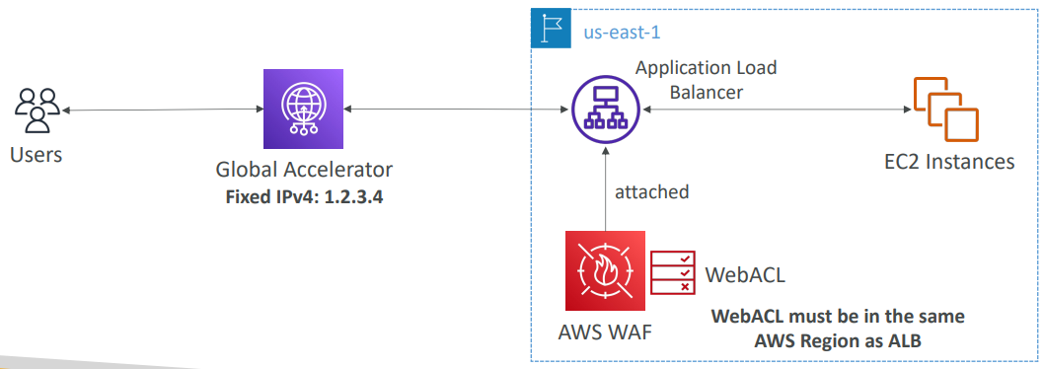

**AWS Shield: protect from DDoS attack**

* DDoS: Distributed Denial of Service – many requests at the same time
* AWS Shield Standard:
  + Free service that is activated for every AWS customer
  + Provides protection from attacks such as SYN/UDP Floods, Reflection attacks and other layer 3/layer 4 attacks
* AWS Shield Advanced:
  + Optional DDoS mitigation service ($3,000 per month per organization)
  + Protect against more sophisticated attack on Amazon EC2, Elastic Load Balancing (ELB), Amazon CloudFront, AWS Global accelerator, and Route 53
  + 24/7 access to AWS DDoS response team (DRP)
  + Protect against higher fees during usage spikes due to DDoS
  + Shield Advanced automatic application layer DDoS mitigation automatically creates, evaluates and deploys AWS WAF rules to mitigate layer 7 attacks

**AWS Firewall Manager**

* Manage rules in all accounts of an AWS Organization
* Security policy: common set of security rules
  + WAF rules (Application Load Balancer, API Gateways, CloudFront)
  + AWS Shield Advanced (ALB, CLB, NLB, Elastic IP, CloudFront)
  + Security Groups for EC2, Application Load BAlancer and ENI resources in VPC
  + AWS Network Firewall (VPC Level)
  + Amazon Route 53 Resolver DNS Firewall
  + Policies are created at the region level
* Rules are applied to new resources as they are created (good for compliance) across all and future accounts in your Organization

**WAF vs. Firewall Manager vs. Shield**

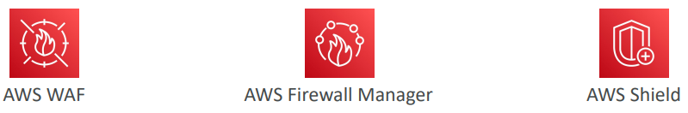

* WAF, Shield and Firewall Manager are used together for comprehensive protection
* Define your Web ACL rules in WAF
* For granular protection of your resources, WAF alone is the correct choice
* If you want to use AWS WAF across accounts, accelerate WAF configuration, automate the
* protection of new resources, use Firewall Manager with AWS WAF
* Shield Advanced adds additional features on top of AWS WAF, such as dedicated support from the Shield Response Team (SRT) and advanced reporting.
* If you’re prone to frequent DDoS attacks, consider purchasing Shield Advanced

**AWS Best Practices for DDoS Resiliency Edge Location Mitigation (BP1, BP3)**

|  |  |
| --- | --- |
| * BP1 – CloudFront   + Web Application delivery at the edge   + Protect from DDoS Common Attacks (SYN floods, UDP reflection…) * BP1 – Global Accelerator   + Access your application from the edge   + Integration with Shield for DDoS protection   + Helpful if your backend is not compatible with CloudFront * BP3 – Route 53   + Domain Name Resolution at the edge   + DDoS Protection mechanism |  |

**AWS Best Practices for DDoS Resiliency Best pratices for DDoS mitigation**

|  |  |
| --- | --- |
| * Infrastructure layer defense (BP1, BP3, BP6) * Protect Amazon EC2 against high traffic * That includes using Global Accelerator, Route 53, CloudFront, Elastic Load Balancing * Amazon EC2 with Auto Scaling (BP7) * Helps scale in case of sudden traffic surges including a flash crowd or a DDoS attack * Elastic Load Balancing (BP6) * Elastic Load Balancing scales with the traffic increases and will distribute the traffic to many EC2 instances |  |

**AWS Best Practices for DDoS Resiliency Application Layer Defense**

|  |  |
| --- | --- |
| * Detect and filter malicious web requests (BP1, BP2) * CloudFront cache static content and serve it from edge locations, protecting your backend * AWS WAF is used on top of CloudFront and Application Load Balancer to filter and block requests based on request signatures * WAF rate-based rules can automatically block the IPs of bad actors * Use managed rules on WAF to block attacks based on IP reputation, or block anonymous Ips * CloudFront can block specific geographies * Shield Advanced (BP1, BP2, BP6) * Shield Advanced automatic application layer DDoS mitigation automatically creates, evaluates and deploys AWS WAF rules to mitigate layer 7 attacks |  |

**AWS Best Practices for DDoS Resiliency Attack surface reduction**

|  |  |
| --- | --- |
| * Obfuscating AWS resources (BP1, BP4, BP6)   + Using CloudFront, API Gateway, Elastic Load Balancing to hide your backend resources (Lambda functions, EC2 instances) * Security groups and Network ACLs (BP5)   + Use security groups and NACLs to filter traffic based on specific IP at the subnet or ENI-level   + Elastic IP are protected by AWS Shield Advanced * Protecting API endpoints (BP4)   + Hide EC2, Lambda, elsewhere   + Edge-optimized mode, or CloudFront + regional mode (more control for DDoS)   + WAF + API Gateway: burst limits, headers filtering, use API keys |  |

**Amazon GuardDuty**

* Intelligent Threat discovery to protect your AWS Account
* Uses Machine Learning algorithms, anomaly detection, 3rd party data
* One click to enable (30 days trial), no need to install software
* Input data includes:
* CloudTrail Events Logs – unusual API calls, unauthorized deployments
* CloudTrail Management Events – create VPC subnet, create trail, …
* CloudTrail S3 Data Events – get object, list objects, delete object, …
* VPC Flow Logs – unusual internal traffic, unusual IP address
* DNS Logs – compromised EC2 instances sending encoded data within DNS queries
* Optional Features – EKS Audit Logs, RDS & Aurora, EBS, Lambda, S3 Data Events…
* Can setup EventBridge rules to be notified in case of findings
* EventBridge rules can target AWS Lambda or SNS
* Can protect against CryptoCurrency attacks (has a dedicated “finding” for it)

**Amazon GuardDuty1**

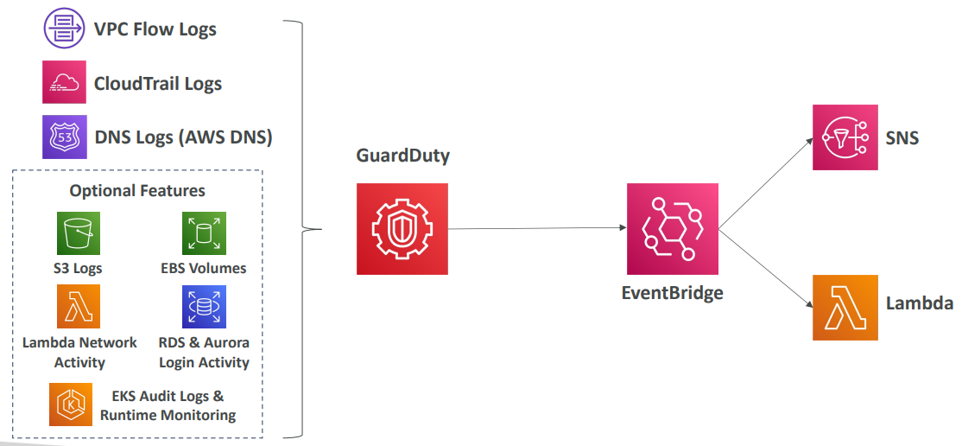

**Amazon Inspector**

|  |  |
| --- | --- |
| * Automated Security Assessments * For EC2 instances * Leveraging the AWS System Manager (SSM) agent * Analyze against unintended network accessibility * Analyze the running OS against known vulnerabilities * For Container Images push to Amazon ECR * Assessment of Container Images as they are pushed * For Lambda Functions * Identifies software vulnerabilities in function code and package dependencies * Assessment of functions as they are deployed * Reporting & integration with AWS Security Hub * Send findings to Amazon Event Bridge |  |

**What does Amazon Inspector evaluate?**

* Remember: only for EC2 instances, Container Images & Lambda functions
* Continuous scanning of the infrastructure, only when needed
* Package vulnerabilities (EC2, ECR & Lambda) – database of CVE
* Network reachability (EC2)
* A risk score is associated with all vulnerabilities for prioritization

**AWS Macie**

* Amazon Macie is a fully managed data security and data privacy service that uses machine learning and pattern matching to discover and protect your sensitive data in AWS.
* Macie helps identify and alert you to sensitive data, such as personally identifiable information (PII)

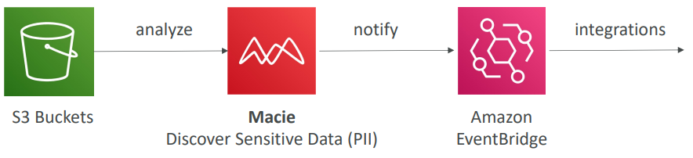

# Amazon VPC

VPC Components Diagram

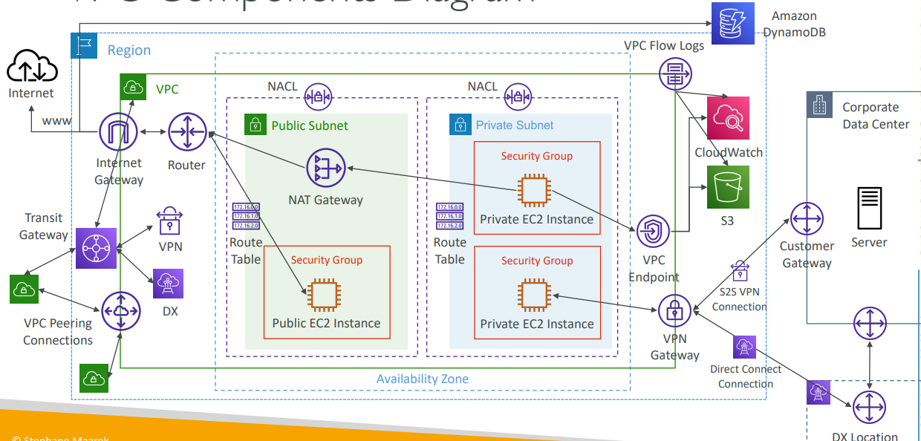

**Understanding CIDR – IPv4**

* Classless Inter-Domain Routing – a method for allocating IP addresses
* Used in Security Groups rules and AWS networking in general

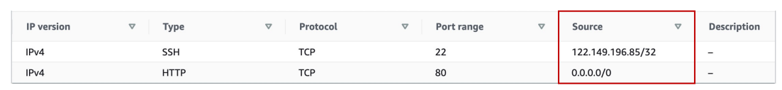

* They help to define an IP address range:
  + We’ve seen WW.XX.YY.ZZ/32 => one IP
  + We’ve seen 0.0.0.0/0 => all IPs
  + But we can define:192.168.0.0/26 =>192.168.0.0 – 192.168.0.63 (64 IP addresses)

**Understanding CIDR – IPv4**

* A CIDR consists of two components
* Base IP
  + Represents an IP contained in the range (XX.XX.XX.XX)
  + Example: 10.0.0.0, 192.168.0.0, …
* Subnet Mask
  + Defines how many bits can change in the IP
  + Example: /0, /24, /32
  + Can take two forms:
    - /8 <-> 255.0.0.0
    - /16 <-> 255.255.0.0
    - /24 <-> 255.255.255.0
    - /32 <-> 255.255.255.255

**Understanding CIDR – Subnet Mask**

The Subnet Mask basically allows part of the underlying IP to get additional next values from the base IP

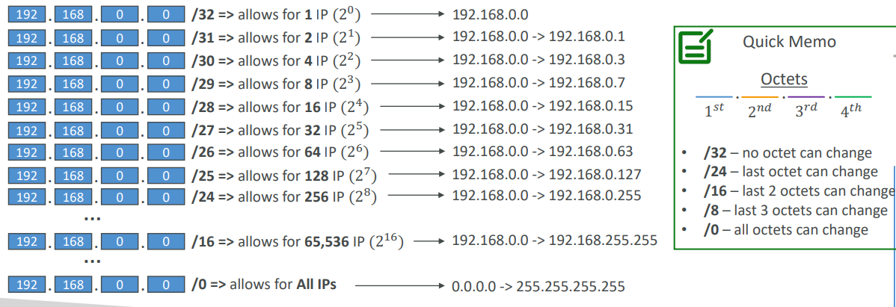

**Understanding CIDR – Little Exercise**

* 192.168.0.0/24 = … ?
  + 192.168.0.0 – 192.168.0.255 (256 IPs)
* 192.168.0.0/16 = … ?
  + 192.168.0.0 – 192.168.255.255 (65,536 IPs)
* 134.56.78.123/32 = … ?
  + Just 134.56.78.123
* 0.0.0.0/0
  + All IPs!
* When in doubt, use this website <https://www.ipaddressguide.com/cidr>

**Public vs. Private IP (IPv4)**

* The Internet Assigned Numbers Authority (IANA) established certain blocks of IPv4 addresses for the use of private (LAN) and public (Internet) addresses
* Private IP can only allow certain values:
  + 10.0.0.0 – 10.255.255.255 (10.0.0.0/8) ç in big networks
  + 172.16.0.0 – 172.31.255.255 (172.16.0.0/12) ç AWS default VPC in that range
  + 192.168.0.0 – 192.168.255.255 (192.168.0.0/16) ç e.g., home networks
* All the rest of the IP addresses on the Internet are Public

**Default VPC Walkthrough**

* All new AWS accounts have a default VPC
* New EC2 instances are launched into the default VPC if no subnet is specified
* Default VPC has Internet connectivity and all EC2 instances inside it have public IPv4 addresses
* We also get a public and a private IPv4 DNS names

**VPC in AWS – IPv4**

* VPC = Virtual Private Cloud
* You can have multiple VPCs in an AWS region (max. 5 per region – soft limit)
* Max. CIDR per VPC is 5, for each CIDR:
  + Min. size is /28 (16 IP addresses)
  + Max. size is /16 (65536 IP addresses)
* Because VPC is private, only the Private IPv4 ranges are allowed:
  + 10.0.0.0 – 10.255.255.255 (10.0.0.0/8)
  + 172.16.0.0 – 172.31.255.255 (172.16.0.0/12)
  + 192.168.0.0 – 192.168.255.255 (192.168.0.0/16)
* Your VPC CIDR should NOT overlap with your other networks (e.g., corporate)

**State of Hands -on**

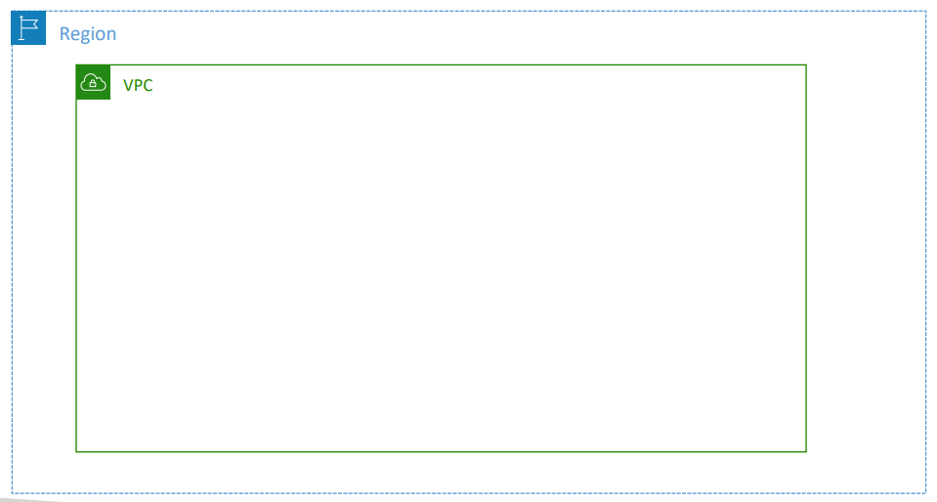

**Adding Subnets**

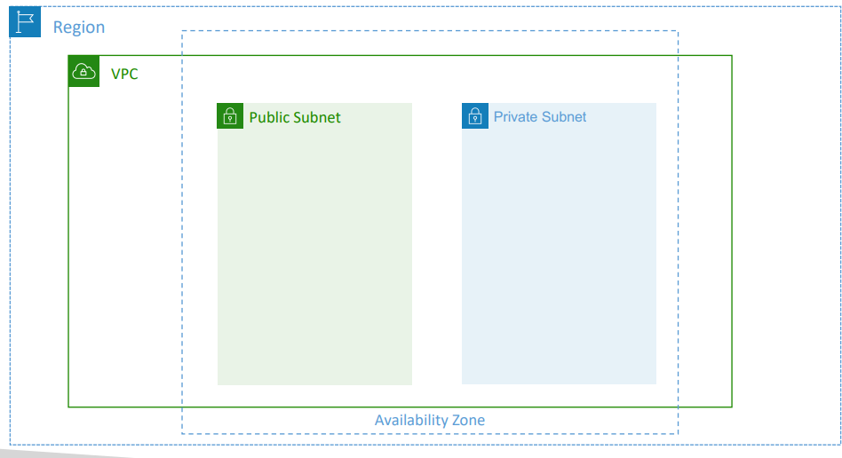

**VPC – Subnet (IPv4)**

* AWS reserves 5 IP addresses (first 4 & last 1) in each subnet
* These 5 IP addresses are not available for use and can’t be assigned to an EC2 instance
* Example: if CIDR block 10.0.0.0/24, then reserved IP addresses are:
  + 10.0.0.0 – Network Address
  + 10.0.0.1 – reserved by AWS for the VPC router
  + 10.0.0.2 – reserved by AWS for mapping to Amazon-provided DNS
  + 10.0.0.3 – reserved by AWS for future use
  + 10.0.0.255 – Network Broadcast Address. AWS does not support broadcast in a VPC, therefore the address is reserved
* Exam Tip, if you need 29 IP addresses for EC2 instances:
  + You can’t choose a subnet of size /27 (32 IP addresses, 32 – 5 = 27 < 29)
  + You need to choose a subnet of size /26 (64 IP addresses, 64 – 5 = 59 > 29)

**Internet Gateway (IGW)**

* Allows resources (e.g., EC2 instances) in a VPC connect to the Internet
* It scales horizontally and is highly available and redundant
* Must be created separately from a VPC
* One VPC can only be attached to one IGW and vice versa
* Internet Gateways on their own do not allow Internet access…
* Route tables must also be edited!

**Adding Internet Gateway**

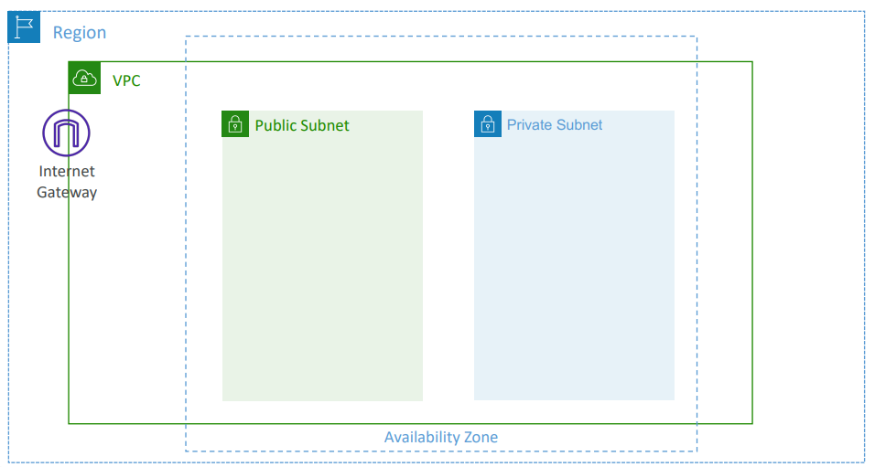

**Editing Route Tables**

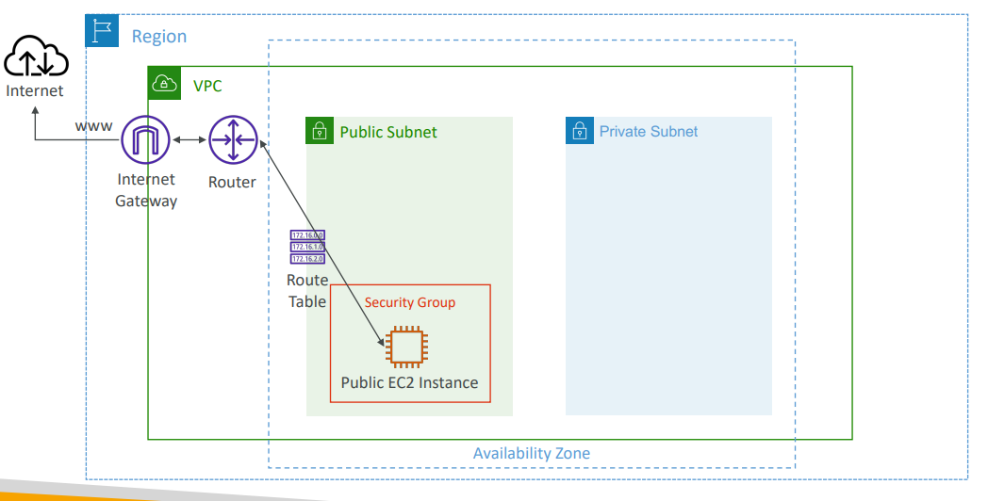

**Bastion Hosts**

|  |  |
| --- | --- |
| * We can use a Bastion Host to SSH into our private EC2 instances * The bastion is in the public subnet which is then connected to all other private subnets * Bastion Host security group must allow inbound from the internet on port 22 from restricted CIDR, for example the public CIDR of your corporation * Security Group of the EC2 Instances must allow the Security Group of the Bastion Host, or the private IP of the Bastion host |  |

**NAT Instance (outdated, but still at the exam)**

|  |  |
| --- | --- |
| * NAT = Network Address Translation * Allows EC2 instances in private subnets to connect to the Internet * Must be launched in a public subnet * Must disable EC2 setting: Source /destination Check * Must have Elastic IP attached to it * Route Tables must be configured to route traffic from private subnets to the NAT Instance |  |

**NAT Instance**

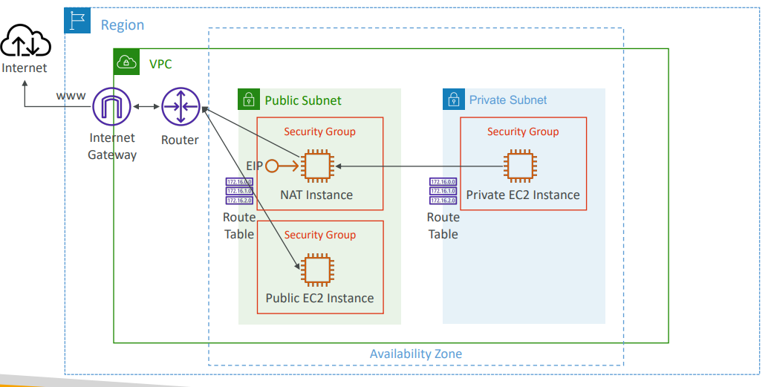

**NAT Instance – Comments**

* Pre-configured Amazon Linux AMI is available
  + Reached the end of standard support on December 31, 2020
* Not highly available / resilient setup out of the box
  + You need to create an ASG in multi-AZ + resilient user-data script
* Internet traffic bandwidth depends on EC2 instance type
* You must manage Security Groups & rules:
* Inbound:
  + Allow HTTP / HTTPS traffic coming from Private Subnets
  + Allow SSH from your home network (access is provided through Internet Gateway)
* Outbound:
  + Allow HTTP / HTTPS traffic to the Internet

**NAT Gateway**

* AWS-managed NAT, higher bandwidth, high availability, no administration
* Pay per hour for usage and bandwidth
* NATGW is created in a specific Availability Zone, uses an Elastic IP
* Can’t be used by EC2 instance in the same subnet (only from other subnets)
* Requires an IGW (Private Subnet => NATGW => IGW)
* 5 Gbps of bandwidth with automatic scaling up to 100 Gbps
* No Security Groups to manage / required

**NAT Gateway**

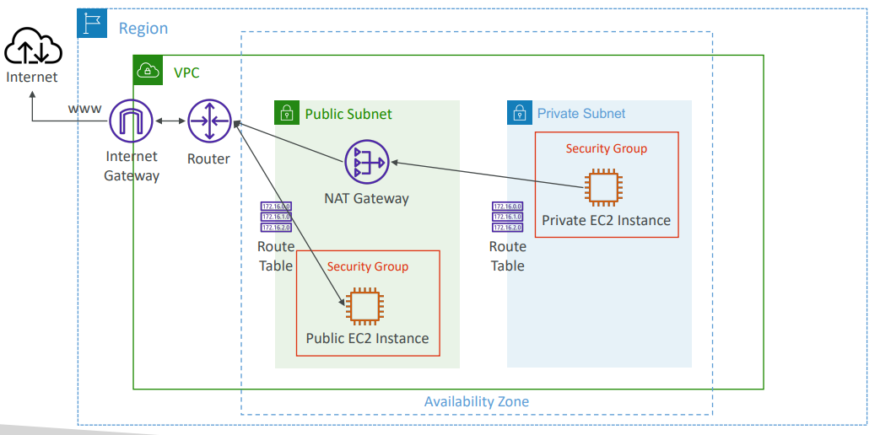

**NAT Gateway with High Availability**

|  |  |
| --- | --- |
| * NAT Gateway is resilient within a single Availability Zone * Must create multiple NAT Gateways in multiple AZs for fault-tolerance * There is no cross-AZ failover needed because if an AZ goes down it doesn't need NAT |  |

**NAT Gateway vs. NAT Instance**

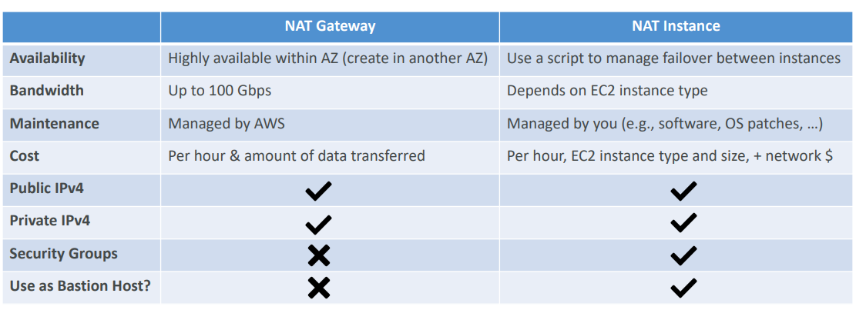

[**https://docs.aws.amazon.com/vpc/latest/userguide/vpc-nat-comparison.html**](https://docs.aws.amazon.com/vpc/latest/userguide/vpc-nat-comparison.html)

**Security Groups & NACLs**

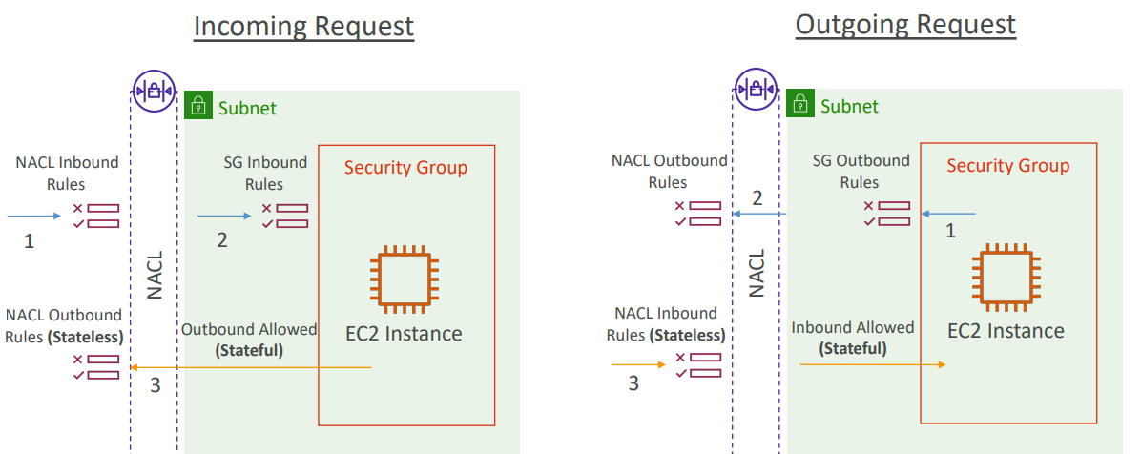

**Network Access Control List (NACL)**

* NACL are like a firewall which control traffic from and to subnets
* One NACL per subnet, new subnets are assigned the Default NACL
* You define NACL Rules:
  + Rules have a number (1-32766), higher precedence with a lower number
  + First rule match will drive the decision
  + Example: if you define #100 ALLOW 10.0.0.10/32 and #200 DENY 10.0.0.10/32, the IP address will be allowed because 100 has a higher precedence over 200
  + The last rule is an asterisk (*) and denies a request in case of no rule match
  + AWS recommends adding rules by increment of 100
* Newly created NACLs will deny everything
* NACL are a great way of blocking a specific IP address at the subnet level

**NACLs**

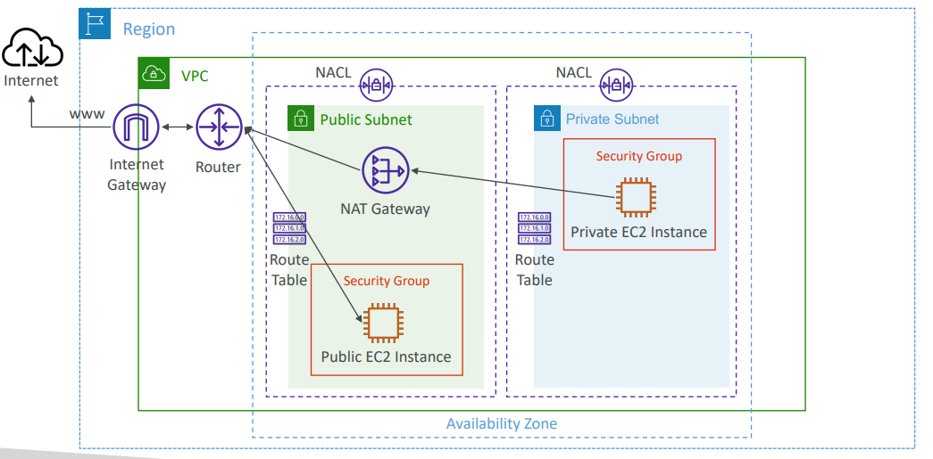

**Default NACL**

* Accepts everything inbound/outbound with the subnets it’s associated with
* Do NOT modify the Default NACL, instead create custom NACLs

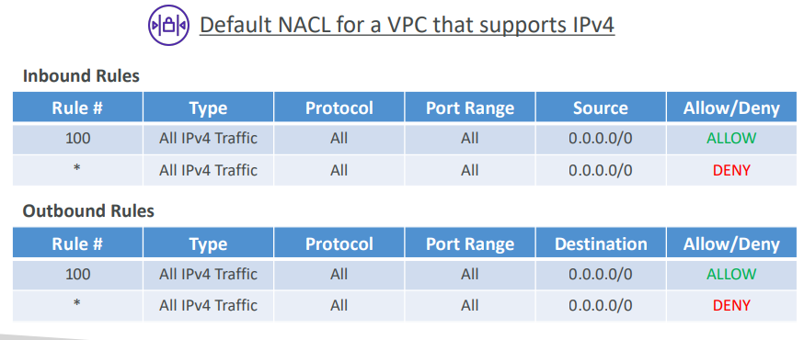

**Ephemeral Ports**

* For any two endpoints to establish a connection, they must use ports
* Clients connect to a defined port, and expect a response on an ephemeral port
* Different Operating Systems use different port ranges, examples:
  + IANA & MS Windows 10 è 49152 – 65535
  + Many Linux Kernels è 32768 – 60999

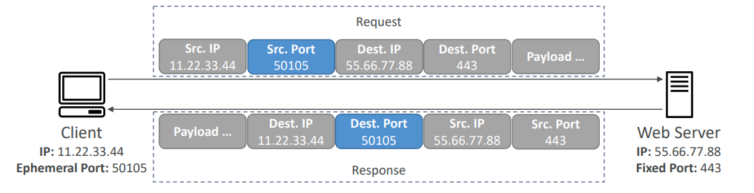

**NACL with Ephemeral Ports**

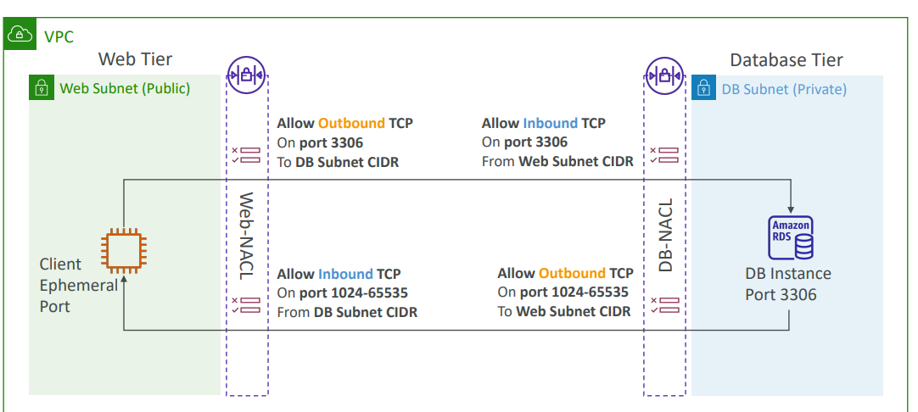

[**https://docs.aws.amazon.com/vpc/latest/userguide/vpc-network-acls.html**](https://docs.aws.amazon.com/vpc/latest/userguide/vpc-network-acls.html)

**Create NACL rules for each target subnets CIDR**

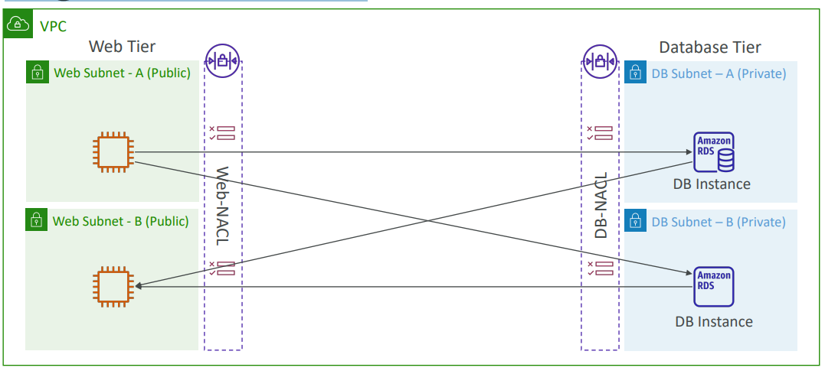

**Security Group vs. NACLs**

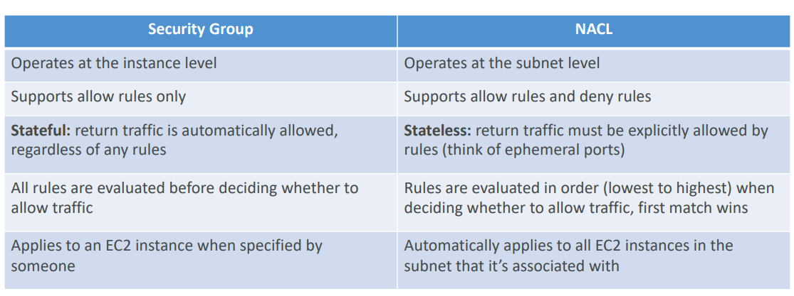

[**https://docs.aws.amazon.com/vpc/latest/userguide/vpc-network-acls.html**](https://docs.aws.amazon.com/vpc/latest/userguide/vpc-network-acls.html)

**VPC Peering**

|  |  |
| --- | --- |
| * Privately connect two VPCs using AWS’ network * Make them behave as if they were in the same network * Must not have overlapping CIDRs * VPC Peering connection is NOT transitive (must be established for each VPC that need to communicate with one another) * You must update route tables in each VPC’s subnets to ensure EC2 instances can communicate with each other |  |

**VPC Peering – Good to know**

* You can create VPC Peering connection between VPCs in different AWS accounts/regions
* You can reference a security group in a peered VPC (works cross accounts – same region)

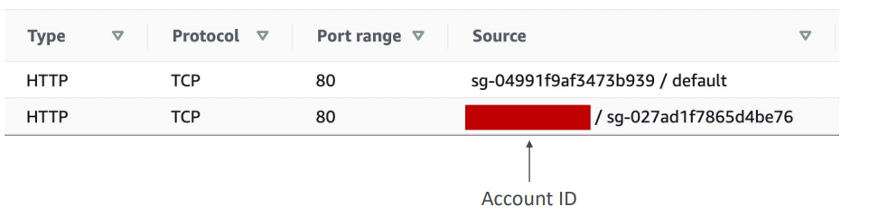

**VPC Peering**

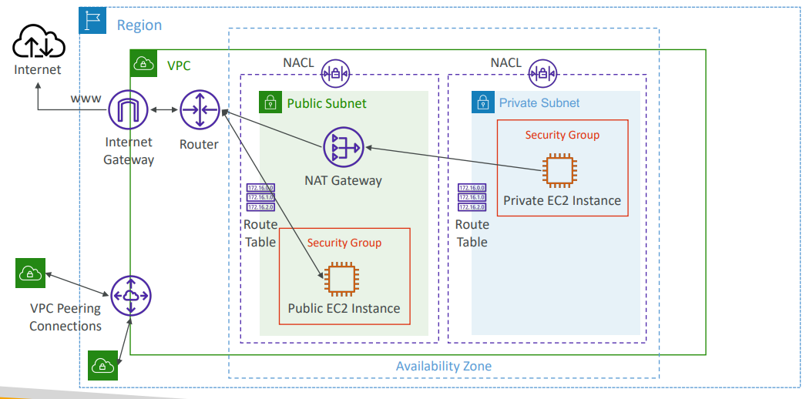

**VPC Endpoints**

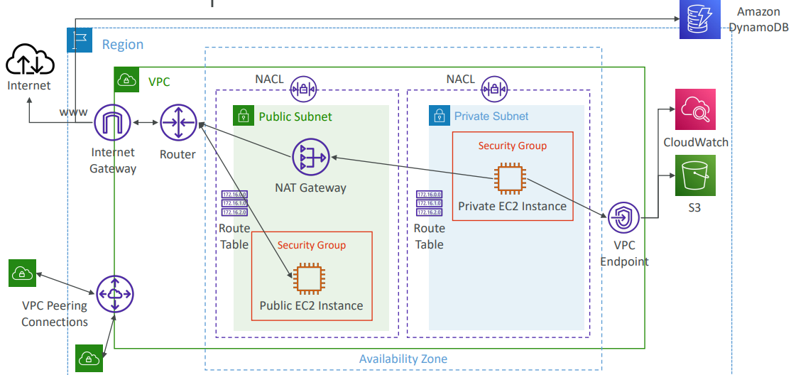

**VPC Endpoints (AWS PrivateLink)**

|  |  |
| --- | --- |
| * Every AWS service is publicly exposed (public URL) * VPC Endpoints (powered by AWS PrivateLink) allows you to connect to AWS services using a private network instead of using the public Internet * They’re redundant and scale horizontally * They remove the need of IGW, NATGW, … to access AWS Services * In case of issues:   + Check DNS Setting Resolution in your VPC   + Check Route Tables |  |

**Types of Endpoints**

* Interface Endpoints (powered by PrivateLink)
  + Provisions an ENI (private IP address) as an entry point (must attach a Security Group)
  + Supports most AWS services
  + $ per hour + $ per GB of data processed
* Gateway Endpoints
  + Provisions a gateway and must be used as a target in a route table (does not use security groups)
  + Supports both S3 and DynamoDB
  + Free

**Gateway or Interface Endpoint for S3?**

|  |  |
| --- | --- |
| * Gateway is most likely going to be preferred all the time at the exam * Cost: free for Gateway, $ for interface endpoint * Interface Endpoint is preferred access is required from onpremises (Site to Site VPN or Direct Connect), a different VPC or a different region |  |

**Lambda in VPC accessing DynamoDB**

|  |  |
| --- | --- |
| * DynamoDB is a public service from AWS * Option 1: Access from the public internet   + Because Lambda is in a VPC, it needs a NAT Gateway in a public subnet and an internet gateway * Option 2 (better & free): Access from the private VPC network   + Deploy a VPC Gateway endpoint for DynamoDB   + Change the Route Tables |  |

**VPC Flow Logs**

* Capture information about IP traffic going into your interfaces:
  + VPC Flow Logs
  + Subnet Flow Logs
  + Elastic Network Interface (ENI) Flow Logs
* Helps to monitor & troubleshoot connectivity issues
* Flow logs data can go to S3, CloudWatch Logs, and Kinesis Data Firehose
* Captures network information from AWS managed interfaces too: ELB, RDS, ElastiCache, Redshift, WorkSpaces, NATGW, Transit Gateway…

**VPC Flow Logs**

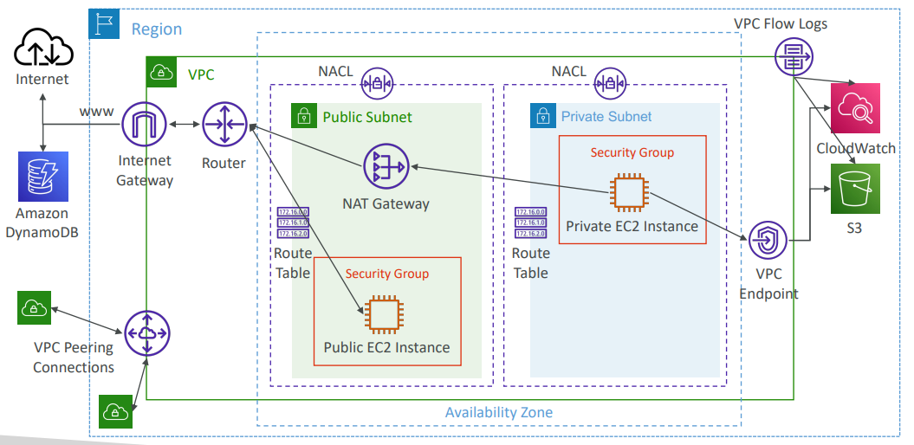

**VPC Flow Logs Syntax**

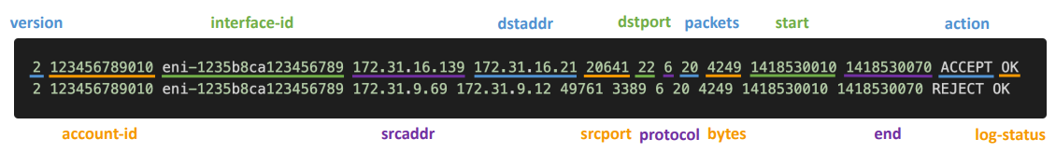

* srcaddr & dstaddr – help identify problematic IP
* srcport & dstport – help identity problematic ports
* Action – success or failure of the request due to Security Group / NACL
* Can be used for analytics on usage patterns, or malicious behavior
* Query VPC flow logs using Athena on S3 or CloudWatch Logs Insights
* Flow Logs examples: https://docs.aws.amazon.com/vpc/latest/userguide/flow-logs- records-examples.html

**VPC Flow Logs –Troubleshoot SG & NACL issues**

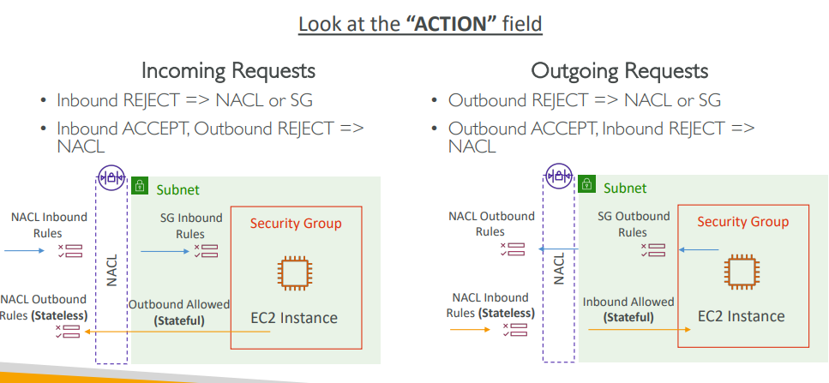

**VPC Flow Logs – Architectures**

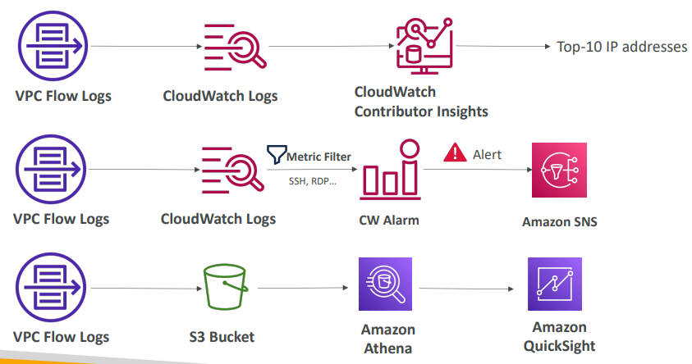

**AWS Site-to-Site VPN**

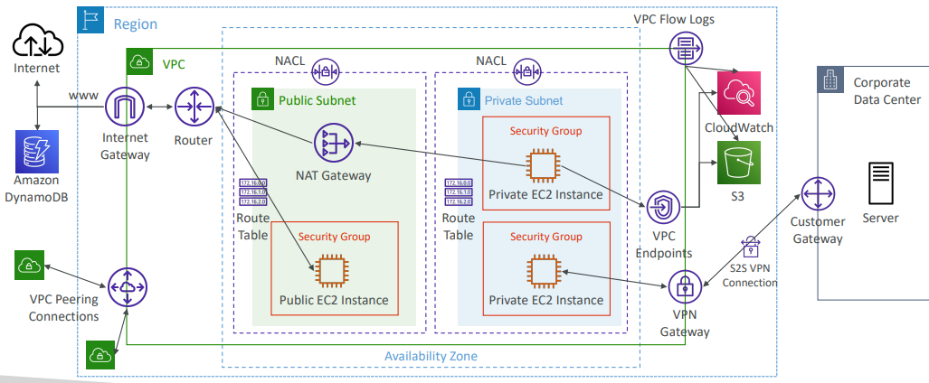

**AWS Site-to-Site VPN**

* Virtual Private Gateway (VGW)
  + VPN concentrator on the AWS side of the VPN connection
  + VGW is created and attached to the VPC from which you want to create the Site-to-Site VPN connection
  + Possibility to customize the ASN (Autonomous System Number)
* Customer Gateway (CGW)
  + Software application or physical device on customer side of the VPN connection
  + <https://docs.aws.amazon.com/vpn/latest/s2svpn/your-cgw.html#DevicesTested>

**Site-to-Site VPN Connections**

|  |  |
| --- | --- |
| * Customer Gateway Device (On-premises)   + What IP address to use?     - Public Internet-routable IP address for your Customer Gateway device     - If it’s behind a NAT device that’s enabled for NAT traversal (NAT-T), use the public IP address of the NAT device * Important step: enable Route Propagation for the Virtual Private Gateway in the route table that is associated with your subnets * If you need to ping your EC2 instances from on-premises, make sure you add the ICMP protocol on the inbound of your security groups |  |

**AWS VPN CloudHub**

|  |  |
| --- | --- |
| * Provide secure communication betweenmultiple sites, if you have multiple VPN connections * Low -cost hub -and -spoke model for primary or secondary network connectivity between different locations (VPN only) * It’s a VPN connection so it goes over the public Internet * To set it up, connect multiple VPN connections on the same VGW, setup dynamic routing and configure route tables |  |

**Direct Connect (DX)**

* Provides a dedicated private connection from a remote network to your VPC
* Dedicated connection must be setup between your DC and AWS Direct Connect locations
* You need to setup a Virtual Private Gateway on your VPC
* Access public resources (S3) and private (EC2) on same connection
* Use Cases:
  + Increase bandwidth throughput - working with large data sets – lower cost
  + More consistent network experience - applications using real-time data feeds
  + Hybrid Environments (on prem + cloud)
* Supports both IPv4 and IPv6

**Direct Connect Diagram**

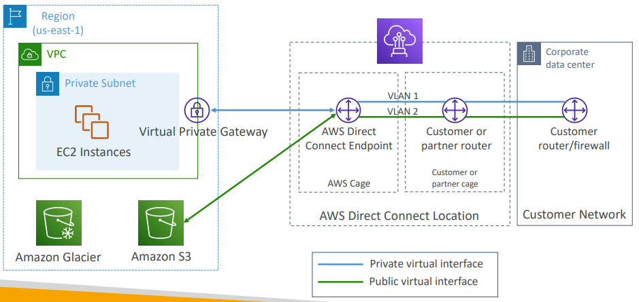

**Direct Connect Gateway**

• If you want to setup a Direct Connect to one or more VPC in many different regions (same account), you must use a Direct Connect Gateway

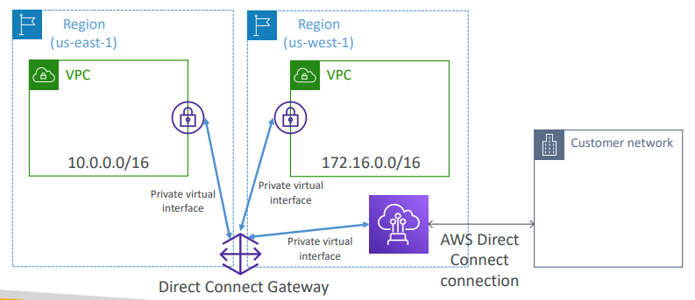

**Direct Connect – Connection Types**

* Dedicated Connections: 1Gbps,10 Gbps and 100 Gbps capacity
  + Physical ethernet port dedicated to a customer
  + Request made to AWS first, then completed by AWS Direct Connect Partners
* Hosted Connections: 50Mbps, 500 Mbps, to 10 Gbps
  + Connection requests are made via AWS Direct Connect Partners
  + Capacity can be added or removed on demand
  + 1, 2, 5, 10 Gbps available at select AWS Direct Connect Partners
* Lead times are often longer than 1 month to establish a new connection

**Direct Connect – Encryption**

|  |  |
| --- | --- |
| * Data in transit is not encrypted but is private * AWS Direct Connect + VPN provides an IPsec-encrypted private connection * Good for an extra level of security, but slightly more complex to put in place |  |

**Direct Connect – Resiliency**

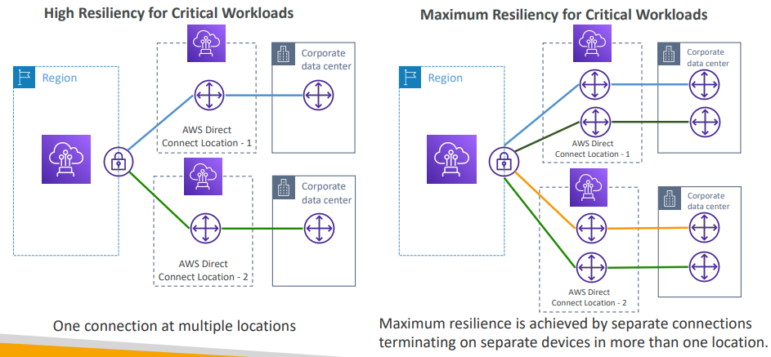

**Site-to-Site VPN connection as a backup**

• In case Direct Connect fails, you can set up a backup Direct Connect connection (expensive), or a Site-to-Site VPN connection

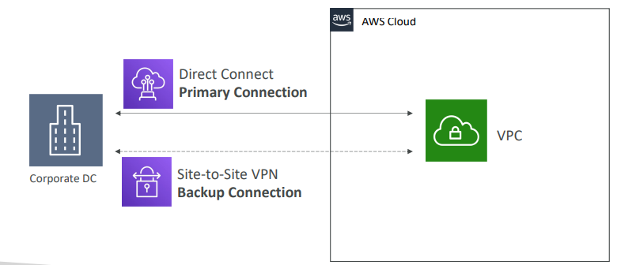

**Network topologies can become complicated**

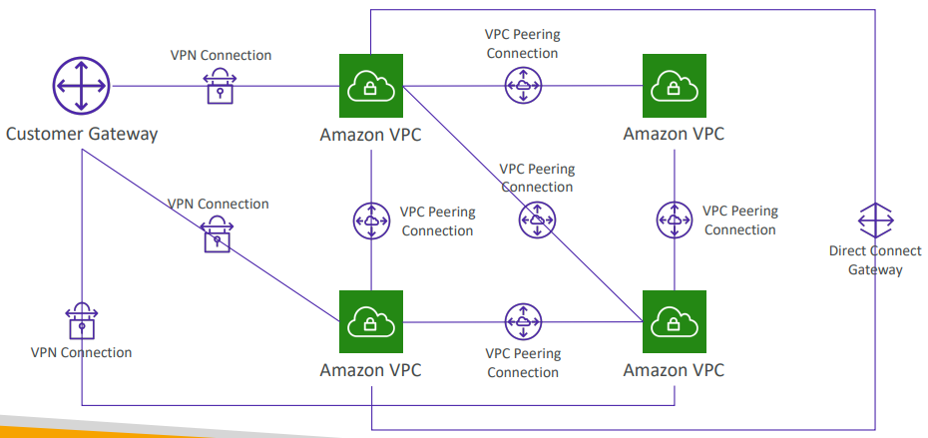

**Transit Gateway**

|  |  |
| --- | --- |
| * For having transitive peering between thousands of VPC and on-premises, hub-and-spoke (star) connection * Regional resource, can work cross-region * Share cross-account using Resource Access Manager (RAM) * You can peer Transit Gateways across regions * Route Tables: limit which VPC can talk with other VPC * Works with Direct Connect Gateway, VPN connections * Supports IP Multicast (not supported by any other AWS service) |  |

**Transit Gateway: Site-to-Site VPN ECMP**

|  |  |
| --- | --- |
| * ECMP = Equal-cost multi-path routing * Routing strategy to allow to forward a packet over multiple best path * Use case: create multiple Siteto-Site VPN connections to increase the bandwidth of your connection to AWS |  |

**Transit Gateway: throughput with ECMP**

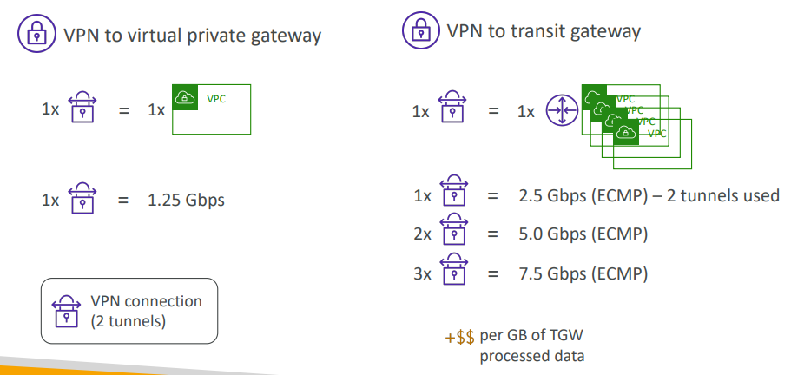

**Transit Gateway – Share Direct Connect between multiple accounts**

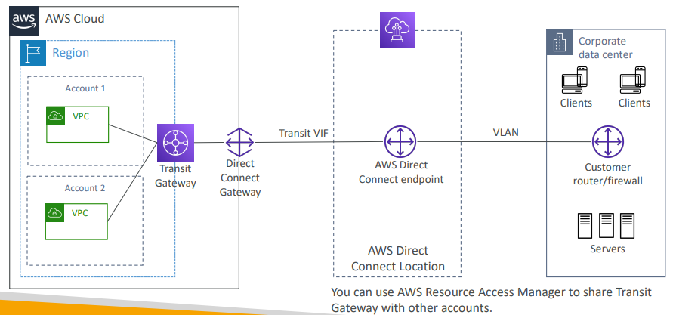

**VPC –Traffic Mirroring**

|  |  |
| --- | --- |
| * Allows you to capture and inspect network traffic in your VPC * Route the traffic to security appliances that you manage * Capture the traffic   + From (Source) – ENIs   + To (Targets) – an ENI or a Network Load Balancer * Capture all packets or capture the packets of your interest (optionally, truncate packets) * Source and Target can be in the same VPC or different VPCs (VPC Peering) * Use cases: content inspection, threat monitoring, troubleshooting, … |  |

**What is IPv6?**

* IPv4 designed to provide 4.3 Billion addresses (they’ll be exhausted soon)
* IPv6 is the successor of IPv4
* IPv6 is designed to provide 3.4 × 10^38 unique IP addresses
* Every IPv6 address in AWS is public and Internet-routable (no private range)
* Format 🡪 x.x.x.x.x.x.x.x (x is hexadecimal, range can be from 0000 to ffff)
* Examples:
  + 2001:db8:3333:4444:5555:6666:7777:8888
  + 2001:db8:3333:4444:cccc:dddd:eeee:ffff
  + :: 🡪 all 8 segments are zero
  + 2001:db8:: 🡪 the last 6 segments are zero
  + ::1234:5678 🡪 the first 6 segments are zero
  + 2001:db8::1234:5678 🡪 the middle 4 segments are zero

**IPv6 in VPC**

|  |  |
| --- | --- |
| * IPv4 cannot be disabled for your VPC and subnets * You can enable IPv6 (they’re public IP addresses) to operate in dual-stack mode * Your EC2 instances will get at least a private internal IPv4 and a public IPv6 * They can communicate using either IPv4 or IPv6 to the internet through an Internet Gateway |  |

**IPv6 Troubleshooting**

|  |  |
| --- | --- |
| * IPv4 cannot be disabled for your VPC and subnets * So, if you cannot launch an EC2 instance in your subnet * It’s not because it cannot acquire an IPv6 (the space is very large) * It’s because there are no available IPv4 in your subnet * Solution: create a new IPv4 CIDR in your subnet |  |

**Egress-only Internet Gateway**

|  |  |
| --- | --- |
| * Used for IPv6 only * (similar to a NAT Gateway but for IPv6) * Allows instances in your VPC outbound connections over IPv6 while preventing the internet to initiate an IPv6 connection to your instances * You must update the Route Tables |  |

**IPv6 Routing**

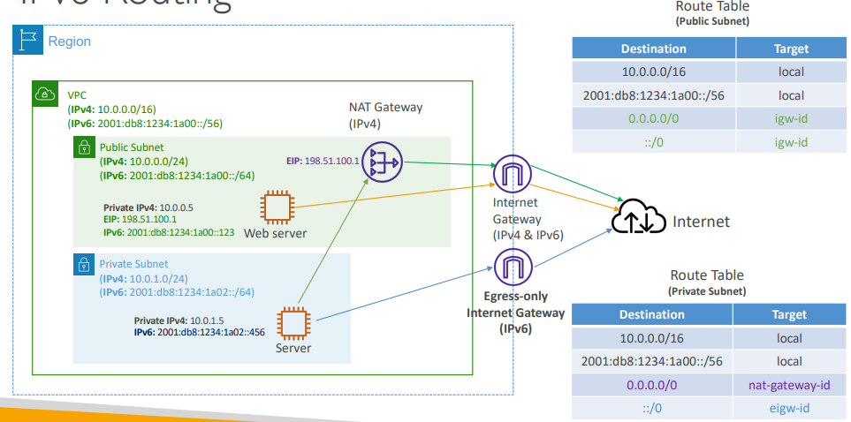

**VPC Section Summary (1/3)**

* CIDR – IP Range
* VPC – Virtual Private Cloud => we define a list of IPv4 & IPv6 CIDR
* Subnets – tied to an AZ, we define a CIDR
* Internet Gateway – at the VPC level, provide IPv4 & IPv6 Internet Access
* Route Tables – must be edited to add routes from subnets to the IGW, VPC Peering Connections, VPC Endpoints, …
* Bastion Host – public EC2 instance to SSH into, that has SSH connectivity to EC2 instances in private subnets
* NAT Instances – gives Internet access to EC2 instances in private subnets. Old, must be setup in a public subnet, disable Source / Destination check flag
* NAT Gateway – managed by AWS, provides scalable Internet access to private EC2 instances, when the target is an IPv4 address

**VPC Section Summary (2/3)**

* NACL – stateless, subnet rules for inbound and outbound, don’t forget Ephemeral Ports
* Security Groups – stateful, operate at the EC2 instance level
* VPC Peering – connect two VPCs with non overlapping CIDR, non-transitive
* VPC Endpoints – provide private access to AWS Services (S3, DynamoDB, CloudFormation, SSM) within a VPC
* VPC Flow Logs – can be setup at the VPC / Subnet / ENI Level, for ACCEPT and REJECT traffic, helps identifying attacks, analyze using Athena or CloudWatch Logs Insights
* Site-to-Site VPN – setup a Customer Gateway on DC, a Virtual Private Gateway on VPC, and site-to-site VPN over public Internet
* AWS VPN CloudHub – hub-and-spoke VPN model to connect your sites

**VPC Section Summary (3/3)**

* Direct Connect – setup a Virtual Private Gateway on VPC, and establish a direct private connection to an AWS Direct Connect Location
* Direct Connect Gateway – setup a Direct Connect to many VPCs in different AWS regions
* AWS PrivateLink / VPC Endpoint Services:
* Connect services privately from your service VPC to customers VPC
* Doesn’t need VPC Peering, public Internet, NAT Gateway, Route Tables
* Must be used with Network Load Balancer & ENI
* ClassicLink – connect EC2-Classic EC2 instances privately to your VPC
* Transit Gateway – transitive peering connections for VPC, VPN & DX
* Traffic Mirroring – copy network traffic from ENIs for further analysis
* Egress-only Internet Gateway – like a NAT Gateway, but for IPv6 targets

**Networking Costs in AWS per GB – Simplified**

* Use Private IP instead of Public IP for good savings and better network performance
* Use same AZ for maximum savings (at the cost of high availability)

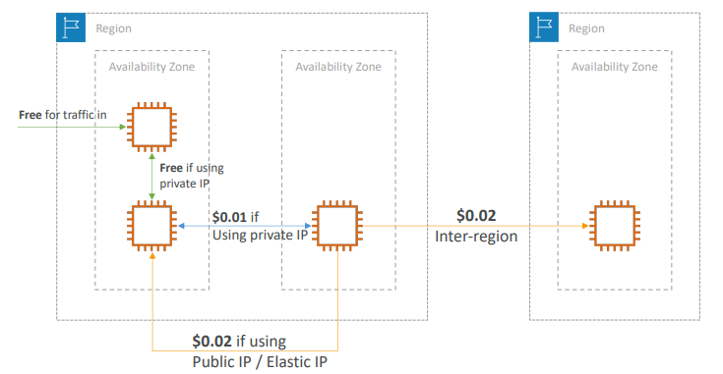

**Minimizing egress traffic network cost**

• Egress traffic: outbound traffic (from AWS to outside)

• Ingress traffic: inbound traffic - from outside to AWS (typically free)

• Try to keep as much internet traffic within AWS to minimize costs

• Direct Connect location that are co-located in the same AWS Region result in lower cost for egress network

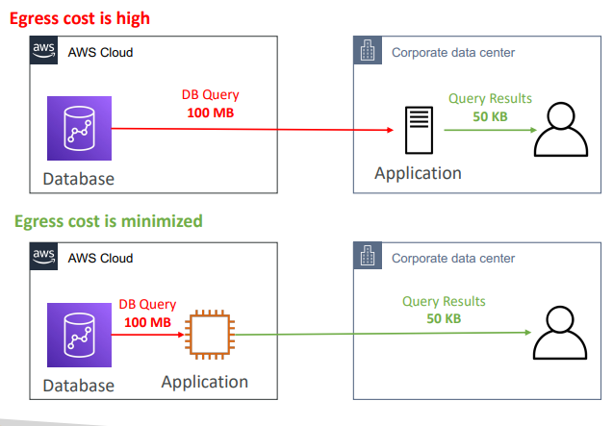

**S3 Data Transfer Pricing – Analysis for USA**

|  |  |
| --- | --- |
| * S3 ingress: free * S3 to Internet: $0.09 per GB * S3 Transfer Acceleration:   + Faster transfer times (50 to 500% better)   + Additional cost on top of Data Transfer   + Pricing: +$0.04 to $0.08 per GB * S3 to CloudFront: $0.00 per GB * CloudFront to Internet: $0.085 per GB (slightly cheaper than S3)   + Caching capability (lower latency)   + Reduce costs associated with S3 Requests Pricing (7x cheaper with CloudFront) * S3 Cross Region Replication: $0.02 per GB |  |

**Pricing: NAT Gateway vs Gateway VPC Endpoint**

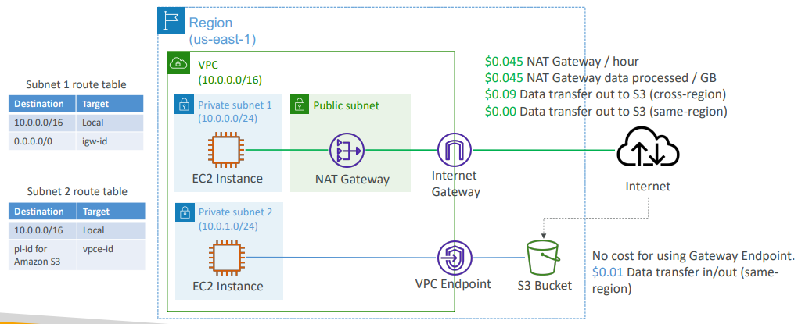

**Network Protection on AWS**

* To protect network on AWS, we’ve seen
  + Network Access Control Lists (NACLs)
  + Amazon VPC security groups
  + AWS WAF (protect against malicious requests)
  + AWS Shield & AWS Shield Advanced
  + AWS Firewall Manager (to manage them across accounts)
* But what if we want to protect in a sophisticated way our entire VPC?

**AWS Network Firewall**

|  |  |
| --- | --- |
| * Protect your entire Amazon VPC * From Layer 3 to Layer 7 protection * Any direction, you can inspect   + VPC to VPC traffic   + Outbound to internet   + Inbound from internet   + To / from Direct Connect & Site-to-Site VPN * Internally, the AWS Network Firewall uses the AWS Gateway Load Balancer * Rules can be centrally managed cross- account by AWS Firewall Manager to apply to many VPCs |  |

**Network Firewall – Fine Grained Controls**

* Supports 1000s of rules
  + IP & port - example: 10,000s of IPs filtering
  + Protocol – example: block the SMB protocol for outbound communications
  + Stateful domain list rule groups: only allow outbound traffic to *.mycorp.com or third-party software repo
  + General pattern matching using regex
* Traffic filtering: Allow, drop, or alert for the traffic that matches the rules
* Active flow inspection to protect against network threats with intrusionprevention capabilities (like Gateway Load Balancer, but all managed by AWS)
* Send logs of rule matches to Amazon S3, CloudWatch Logs, Kinesis Data Firehose

# Disaster Recovery & Migrations

* Any event that has a negative impact on a company’s business continuity or finances is a disaster
* Disaster recovery (DR) is about preparing for and recovering from a disaster
* What kind of disaster recovery?
  + On-premise => On-premise: traditional DR, and very expensive
  + On-premise => AWS Cloud: hybrid recovery
  + AWS Cloud Region A => AWS Cloud Region B
* Need to define two terms:
  + RPO: Recovery Point Objective
  + RTO: Recovery Time Objective

**RPO and RTO**

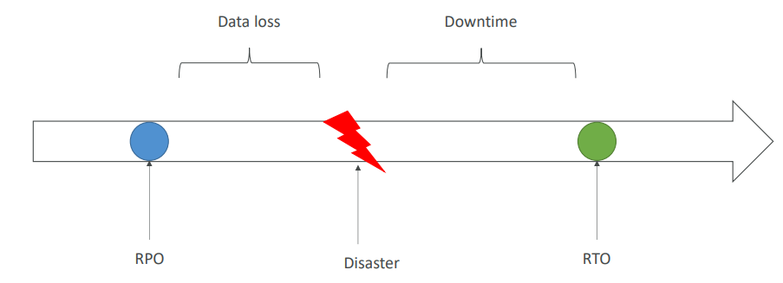

**Disaster Recovery Strategies**

* Backup and Restore
* Pilot Light
* Warm Standby
* Hot Site / Multi Site Approach

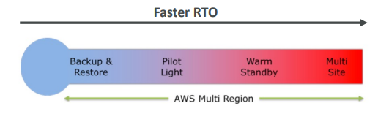

**Backup and Restore (High RPO)**

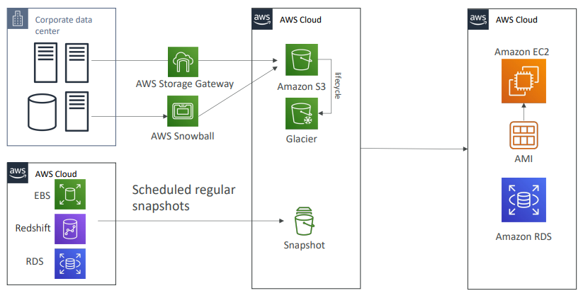

**Disaster Recovery – Pilot Light**

* A small version of the app is always running in the cloud
* Useful for the critical core (pilot light)
* Very similar to Backup and Restore
* Faster than Backup and Restore as critical systems are already up

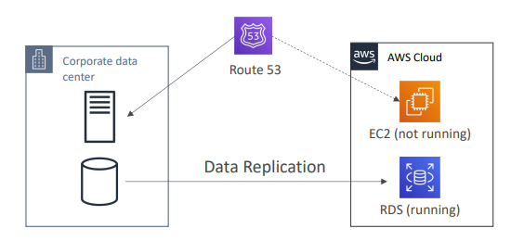

**Warm Standby**

* Full system is up and running, but at minimum size
* Upon disaster, we can scale to production load

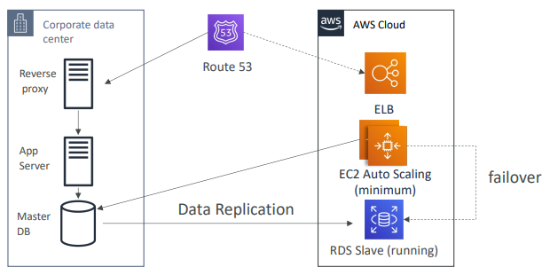

**Multi Site / Hot Site Approach**

* Very low RTO (minutes or seconds) – very expensive
* Full Production Scale is running AWS and On Premis

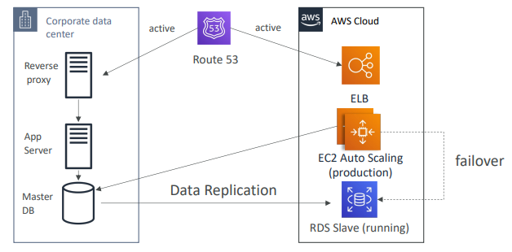

**All AWS Multi Region**

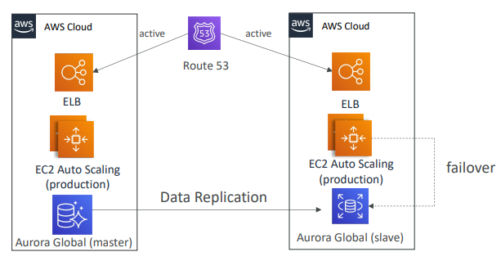

**Disaster Recovery Tips**

* Backup
  + EBS Snapshots, RDS automated backups / Snapshots, etc…
  + Regular pushes to S3 / S3 IA / Glacier, Lifecycle Policy, Cross Region Replication
  + From On-Premise: Snowball or Storage Gateway
* High Availability
  + Use Route53 to migrate DNS over from Region to Region
  + RDS Multi-AZ, ElastiCache Multi-AZ, EFS, S3
  + Site to Site VPN as a recovery from Direct Connect
* Replication
  + RDS Replication (Cross Region), AWS Aurora + Global Databases
  + Database replication from on-premises to RDS
  + Storage Gateway
* Automation
  + CloudFormation / Elastic Beanstalk to re-create a whole new environment
  + Recover / Reboot EC2 instances with CloudWatch if alarms fail
  + AWS Lambda functions for customized automations
* Chaos
  + Netflix has a “simian-army” randomly terminating EC2

**DMS – Database Migration Service**

|  |  |
| --- | --- |
| * Quickly and securely migrate databases to AWS, resilient, self healing * The source database remains available during the migration * Supports:   + Homogeneous migrations: ex Oracle to Oracle   + Heterogeneous migrations: ex Microsoft SQL Server to Aurora * Continuous Data Replication using CDC * You must create an EC2 instance to perform the replication tasks |  |

**DMS Sources and Targets**

|  |  |
| --- | --- |
| SOURCES:   * On-Premises and EC2 instances databases: Oracle, MS SQL Server, MySQL, MariaDB, PostgreSQL, MongoDB, SAP, DB2 * Azure: Azure SQL Database * Amazon RDS: all including Aurora * Amazon S3 * DocumentDB | TARGETS:   * On-Premises and EC2 instances databases: Oracle, MS SQL Server, MySQL, MariaDB, PostgreSQL, SAP * Amazon RDS * Redshift, DynamoDB, S3 * OpenSearch Service * Kinesis Data Streams * Apache Kafka * DocumentDB & Amazon Neptune * Redis & Babelfish |

**AWS Schema Conversion Tool (SCT)**

* Convert your Database’s Schema from one engine to another
* Example OLTP: (SQL Server or Oracle) to MySQL, PostgreSQL, Aurora
* Example OLAP: (Teradata or Oracle) to Amazon Redshift
* Prefer compute-intensive instances to optimize data conversions

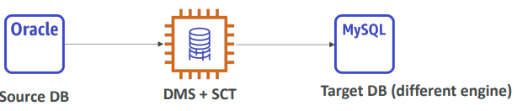

* You do not need to use SCT if you are migrating the same DB engine
  + Ex: On-Premise PostgreSQL => RDS PostgreSQL
  + The DB engine is still PostgreSQL (RDS is the platform)

**DMS - Continuous Replication**

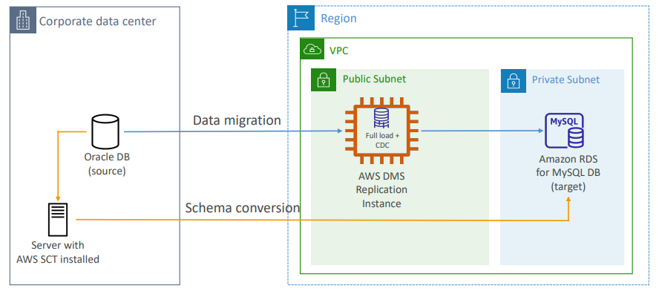

**AWS DMS – Multi-AZ Deployment**

|  |  |
| --- | --- |
| * When Multi-AZ Enabled, DMS provisions and maintains a synchronously stand replica in a different AZ * Advantages:   + Provides Data Redundancy   + Eliminates I/O freezes   + Minimizes latency spikes |  |

**RDS & Aurora MySQL Migrations**

|  |  |
| --- | --- |
| * RDS MySQL to Aurora MySQL   + Option 1: DB Snapshots from RDS MySQL restored as MySQL Aurora DB   + Option 2: Create an Aurora Read Replica from your RDS MySQL, and when the replication lag is 0, promote it as its own DB cluster (can take time and cost $) * External MySQL to Aurora MySQL   + Option 1:     - Use Percona XtraBackup to create a file backup in Amazon S3     - Create an Aurora MySQL DB from Amazon S3   + Option 2:     - Create an Aurora MySQL DB     - Use the mysqldump utility to migrate MySQL into Aurora (slower than S3 method) * Use DMS if both databases are up and running |  |

**RDS & Aurora PostgreSQL Migrations**

|  |  |
| --- | --- |
| * RDS PostgreSQL to Aurora PostgreSQL * Option 1: DB Snapshots from RDS PostgreSQL restored as PostgreSQL Aurora DB * Option 2: Create an Aurora Read Replica from your RDS PostgreSQL, and when the replication lag is 0, promote it as its own DB cluster (can take time and cost $) * External PostgreSQL to Aurora PostgreSQL * Create a backup and put it in Amazon S3 * Import it using the aws_s3 Aurora extension * Use DMS if both databases are up and running |  |

**On -Premise strategy with AWS**

* Ability to download Amazon Linux 2 AMI as a VM (.iso format)
  + VMWare, KVM, VirtualBox (Oracle VM), Microsoft Hyper-V
* VM Import / Export
  + Migrate existing applications into EC2
  + Create a DR repository strategy for your on-premises VMs
  + Can export back the VMs from EC2 to on-premises
* AWS Application Discovery Service
  + Gather information about your on-premises servers to plan a migration
  + Server utilization and dependency mappings
  + Track with AWS Migration Hub
* AWS Database Migration Service (DMS)
  + replicate On-premise => AWS , AWS => AWS, AWS => On-premise
  + Works with various database technologies (Oracle, MySQL, DynamoDB, etc..)
* AWS Server Migration Service (SMS)
  + Incremental replication of on-premises live servers to AWS

**AWS Backup**

* Fully managed service
* Centrally manage and automate backups across AWS services
* No need to create custom scripts and manual processes
* Supported services:
  + Amazon EC2 / Amazon EBS
  + Amazon S3
  + Amazon RDS (all DBs engines) / Amazon Aurora / Amazon DynamoDB
  + Amazon DocumentDB / Amazon Neptune
  + Amazon EFS / Amazon FSx (Lustre & Windows File Server)
  + AWS Storage Gateway (Volume Gateway)
* Supports cross-region backups
* Supports cross-account backups

**AWS Backup**

* Supports PITR for supported services
* On-Demand and Scheduled backups
* Tag-based backup policies
* You create backup policies known as Backup Plans
  + Backup frequency (every 12 hours, daily, weekly, monthly, cron expression)
  + Backup window
  + Transition to Cold Storage (Never, Days, Weeks, Months, Years)
  + Retention Period (Always, Days, Weeks, Months, Years)

**AWS Backup**

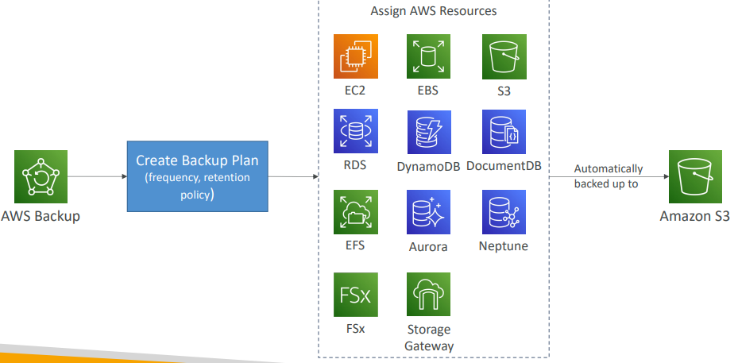

**AWS Backup Vault Lock**

|  |  |
| --- | --- |
| * Enforce a WORM (Write Once Read Many) state for all the backups that you store in your AWS Backup Vault * Additional layer of defense to protect your backups against:   + Inadvertent or malicious delete operations   + Updates that shorten or alter retention periods * Even the root user cannot delete backups when enabled |  |

**AWS Application Discovery Service**

* Plan migration projects by gathering information about on-premises data centers
* Server utilization data and dependency mapping are important for migrations
* Agentless Discovery (AWS Agentless Discovery Connector)
  + VM inventory, configuration, and performance history such as CPU, memory, and disk usage
* Agent-based Discovery (AWS Application Discovery Agent)
  + System configuration, system performance, running processes, and details of the network connections between systems
* Resulting data can be viewed within AWS Migration Hub

**AWS Application Migration Service (MGN)**

* The “AWS evolution” of CloudEndure Migration, replacing AWS Server Migration Service (SMS)
* Lift-and-shift (rehost) solution which simplify migrating applications to AWS
* Converts your physical, virtual, and cloud-based servers to run natively on AWS
* Supports wide range of platforms, Operating Systems, and databases
* Minimal downtime, reduced costs

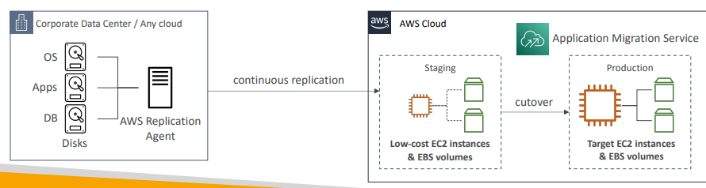

**VMware Cloud on AWS**

* Some customers use VMware Cloud to manage their on-premises Data Center
* They want to extend the Data Center capacity to AWS, but keep using the VMware Cloud software
* …Enter VMware Cloud on AWS
* Use cases
  + Migrate your VMware vSphere-based workloads to AWS
  + Run your production workloads across VMware vSphere-based private, public, and hybrid cloud environments
  + Have a disaster recover strategy

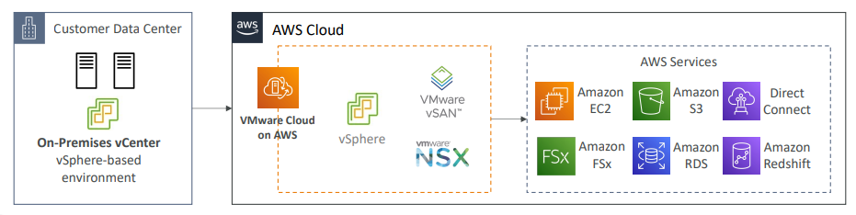

**Transferring large amount of data into AWS**

* Example: transfer 200 TB of data in the cloud. We have a 100 Mbps internet connection.
* Over the internet / Site-to-Site VPN:
  + Immediate to setup
  + Will take 200(TB)*1000(GB)*1000(MB)*8(Mb)/100 Mbps = 16,000,000s = 185d
* Over direct connect 1Gbps:
  + Long for the one-time setup (over a month)
  + Will take 200(TB)*1000(GB)*8(Gb)/1 Gbps = 1,600,000s = 18.5d
* Over Snowball:
  + Will take 2 to 3 snowballs in parallel
  + Takes about 1 week for the end-to-end transfer
  + Can be combined with DMS
* For on-going replication / transfers: Site-to-Site VPN or DX with DMS or DataSync

# More Solutions Architecture

**Lambda, SNS & SQS**

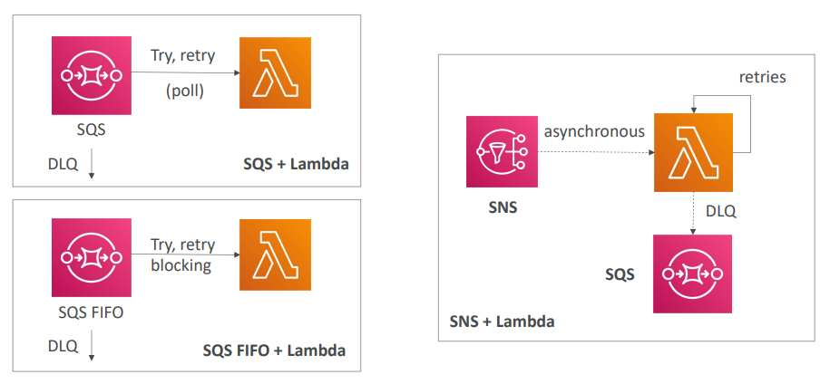

**Fan Out Pattern: deliver to multiple SQS**

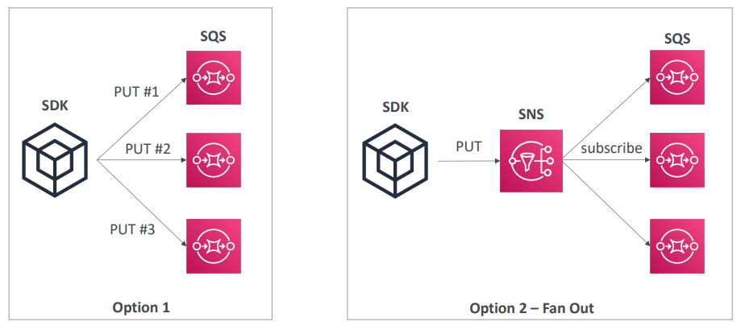

**S3 Event Notifications**

|  |  |
| --- | --- |
| * S3:ObjectCreated, S3:ObjectRemoved, S3:ObjectRestore, S3:Replication… * Object name filtering possible (*.jpg) * Use case: generate thumbnails of images uploaded to S3 * Can create as many “S3 events” as desired * S3 event notifications typically deliver events in seconds but can sometimes take a minute or longer |  |

**S3 Event Notifications with Amazon EventBridge**

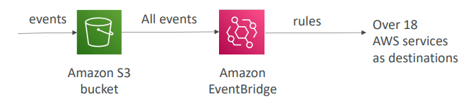

* Advanced filtering options with JSON rules (metadata, object size, name...)
* Multiple Destinations – ex Step Functions, Kinesis Streams / Firehose…
* EventBridge Capabilities – Archive, Replay Events, Reliable delivery

**Amazon EventBridge – Intercept API Calls**

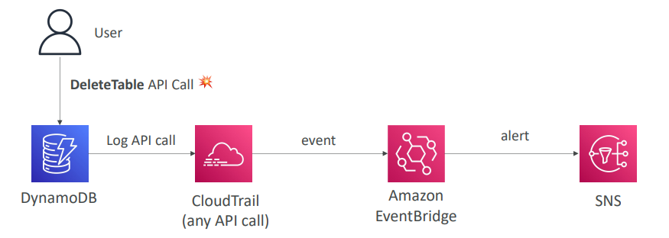

**API Gateway – AWS Service Integration Kinesis Data Streams example**

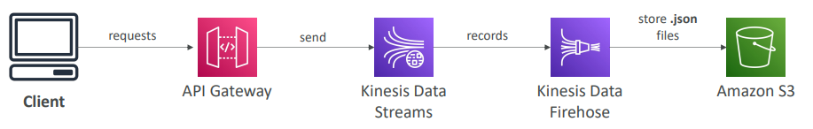

**Caching Strategies**

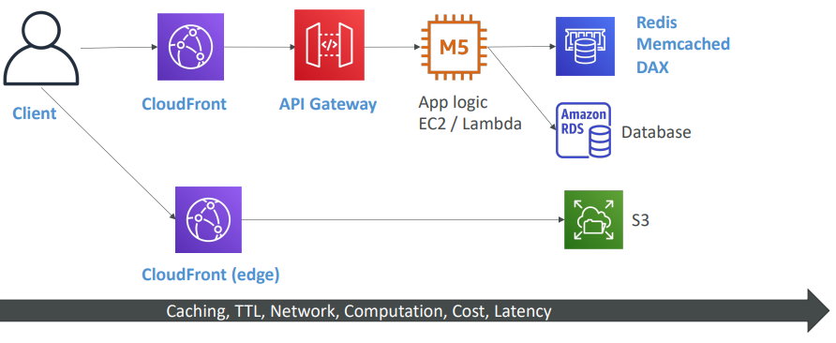

**Blocking an IP address**

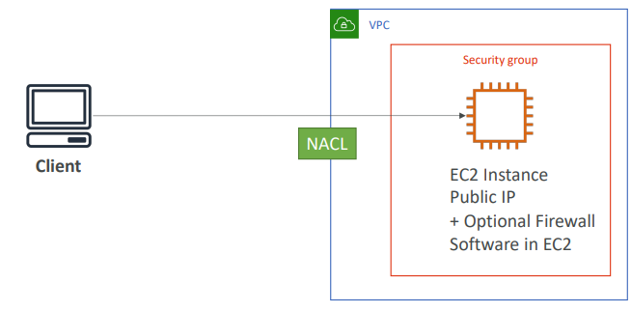

**Blocking an IP address – with an ALB**

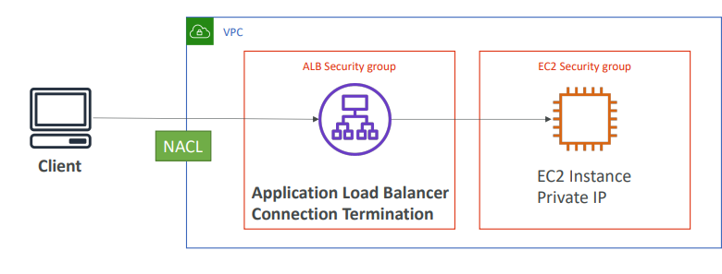

**Blocking an IP address – with an NLB**

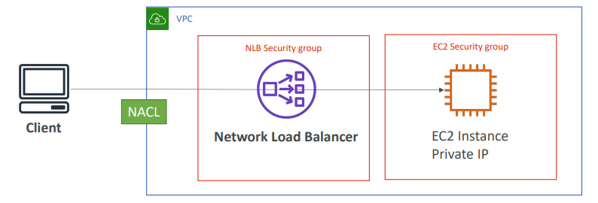

**Blocking an IP address – ALB + WAF**

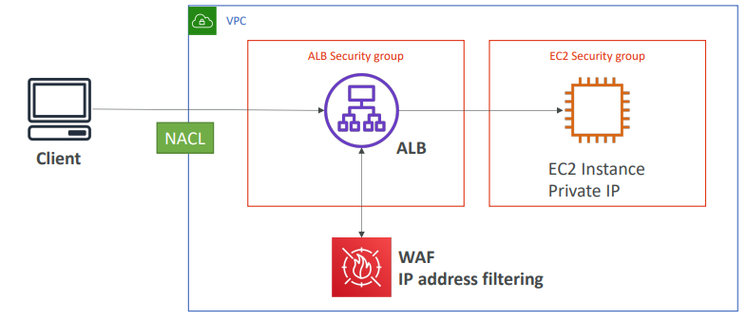

**Blocking an IP address – ALB, CloudFront WAF**

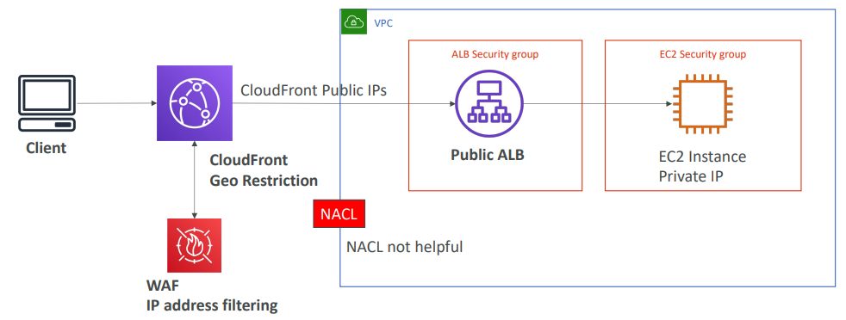

**High Performance Computing (HPC)**

* The cloud is the perfect place to perform HPC
* You can create a very high number of resources in no time
* You can speed up time to results by adding more resources
* You can pay only for the systems you have used
* Perform genomics, computational chemistry, financial risk modeling, weather prediction, machine learning, deep learning, autonomous driving
* Which services help perform HPC?

**Data Management & Transfer**

* AWS Direct Connect:
  + Move GB/s of data to the cloud, over a private secure network
* Snowball & Snowmobile
  + Move PB of data to the cloud
* AWS DataSync
  + Move large amount of data between on-premises and S3, EFS, FSx for Windows

**Compute and Networking**

* EC2 Instances:
  + CPU optimized, GPU optimized
  + Spot Instances / Spot Fleets for cost savings + Auto Scaling
* EC2 Placement Groups: Cluster for good network performance

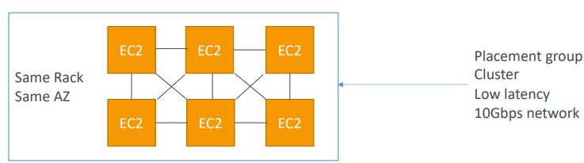

**Compute and Networking**

* EC2 Enhanced Networking (SR-IOV)
  + Higher bandwidth, higher PPS (packet per second), lower latency
  + Option 1: Elastic Network Adapter (ENA) up to 100 Gbps
  + Option 2: Intel 82599 VF up to 10 Gbps – LEGACY
* Elastic Fabric Adapter (EFA)
  + Improved ENA for HPC, only works for Linux
  + Great for inter-node communications, tightly coupled workloads
  + Leverages Message Passing Interface (MPI) standard
  + Bypasses the underlying Linux OS to provide low-latency, reliable transport

**Storage**

* Instance-attached storage:
  + EBS: scale up to 256,000 IOPS with io2 Block Express
  + Instance Store: scale to millions of IOPS, linked to EC2 instance, low latency
* Network storage:
  + Amazon S3: large blob, not a file system
  + Amazon EFS: scale IOPS based on total size, or use provisioned IOPS
  + Amazon FSx for Lustre:
    - HPC optimized distributed file system, millions of IOPS
    - Backed by S3

**Automation and Orchestration**

* AWS Batch
  + AWS Batch supports multi-node parallel jobs, which enables you to run single jobs that span multiple EC2 instances.
  + Easily schedule jobs and launch EC2 instances accordingly
* AWS ParallelCluster
  + Open-source cluster management tool to deploy HPC on AWS
  + Configure with text files
  + Automate creation of VPC, Subnet, cluster type and instance types
  + Ability to enable EFA on the cluster (improves network performance)

**Creating a highly available EC2 instance**

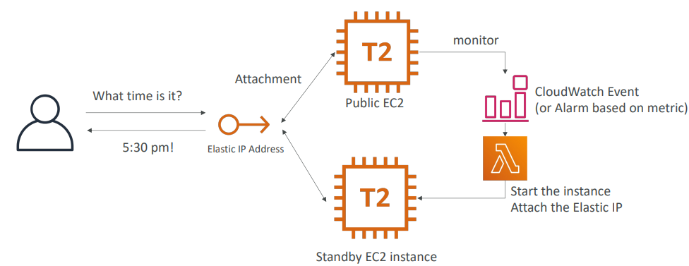

**Creating a highly available EC2 instance With an Auto Scaling Group**

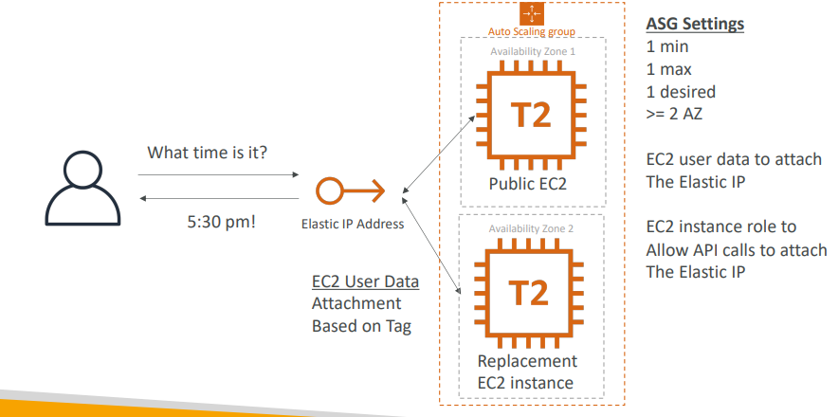

**Creating a highly available EC2 instance With ASG + EBS**

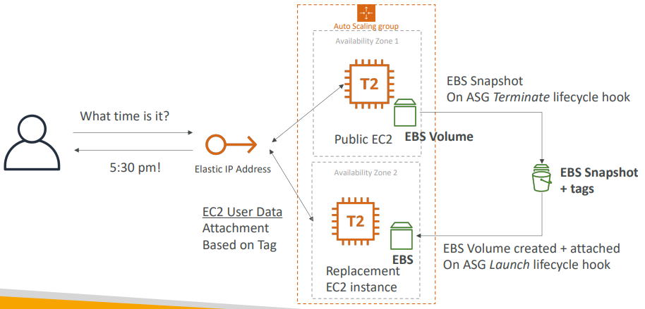

# Other Services

What is CloudFormation

* CloudFormation is a declarative way of outlining your AWS Infrastructure, for any resources (most of them are supported).
* For example, within a CloudFormation template, you say:
  + I want a security group
  + I want two EC2 instances using this security group
  + I want an S3 bucket
  + I want a load balancer (ELB) in front of these machines
* Then CloudFormation creates those for you, in the right order, with the exact configuration that you specify

**Benefits of AWS CloudFormation (1/2)**

* Infrastructure as code
  + No resources are manually created, which is excellent for control
  + Changes to the infrastructure are reviewed through code
* Cost
  + Each resources within the stack is tagged with an identifier so you can easily see how much a stack costs you
  + You can estimate the costs of your resources using the CloudFormation template
  + Savings strategy: In Dev, you could automation deletion of templates at 5 PM and recreated at 8 AM, safely

**Benefits of AWS CloudFormation (2/2)**

* Productivity
  + Ability to destroy and re-create an infrastructure on the cloud on the fly
  + Automated generation of Diagram for your templates!
  + Declarative programming (no need to figure out ordering and orchestration)
* Don’t re-invent the wheel
  + Leverage existing templates on the web!
  + Leverage the documentation
* Supports (almost) all AWS resources:
  + Everything we’ll see in this course is supported
  + You can use “custom resources” for resources that are not supported

**CloudFormation + Application Composer**

* Example: WordPress CloudFormation Stack
* We can see all the resources
* We can see the relations between the components

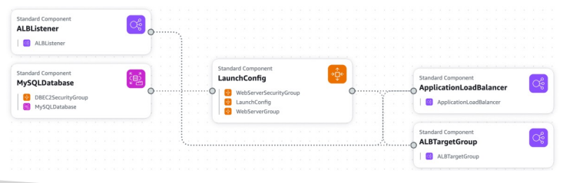 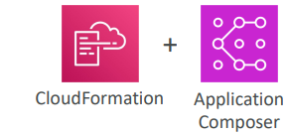

**CloudFormation – Service Role**

|  |  |
| --- | --- |
| * IAM role that allows CloudFormation to create/update/delete stack resources on your behalf * Give ability to users to create/update/delete the stack resources even if they don’t have permissions to work with the resources in the stack * Use cases: * You want to achieve the least privilege principle * But you don’t want to give the user all the required permissions to create the stack resources * User must have iam:PassRole permissions |  |

**Amazon Simple Email Service (Amazon SES)**

|  |  |
| --- | --- |
| * Fully managed service to send emails securely, globally and at scale * Allows inbound/outbound emails * Reputation dashboard, performance insights, anti-spam feedback * Provides statistics such as email deliveries, bounces, feedback loop results, email open * Supports DomainKeys Identified Mail (DKIM) and Sender Policy Framework (SPF) * Flexible IP deployment: shared, dedicated, and customer-owned IPs * Send emails using your application using AWS Console, APIs, or SMTP * Use cases: transactional, marketing and bulk email communications |  |

**Amazon Pinpoint**

|  |  |
| --- | --- |
| * Scalable 2-way (outbound/inbound) marketing communications service * Supports email, SMS, push, voice, and in-app messaging * Ability to segment and personalize messages with the right content to customers * Possibility to receive replies * Scales to billions of messages per day * Use cases: run campaigns by sending marketing, bulk, transactional SMS messages * Versus Amazon SNS or Amazon SES   + In SNS & SES you managed each message's audience, content, and delivery schedule   In Amazon Pinpoint, you create message templates, delivery schedules, highly-targeted segments, and full campaigns |  |

**Systems Manager – SSM Session Manager**

|  |  |
| --- | --- |
| • Allows you to start a secure shell on your EC2 and on-premises servers  • No SSH access, bastion hosts, or SSH keys needed  • No port 22 needed (better security)  • Supports Linux, macOS, and Windows  • Send session log data to S3 or CloudWatch Logs |  |

**Systems Manager – Run Command**

|  |  |
| --- | --- |
| • Execute a document (= script) or just run a command  • Run command across multiple instances (using resource groups)  • No need for SSH  • Command Output can be shown in the AWS Console, sent to S3 bucket or CloudWatch Logs  • Send notifications to SNS about command status (In progress, Success, Failed, …)  • Integrated with IAM & CloudTrail  • Can be invoked using EventBridge |  |

**Systems Manager – Patch Manager**

|  |  |
| --- | --- |
| * Automates the process of patching managed instances * OS updates, applications updates, security updates * Supports EC2 instances and on-premises servers * Supports Linux, macOS, and Windows * Patch on-demand or on a schedule using Maintenance Windows * Scan instances and generate patch compliance report (missing patches) |  |

**Systems Manager – Maintenance Windows**

* Defines a schedule for when to perform actions on your instances
* Example: OS patching, updating drivers, installing software, …
* Maintenance Window contains
  + Schedule
  + Duration
  + Set of registered instances
  + Set of registered tasks

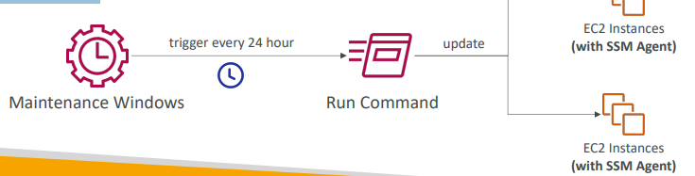-.l,

**Systems Manager – Automation**

|  |  |
| --- | --- |
| * Simplifies common maintenance and deployment tasks of EC2 instances and other AWS resources * Examples: restart instances, create an AMI, EBS snapshot * Automation Runbook – SSM Documents to define actions preformed on your EC2 instances or AWS resources (pre-defined or * custom) * Can be triggered using: * Manually using AWS Console, AWS CLI or SDK * Amazon EventBridge * On a schedule using Maintenance Windows * By AWS Config for rules remediations |  |

**Cost Explorer**

* Visualize, understand, and manage your AWS costs and usage over time
* Create custom reports that analyze cost and usage data.
* Analyze your data at a high level: total costs and usage across all accounts
* Or Monthly, hourly, resource level granularity
* Choose an optimal Savings Plan (to lower prices on your bill)
* Forecast usage up to 12 months based on previous usage

**Cost Explorer – Monthly Cost by AWS Service**

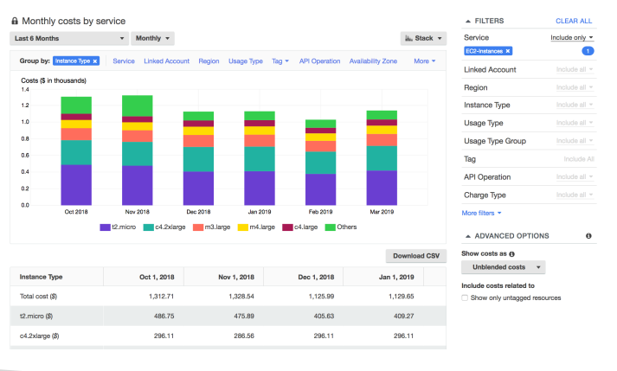

**Cost Explorer– Hourly & Resource Level**

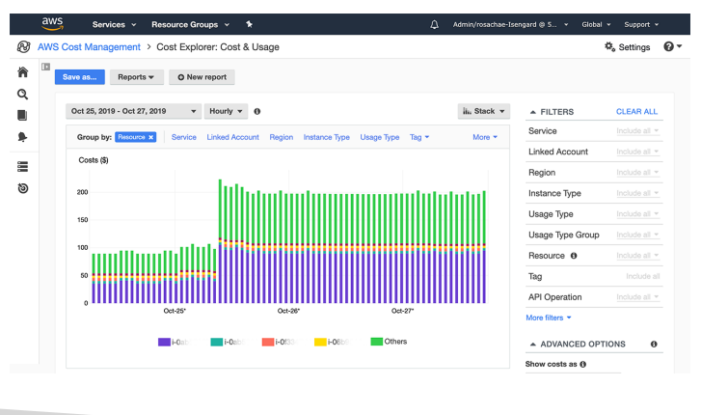

**Cost Explorer – Savings Plan Alternative to Reserved Instances**

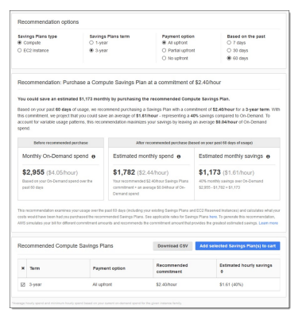

**Cost Explorer – Forecast Usage**

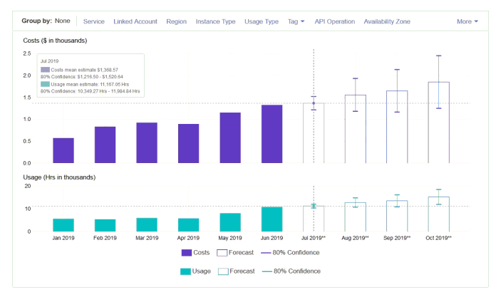

**AWS Cost Anomaly Detection**

* Continuously monitor your cost and usage using ML to detect unusual spends
* It learns your unique, historic spend patterns to detect one-time cost spike and/or continuous cost increases (you don’t need to define thresholds)
* Monitor AWS services, member accounts, cost allocation tags, or cost categories
* Sends you the anomaly detection report with root-cause analysis
* Get notified with individual alerts or daily/weekly summary (using SNS)

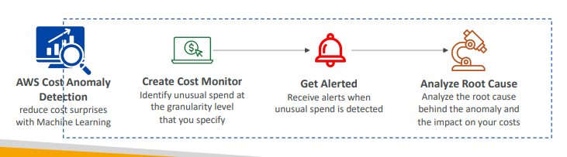

**AWS Outposts**

|  |  |
| --- | --- |
| * Hybrid Cloud: businesses that keep an on - premises infrastructure alongside a cloud infrastructure * Therefore, two ways of dealing with IT systems:   + One for the AWS cloud (using the AWS console, CLI, and AWS APIs)   + One for their on -premises infrastructure * AWS Outposts are “server racks” that offers the same AWS infrastructure, services, APIs & tools to build your own applications on-premises just as in the cloud * AWS will setup and manage “Outposts Racks” within your on -premises infrastructure and you can start leveraging AWS services on-premises * You are responsible for the Outposts Rack physical security |  |

**AWS Outposts**

* Benefits:
  + Low-latency access to on-premises systems
  + Local data processing
  + Data residency
  + Easier migration from on-premises to the cloud
  + Fully managed service
* Some services that work on Outposts:

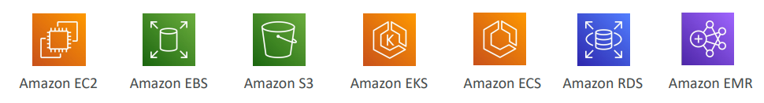

**AWS Batch**

* Fully managed batch processing at any scale
* Efficiently run 100,000s of computing batch jobs on AWS
* A “batch” job is a job with a start and an end (opposed to continuous)
* Batch will dynamically launch EC2 instances or Spot Instances
* AWS Batch provisions the right amount of compute / memory
* You submit or schedule batch jobs and AWS Batch does the rest!
* Batch jobs are defined as Docker images and run on ECS
* Helpful for cost optimizations and focusing less on the infrastructure

**AWS Batch – Simplified Example**

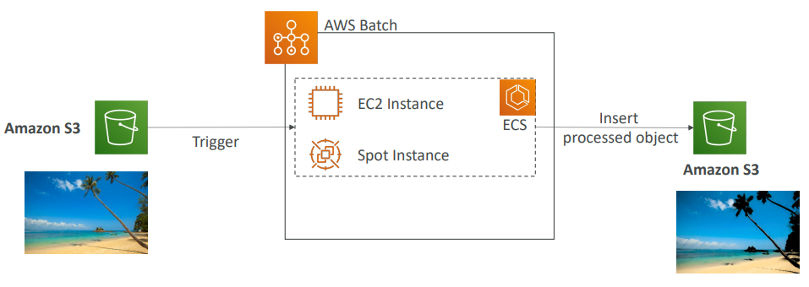

**Batch vs Lambda**

|  |  |
| --- | --- |
| * Lambda:   + Time limit   + Limited runtimes   + Limited temporary disk space   + Serverless * Batch:   + No time limit   + Any runtime as long as it’s packaged as a Docker image   + Rely on EBS / instance store for disk space   + Relies on EC2 (can be managed by AWS) |  |

**Amazon AppFlow**

* Fully managed integration service that enables you to securely transfer data between Software-as-a-Service (SaaS) applications and AWS
* Sources: Salesforce, SAP, Zendesk, Slack, and ServiceNow
* Destinations: AWS services like Amazon S3, Amazon Redshift or nonAWS such as SnowFlake and Salesforce
* Frequency: on a schedule, in response to events, or on demand
* Data transformation capabilities like filtering and validation
* Encrypted over the public internet or privately over AWS PrivateLink
* Don’t spend time writing the integrations and leverage APIs immediately

**AWS Amplify - web and mobile applications**

* A set of tools and services that helps you develop and deploy scalable full stack web and mobile applications
* Authentication, Storage, API (REST, GraphQL), CI/CD, PubSub, Analytics, AI/ML Predictions, Monitoring, …
* Connect your source code from GitHub, AWS CodeCommit, Bitbucket, GitLab, or upload directly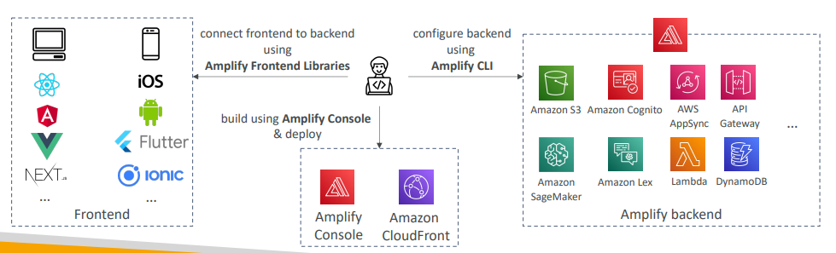

**Instance Scheduler on AWS**

* AWS solution deployed through CloudFormation (not a service)
* Automatically start/stop your AWS services to reduce costs (up to 70%) • Example: stop company’s EC2 instances outside
* business hours
* Supports EC2 instances, EC2 Auto Scaling Groups, and RDS instances
* Schedules are managed in a DynamoDB table • Uses resources’ tags and Lambda to stop/start instances
* Supports cross -account and cross -region resources
* <https://aws.amazon.com/solutions/implementations/instance-scheduler-on-aws/>

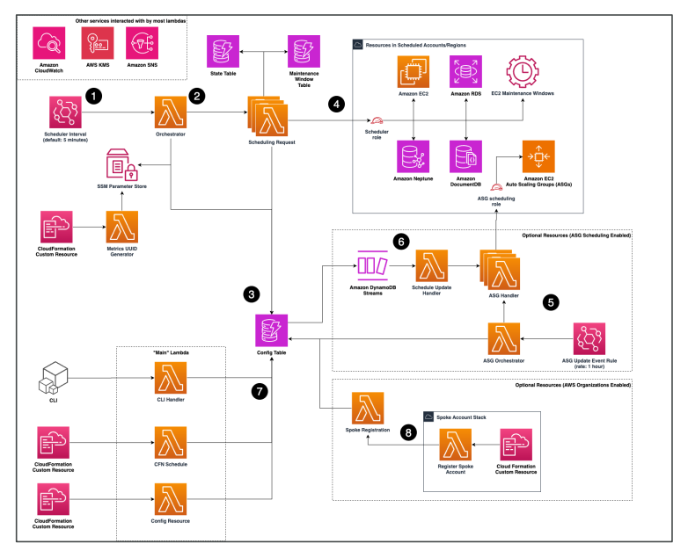

# White Papers & Architectures

Section Overview

• Well Architected Framework Whitepaper

• Well Architected Tool

• AWS Trusted Advisor

• Reference architectures resources (for real -world)

• Disaster Recovery on AWS Whitepaper

**Well Architected Framework General Guiding Principles**

* <https://aws.amazon.com/architecture/well-architected>
* Stop guessing your capacity needs
* Test systems at production scale
* Automate to make architectural experimentation easier
* Allow for evolutionary architectures
* Design based on changing requirements
* Drive architectures using data
* Improve through game days
* Simulate applications for flash sale days

**Well Architected Framework 6 Pillars**

* 1) Operational Excellence
* 2) Security
* 3) Reliability
* 4) Performance Efficiency
* 5) Cost Optimization
* 6) Sustainability

• They are not something to balance, or trade-offs, they’re a synergy

**AWS Well-Architected Tool**

* Free tool to review your architectures against the 6 pillars Well-Architected Framework and adopt architectural best practices
* How does it work?
  + Select your workload and answer questions
  + Review your answers against the 6 pillars
  + Obtain advice: get videos and documentations, generate a report, see the results in a dashboard
* Let’s have a look: <https://console.aws.amazon.com/wellarchitected>

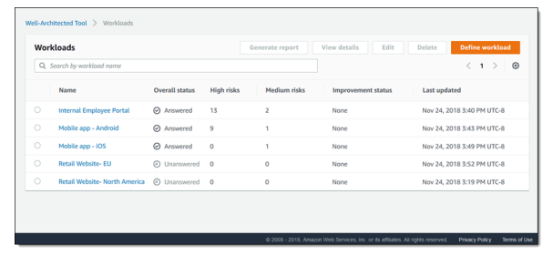

<https://aws.amazon.com/blogs/aws/new-aws-well-architected-tool-review-workloads-against-best-practices/>

**Trusted Advisor**

|  |  |
| --- | --- |
| * No need to install anything – high level AWS account assessment * Analyze your AWS accounts and provides recommendation on 6 categories:   + Cost optimization   + Performance   + Security   + Fault tolerance   + Service limits   + Operational Excellence * Business & Enterprise Support plan * Full Set of Checks * Programmatic Access using AWS Support API |  |

**More Architecture Examples**

* We’ve explored the most important architectural patterns:
  + Classic: EC2, ELB, RDS, ElastiCache, etc…
  + Serverless: S3, Lambda, DynamoDB, CloudFront, API Gateway, etc…
* If you want to see more AWS architectures:
* https://aws.amazon.com/architecture/
* <https://aws.amazon.com/solutions/>

# Exam Review & Tips

**State of learning checkpoint**

* Let’s look how far we’ve gone on our learning journey
* <https://aws.amazon.com/certification/certified-solutions-architectassociate/>

**Practice makes perfect**

* If you’re new to AWS, take a bit of AWS practice thanks to this course before rushing to the exam
* The exam recommends you to have one or more years of hands-on experience on AWS
* Practice makes perfect!
* If you feel overwhelmed by the amount of knowledge you just learned, just go through it one more time

**Proceed by elimination+**

* Most questions are going to be scenario based
* For all the questions, rule out answers that you know for sure are wrong
* For the remaining answers, understand which one makes the most sense
* There are very few trick questions
* Don’t over-think it
* If a solution seems feasible but highly complicated, it’s probably wrong

**Skim the AWS Whitepapers**

* You can read about some AWS White Papers here:
* Architecting for the Cloud: AWS Best Practices
* AWS Well-Architected Framework
* AWS Disaster Recovery (https://aws.amazon.com/disaster-recovery/)
* Overall we’ve explored all the most important concepts in the course
* It’s never bad to have a look at the whitepapers you think are interesting!

**Read each service’s FAQ**

* FAQ = Frequently asked questions
* Example: <https://aws.amazon.com/vpc/faqs/>
* FAQ cover a lot of the questions asked at the exam
* They help confirm your understanding of a service

**Get into the AWS Community**

* Help out and discuss with other people in the course Q&A
* Review questions asked by other people in the Q&A
* Do the practice test in this section
* Read forums online
* Read online blogs
* Attend local meetups and discuss with other AWS engineers
* Watch re-invent videos on Youtube (AWS Conference)

**How will the exam work?**

* You’ll have to register online at <https://www.aws.training/>
* Fee for the exam is 150 USD
* Provide one identity documents (ID, Passport, details are in emails sent to you…)
* No notes are allowed, no pen is allowed, no speaking
* 65 questions will be asked in 130 minutes
* Use the “Flag” feature to mark questions you want to re-visit
* At the end you can optionally review all the questions / answers
* To pass you need a score of a least 720 out of 1000
* You will know within 5 days if you passed / failed the exams (most of the time less)
* You will know the overall score a few days later (email notification)
* You will not know which answers were right / wrong
* If you fail, you can retake the exam again 14 days later

**Your AWS Certification journey**

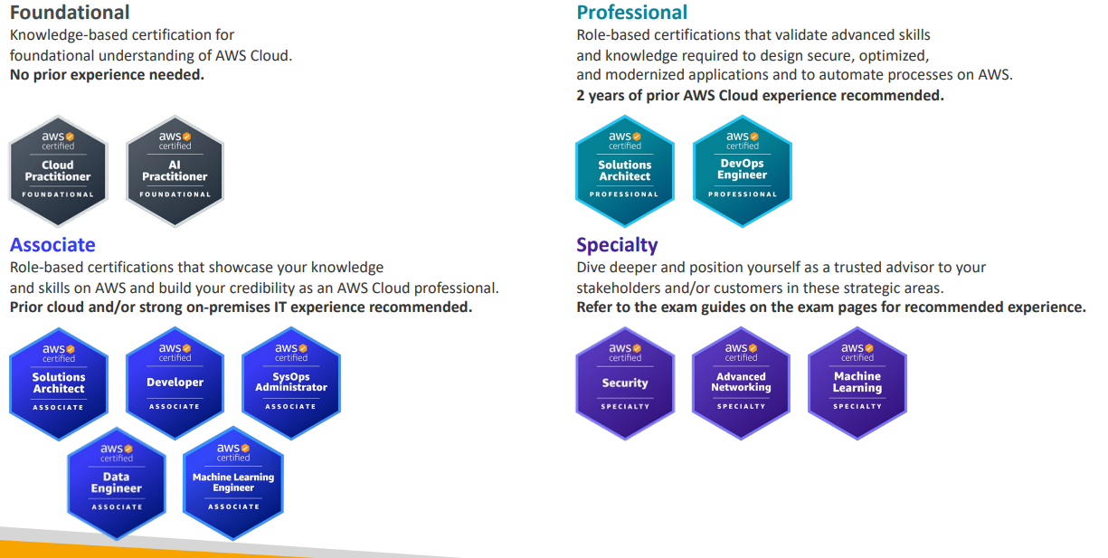

**AWS Certification Paths – Architecture**

|  |  |
| --- | --- |
| Architecture Solutions Architect Design, develop, and manage cloud infrastructure and assets, work with DevOps to migrate applications to the cloud |  |
| Architecture Application Architect Design significant aspects of application architecture including user interface, middleware, and infrastructure, and ensure enterprise-wide scalable, reliable, and manageable systems |  |

<https://d1.awsstatic.com/training-and-certification/docs/AWS_certification_paths.pdf>

**AWS Certification Paths – Operations**

|  |  |
| --- | --- |
| Operations Systems Administrator Install, upgrade, and maintain computer components and software, and integrate automation processes |  |
| Operations Cloud Engineer Implement and operate an organization’s networked computing infrastructure and Implement security systems to maintain data safety |  |

**AWS Certification Paths – DevOps**

|  |  |
| --- | --- |
| DevOps Test Engineer Embed testing and quality best practices for software development from design to release, throughout the product life cycle |  |
| DevOps Cloud DevOps Engineer Design, deployment, and operations of large-scale global hybrid cloud computing environment, advocating for end-to-end automated CI/CD DevOps pipelines |  |
| DevOps DevSecOps Engineer Accelerate enterprise cloud adoption while enabling rapid and stable delivery of capabilities using CI/CD principles, methodologies, and technologies |  |

**AWS Certification Paths – Security**

|  |  |
| --- | --- |
| Security Cloud Security Engineer Design computer security architecture and develop detailed cyber security designs. Develop, execute, and track performance of security measures to protect information |  |
| Security Cloud Security Architect Design and implement enterprise cloud solutions applying governance to identify, communicate, and minimize business and technical risks |  |

**AWS Certification Paths – Development & Networking**

|  |  |
| --- | --- |
| Development Software Development Engineer Develop, construct, and maintain software across platforms and devices |  |
| Networking Network Engineer Design and implement computer and information networks, such as local area networks (LAN), wide area networks (WAN), intranets, extranets, etc. |  |

**AWS Certification Paths – Data Analytics & AI/ML**

|  |  |
| --- | --- |
| Data Analytics Cloud Data Engineer Automate collection and processing of structured/semi-structured data and monitor data pipeline performance |  |
| AI/ML Machine Learning Engineer Research, build, and design artificial intelligence (AI) systems to automate predictive models, and design machine learning systems, models, and schemes |  |

**AWS Certification Paths – AI/ML**

|  |  |
| --- | --- |
| AI/ML Prompt Engineer Design, test, and refine text prompts to optimize the performance of AI language models |  |
| AI/ML Machine Learning Ops Engineer Build and maintain AI and ML platforms and infrastructure. Design, implement, and operationally support AI/ML model activity and deployment infrastructure |  |
| AI/ML Data Scientist Develop and maintain AI/ML models to solve business problems. Train and fine tune models and evaluate their performance |  |